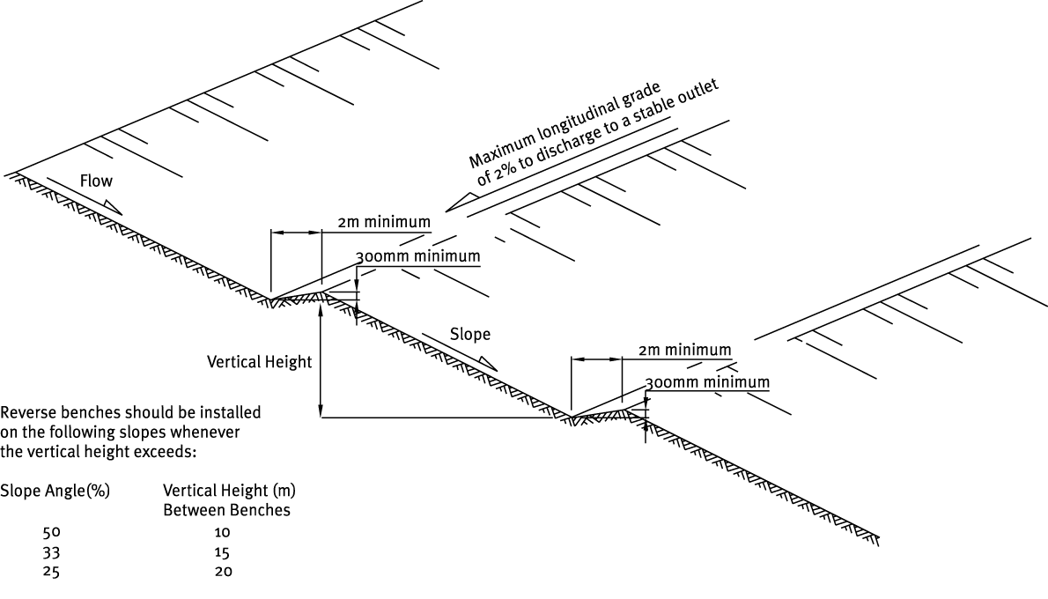

Contractor:  Inspector: | Date:  Time: |  |  | Consent #: |  |  | Site:
Site Inspection of Erosion and Sediment Control Practices
Erosion and Sediment Control Practice |  | Yes | No |  | N/A | Corrective Action
General Information
Do you know what receiving system the project drains into
Are you aware of local rainfall patterns during various times of the year
Soil types and erosion potential for site
Is a copy of the erosion and sediment control plan on site
Is temporary fencing placed in areas where no construction is to take place
Construction
Are all slopes > 25% and higher than 20 m vertical provided with slope benches
Are they located as equal as possible apart
Diversion must be at least 2 m wide and have a reverse slope of 15% and a minimum depth of 0.3 m
The cross-gradient should be < 2%
Flow length in bench < 250 m
Surface water should be diverted away from all cut and fill slopes
Maintenance
Repair and reinstate benches when needed
Check outfalls to ensure that erosion does not occur
Remove accumulated sediment from the diversion
Decommissioning
Check slope and bench area for any rilling or erosion, topsoil and stabilise

