Diversion Channel
Contour Drain
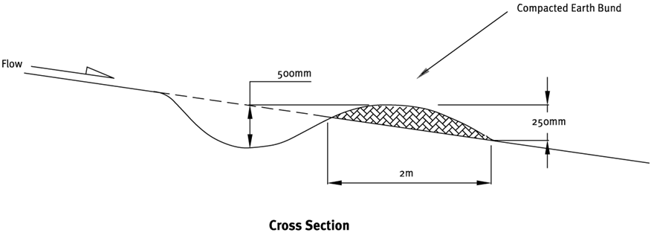

Contractor:  Inspector: | Date:  Time: |  |  | Consent #: |  |  | Site:
Site Inspection of Erosion and Sediment Control Practices
Erosion and Sediment Control Practice |  | Yes | No |  | N/A | Corrective Action
General Information
Do you know what receiving system the project drains into
Are you aware of local rainfall patterns during various times of the year
Soil types and erosion potential for site
Is a copy of the erosion and sediment control plan on site
Is temporary fencing placed in areas where no construction is to take place
Construction
Contour drains
Minimum compacted height is 250 mm
Minimum depth of 500 mm
Longitudinal grade < 2% w/out lining
Catchment area < 0.5 ha
Parabolic flow area and not V shaped
Diversion channels and bunds
Choose a route that avoids trees, services, fence lines or other natural or built features
Channels shall be trapezoidal or parabolic in shape.
Internal side slopes no steeper than 3:1
External side slopes no steeper than 2:1
Bunds shall be well compacted
Outlets shall be stable and protected as needed
Diversions shall be stabilised to prevent erosion
Maintenance
Contour drains
Repair or reinstate drains if destroyed by equipment
Inspect contour drains after rainfall and repair as necessary
Check outfall for erosion and repair as needed
Diversion channels and bunds
Inspect weekly and after every rainfall and repair immediately
Remove accumulated sediment
Check inlets and outlets to ensure that these remain scour and erosion free
Look for low spots where water can pond, formation of tunnel gullies and debris blockage
Check for stabilisation cover
Protect bunds from equipment damage
Decommissioning
Contour drains
Spread bunded area and stablise
Diversion channels and bunds
Fill in channels and spread bunded area and stabilise

