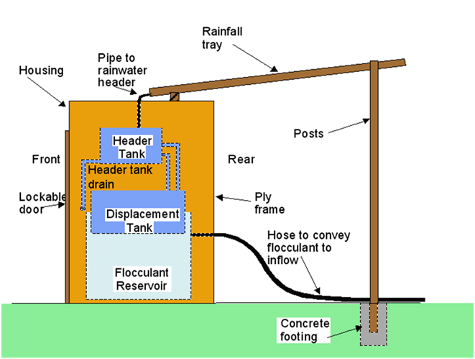

Contractor:  Inspector: | Date:  Time: |  |  | Consent #: |  |  | Site:
Site Inspection of Erosion and Sediment Control Practices
Erosion and Sediment Control Practice |  | Yes | No |  | N/A | Corrective Action
General Information
Do you know what receiving system the project drains into
Are you aware of local rainfall patterns during various times of the year
Soil types and erosion potential for site
Is a copy of the erosion and sediment control plan on site
Is temporary fencing placed in areas where no construction is to take place
Construction
Ensure all components are on site including:
- Rainfall catchment tray
- Header tank
- Displacement tank
- Flocculant reservoir tank
Follow the design approach which provides for sizing of the various elements and pipe sizes. Check that the flocculant volume has been based on site soil testing.
Rainfall tray shall be constructed and sealed along any joints and be graded at approximately a 10:1 slope with a drain to the header tank at the low end.
The header tank is installed properly with pipe sizes and elevations done according to plans
The displacement tank must be of a standard size of approximately 400 L
The flocculant reservoir tank must be larger than the displacement tank and of sufficient capacity to dose a large storm (generally at least 500 L)
The flocculant tank outlet shall be a 20 mm hose located at the point that will retain 400 L of floc w/out displacement
The dosing point of the outlet into the sediment diversion channel should be at least 10 m upstream of the forebay
Maintenance
Assess function after every rainfall or during rain events if they are heavy or prolonged
Service the unit prior to weekends to ensure maximum performance during weekend storms
The header tank volume needs to be manipulated depending on dry weather. After 3 days lower level 50%, after six days empty the header tank. During the winter, the tank should always have water up to the second level
When the volume of flocculant in the reservoir tank is insufficient to dose a storm, the displacement tank must be emptied and the flocculant reservoir refilled.
The size of the rainfall catchment tray needs modification if earthworks alter the extent of the contributing catchment. Also ensure that the tube from the tray does not become clogged
A contingency plan must be established if there is poor performance or other effects, such as reduced pH
There must be a consultant available who is qualified to advise on flocculation related issues.
There must be a spill contingency plan in the event of a PAC spill to prevent it entering water.
Decommissioning
Remove all components of the flocculation shed, store for use on another pond

