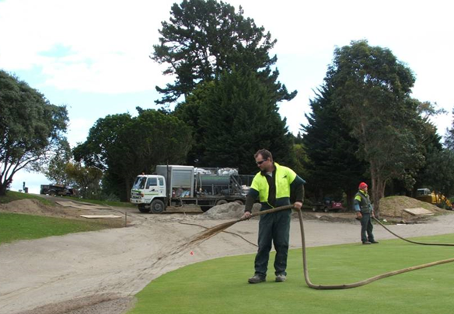

Contractor:  Inspector: | Date:  Time: |  |  | Consent #: |  |  | Site:
Site Inspection of Erosion and Sediment Control Practices
Erosion and Sediment Control Practice |  | Yes | No |  | N/A | Corrective Action
General Information
Do you know what receiving system the project drains into
Are you aware of local rainfall patterns during various times of the year
Soil types and erosion potential for site
Is a copy of the erosion and sediment control plan on site
Is temporary fencing placed in areas where no construction is to take place
Construction
Where hydroseeding is used, the manufacturers recommendations shall be followed.
Maintenance
Where vegetation requirement is unsatisfactory, the area will require a reapplication of hydroseed
Protect all re-vegetated areas from construction traffic or utility construction
Decommissioning
Ensure good stabilisation occurs

