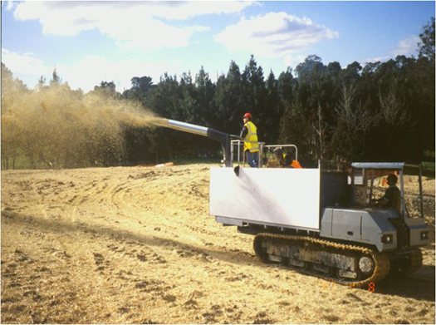
Contractor:  Inspector: | Date:  Time: |  |  | Consent #: |  |  | Site:
Site Inspection of Erosion and Sediment Control Practices
Erosion and Sediment Control Practice |  | Yes | No |  | N/A | Corrective Action
General Information
Do you know what receiving system the project drains into
Are you aware of local rainfall patterns during various times of the year
Soil types and erosion potential for site
Is a copy of the erosion and sediment control plan on site
Is temporary fencing placed in areas where no construction is to take place
Construction
Straw or hay shall be unrotted material and applied at a rate of 6,000 kg/ha
If wind is a problem mulch should be either crimped or bound to prevent blowing
Hydro mulch must contain a minimum of 80% virgin or recycled wood, be in accordance with manufacturers specifications and from 2,200 kg/ha – 2,800 kg/ha and slope length < 150 m
Wood chip can be applied at rates of 10,000 kg/ha – 13,000 kg/ha
Maintenance
Inspect after each rainfall or after strong winds and repair or replace as needed
Decommissioning
Ensure good stabilisation occurs

