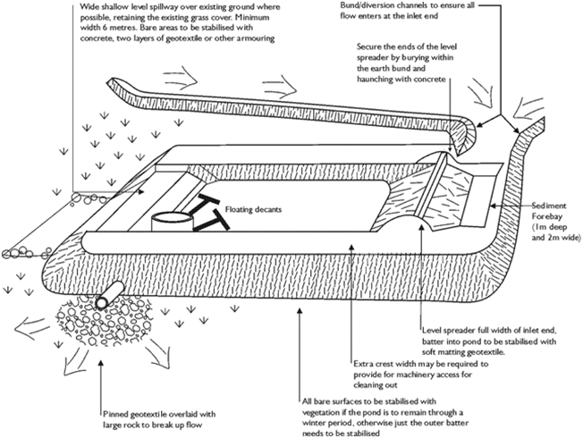

Contractor:  Inspector: | Date:  Time: |  |  | Consent #: |  |  | Site:
Site Inspection of Erosion and Sediment Control Practices
Erosion and Sediment Control Practice |  | Yes | No |  | N/A | Corrective Action
General Information
Do you know what receiving system the project drains into
Are you aware of local rainfall patterns during various times of the year
Soil types and erosion potential for site
Is a copy of the erosion and sediment control plan on site
Is temporary fencing placed in areas where no construction is to take place
Construction
Implement sediment control downslope of the proposed sediment retention pond
Clear areas of proposed fill of topsoil or other suitable material down to competent material.
If the pond is to be converted to a permanent stormwater management pond ensure that a key trench is constructed
Use only approved fill material.
Place and compact fill in layers per the engineering recommendations
Construct fill embankment 10% higher than the design height to allow for settlement
Install pipework and anti-seep collars or filter collars during construction of the embankment and ensure good compaction around pipes
Construct the emergency spillway
Install and stabilise the level spreader
Securely attach the decant system to the horizontal pipework. Make all connections watertight. Place any manhole riser on a firm foundation of concrete or compacted soil
Protect inlet and outlet with fabric
Install baffles when the pond’s length to width ratio < 3:1
Provide an all weather access track for maintenance
Check all elevations to ensure proper function and rectify any inaccuracies
Stabilise both internal and external batters with vegetation and the emergency spillway in accordance with the approved erosion and sediment control plan
Undertake an As Built assessment at the completion of consruction and rectify any discrepancies with the design
Maintenance
Clean out pond before the volume of accumulated sediment reaches 20% of the total pond volume. A staff gauge would assist in this determination
Clean out ponds with high capacity sludge pumps or with excavators loading the material onto sealed tip trucks to an area that will not discharge sediment off-site
Clean out forebay after each runoff event if there is any evidence of sediment deposition
Inspect pond every day and before every forecasted rainfall event
Inspect for correct operation after every runoff event
Immediately repair any damage caused by erosion or construction equipment
Decommissioning
Install a silt fence or other device downhill from the pond
Dewater pond
Remove and correctly dispose of all accumulated sediment
Backfill the pond and compact soil. Regrade as required
Stabilise all exposed surfaces

