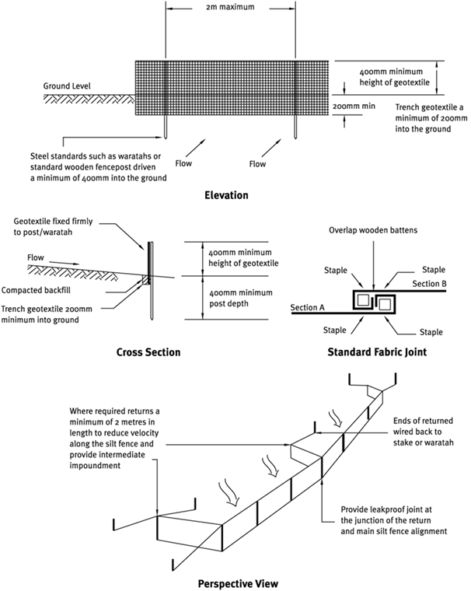

Contractor:  Inspector: | Date:  Time: |  |  | Consent #: |  |  | Site:
Site Inspection of Erosion and Sediment Control Practices
Erosion and Sediment Control Practice |  | Yes | No |  | N/A | Corrective Action
General Information
Do you know what receiving system the project drains into
Are you aware of local rainfall patterns during various times of the year
Soil types and erosion potential for site
Is a copy of the erosion and sediment control plan on site
Is temporary fencing placed in areas where no construction is to take place
Construction
Use silt fence material appropriate to the site conditions and in accordance with the manufacturer’s specifications
Always install silt fences along the contour
Excavate a trench a minimum of 100 mm wide and 200 mm deep along the proposed line of the silt fence
Use supporting posts of tantalised timber a minimum of 50 mm square or steel waratahs at least 1.5 m length
Install the support posts/waratahs on the downslope edge of the trench and silt fence fabric on the upslope side of the support posts to the full depth of the trench and then backfill the trench with compacted soil
Reinforce the top of the silt fence fabric with a support made of high tensile 2.5 mm diameter galvanised wire. Tension the wire using permanent wire streainers attached to angled waratahs at the end of the silt fence
Where ends of silt fence fabric come together, ensure they are overlapped, folded and stapled/screwed to prevent sediment bypass
Maintenance
Inspect silt fences at least once a week and after each rainfall
Check for damage including rips, tears, bulges in the fabric, broken support wires, loose posts/waratahs, overtopping, outflanking, undercutting and leaking joins in the fabric
Make any necessary repairs as soon as they are identified
Remove sediment when bulges occur or when sediment accumulation reaches 50% of the fabric height
Remove sediment deposits as necessary (prior to 50% level) to continue to allow for adequate sediment storage and reduce pressure on the silt fence
Dispose of the sediment to an area where sediment cannot be transported downstream
Decommissioning
Do not remove silt fence and accumulated sediment until the catchment area has been appropriately stabilised
Remove and dispose of accumulated sediment
Backfill trench, regrade and stabilise the disturbed area

