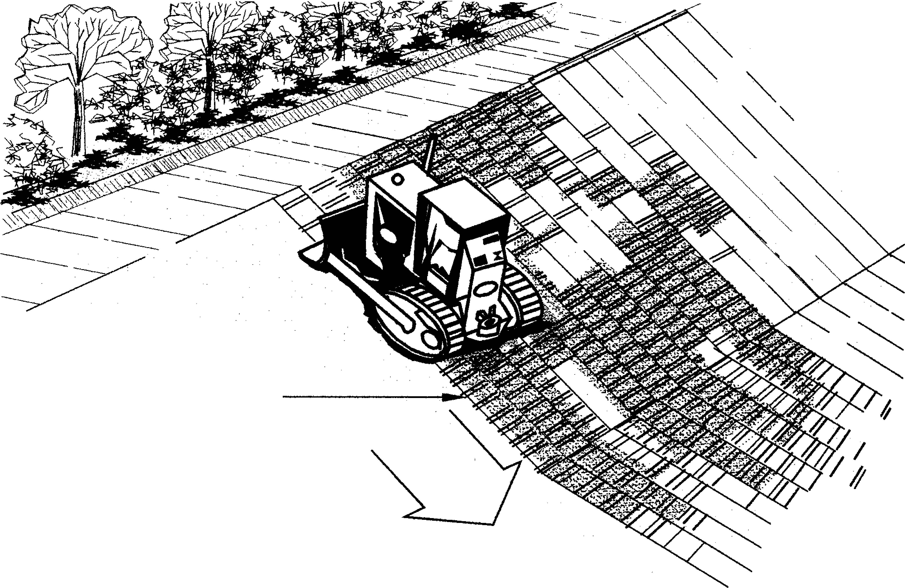
Contractor:  Inspector: | Date:  Time: |  |  | Consent #: |  |  | Site:
Site Inspection of Erosion and Sediment Control Practices
Erosion and Sediment Control Practice |  | Yes | No |  | N/A | Corrective Action
General Information
Do you know what receiving system the project drains into
Are you aware of local rainfall patterns during various times of the year
Soil types and erosion potential for site
Is a copy of the erosion and sediment control plan on site
Is temporary fencing placed in areas where no construction is to take place
Construction
Divert water away from the slope face prior to slope roughening
Fill existing rills before roughening
Roughening must be done perpendicular to surface water flows
When track-walking topsoil material, take care not to compact the slope
Maintenance
Periodically check the slope for erosion and rework or reseed as necessary
Decommissioning
Check slope for any rilling or erosion, topsoil the area and stabilise

