Programme business case title
[AUTHOR]
[DATE]
VERSION
Programme business case

[Insert partner logos / image]

Copyright information
This publication is copyright © NZ Transport Agency. Material in it may be reproduced for personal or in-house use without formal permission or charge, provided suitable acknowledgement is made to this publication and the NZ Transport Agency as the source. Requests and enquiries about the reproduction of material in this publication for any other purpose should be made to:
Manager, Information
NZ Transport Agency
Private Bag 6995
Wellington 6141
The permission to reproduce material in this publication does not extend to any material for which the copyright is identified as being held by a third party. Authorisation to reproduce material belonging to a third party must be obtained from the copyright holder(s) concerned.

Disclaimer
The NZ Transport Agency has endeavoured to ensure material in this document is technically accurate and reflects legal requirements. However, the document does not override governing legislation. The NZ Transport Agency does not accept liability for any consequences arising from the use of this document. If the user of this document is unsure whether the material is correct, they should refer directly to the relevant legislation and contact the NZ Transport Agency.

More information
NZ Transport Agency
Published [month and year]
If you have further queries, call our contact centre on 0800 699 000 or write to us:
NZ Transport Agency
Private Bag 6995
Wellington 6141
This document is available from the NZ Transport Agency on request.

This document provides a template for a programme business case (PBC) and is for guidance purposes only. The layout for your PBC will be determined by your own requirements and its complexity and scale.
PBCs have been devised to support the development and agreement of programmes in support of an agreed strategic case and to realise the problems or opportunities identified. The functional content of the programme may be scoped on either a national, regional or corridor basis. Following agreement to the PBC, the activities comprising the programme must be subject to individual business cases.
Depending on the amount of time passed it may be necessary to confirm or redefine the strategic case prior to commencing the PBC.
The programme business case will:
- Confirm and refine the problems or opportunities identified in the strategic case or alternatively disprove identified problems, through appropriate data collection and analysis. In addition the PBC identifies potential risks, dependencies and constraints;
- Possibly require consultation to gather further evidence and confirm support;
- Identify and confirm whether the network is fully optimised at present, before any new activities are considered – the Network Operating Framework (NOF) is a tool that can be used to demonstrate optimisation of the network or where improvement is needed;
- Identify potential alternatives and options and subsequently form a variety of possible programmes that will give effect to the strategic case;
- Determine time frames, potential benefit realisation returns, costs, risks and dis-benefits;
- Confirm the strategic fit and determine effectiveness and anticipated efficiency rating;
- From this long-list of possible programmes identify a short-list and recommended programme, by identifying a range of cost estimates, risks, trade-offs and the potential benefits expected to be realised;
- Identify sub-programmes (if any) that come out of the recommended programme;
- Recommend a programme of activities and a way forward for further development of the investment proposal; and
- Identify phasing of activities that will support the programme outcomes.
Guidance on the development of programmes is available on the NZ Transport Agency’s Highways Information Portal website http://www.nzta.govt.nz/roads-and-rail/highways-information-portal/processes/project-development/programme-business-case/ and this template should be used in conjunction with the other documents available there.

Approval
Prepared by | Reviewed by | Endorsed by | Endorsed by
[Job title] | [Job title] | Proposal sponsor | P&I Case Manager
Date: | Date: | Date: | Date:

Revision status*
Revision number | Implementation date | Summary of revision
Delete revision status table on production of final version

Template version
Revision number | Implementation date | Summary of revision

TABLE OF CONTENTS

EXECUTIVE SUMMARY 8
PART A – THE STRATEGIC CASE 9
Introduction 9
Programme context 10
Geographic and environmental context 10
Social context 10
Economic context 10
Transport context 10
Partners and key stakeholders 11
Investment partners 11
Key stakeholders 11
Strategic assessments – outlining the need for investment 12
Defining the problem 12
The benefits of assessment 12
Alignment to existing strategies/organisational goals 13
Issues and constraints 14
Problem 1 16
Problem 2 17
Problem x, etc 18
Anticipated strategic fit and effectiveness 19
Strategic fit 19
Effectiveness 19
PART B – DEVELOPING THE PROGRAMME 21
Alternatives and options 21
Alternative and option generation 21
Alternative and option assessment 22
Programme options development and assessment 23
Programme development 23
Do-minimum option 23
Programme assessment 23
Recommended programme 24
Programme overview 24
Programme implementation strategy and trigger points 24
Recommended programme – assessment 25
Programme outcomes 25
Programme risk 25
Value for money 26
Sensitivity analysis 26
Assessment profile 26
Programme financial case 27
Indicative cost 27
Funding arrangements 27
Affordability 27
PART C – DELIVERING AND MONITORING THE PROGRAMME 28
Management case 28
Programme governance and reporting 28
Stakeholder engagement and communications plan 28
Programme performance and review 29
Appendix A – Investment logic map 30
Appendix B – Benefit map 31
Appendix C – Assessment of alternatives summary tables for each option 32
Appendix D – Consultation summary 33
A) Consultation and communication approach 33
B) Professional engagement process 33
C) Views provided 33

Supporting documents
List the supporting documents for the programme business case.

Glossary of terms
Insert the glossary of terms for the programme business case.

EXECUTIVE SUMMARY
Anyone should be able to read the summary and understand:
- That the strategic context is still sound;
- How the outcomes have been formulated into SMART investment objectives;
- A brief summary of evidence behind the key problems, opportunities and constraints;
- The recommended programme for investment;
- The financial impact;
- The economic benefits;
- The case for change;
- Urgency/importance of problems; and
- What benefits will be achieved by the recommended programme.

PART A – THE STRATEGIC CASE
Part A of the programme business case summarises the strategic case and through further evidence collection and analysis, reconfirms and refines the strategic case problems and benefits or conversely, discounts them. The problems are then further developed and shaped into SMART investment objectives that form a line of sight between the problem statements and measureable outcomes.

Introduction
An introduction to the PBC should be succinct and provide the reader the information necessary to understand what is to be discussed in the following sections. It should state the reasons for:
- The purpose and extent eg national, regional or corridor, of the PBC; and
- Whether the PBC has involved a teamed up approach with other stakeholders and investors.

Programme context
This chapter outlines the geographic, economic, social, environmental and transport context to the PBC. The chapter should not describe or analyse the key problems/opportunities but rather provide a relevant context to the area where investment is being sought and follow logically from the scene setting outlined in the introduction.

Geographic and environmental context
Describe the geographic and environmental area likely to be affected by the programme and how the area relates to the problem statements and benefits for investing.
This should include a description of the built and natural environment (baseline information) as well as a description of the existing transport infrastructure.

Social context
Describe the social makeup of the area likely to be affected by the programme. Areas of deprivation and social exclusion should be identified as well as noting any relevant policy designations.

Economic context
Describe the principal sectors and industries within the geographic area and any activities that may be affected outside of the area. Describe how the economic activities relate to the problem statements and benefits for investing.

Transport context
Describe the transport operating environment that the investment sits within and how it relates to the problem statements and benefits for investing.
This section considers the interactions with other modes, key journeys, peak travel, and interactions with major surrounding land uses.

Partners and key stakeholders
This section outlines the key partners to the business case who will have a responsibility for delivering on the investment and explains the approach adopted for identifying key stakeholders who have an interest in the expected outcomes or can influence the investment proposal.

Investment partners

NZ Transport Agency
Example text
The Transport Agency is responsible for managing, operating, planning for and improving state highways. This is fundamentally done by the Highways and Network Operations group on behalf of the Transport Agency.
As a partner to this business case the Transport Agency is fundamentally concerned with [explain]. Investment in the state highway network may be needed to help solve the problems identified in the strategic case, and fully realise the benefits of investing.

Partner organisation 2
Example text
The ………… City Council is responsible for fully managing the local road network that forms, with the state highway, the land transport network connecting Area A to Area B, and is responsible for public transport infrastructure that services the area. Investment by the ………… City Council is required to improve the local road network and/or public transport infrastructure to fully realise the benefits for solving Problems A and B as identified in the strategic case.

Partner organisation 3
Example text
The company ………… Ports Limited is responsible for the operation of Port A that relies primarily on the land transport network for transporting containers and commodities. Investment by ………… Ports Limited is required within the boundaries of its site to fully realise the benefits for solving Problem C as identified in the strategic case.

Key stakeholders
In this section you should briefly outline the key stakeholders and customers of the participating organisations relevant to this investment. Identify commonalities and differences in areas of focus. You can look to briefly address these in a table form as below, or more detailed paragraphs.
Example table
Stakeholders | Focus areas
Stakeholder 1 | Focus areas
Stakeholder 2 | Focus areas

Strategic assessments – outlining the need for investment
Use this chapter to clearly outline the rationale for the investment. This section will be informed by the information and data obtained in this phase to confirm or highlight any stakeholder/investor endorsed amendments to the problem statements and benefits of investment. You should outline what, if any, changes there have been to the strategic case as a result of geographic, economic, social, policy direction impacts and the approach to exploring these and assessing their impact on the strategic case as presented.

Defining the problem
This section will list the problem and opportunity statements as per the strategic case preceding the programme business case and go on to demonstrate robust evidence which supports, discounts or reshapes the problem statement. If the evidence base does not support the problem statement arising from the strategic case new problem statements SHOULD NOT be arbitrarily created to divert the business case to address other issues not supported by the strategic case partners.
Example text
A facilitated investment logic mapping workshop was held on [dd/mm/yyyy] with key stakeholders to gain a better understanding of current issues and business needs. The stakeholder panel identified and agreed the following key problems:
- Problem one: …
- Problem two: …
- Problem three: …
Further analysis of these problems and development of SMART investment objectives is explored further in sections 4.5-4.7.x below. The investment logic map is attached as appendix A.

The benefits of assessment
This section will list the benefits of investing as per the strategic case preceding the programme business case. The reason that it is listed here is to act as a reference for the rest of the document.
Example text
The potential benefits of successfully investing to address these were identified as part of a second facilitated investment logic mapping held on [dd/mm/yyyy]. The stakeholder panel identified and agreed the following potential benefits for the proposal:
- Benefit one: …
- Benefit two: …
- Benefit three: …
The benefit map is attached as appendix B.

Alignment to existing strategies/organisational goals
Describe how the proposed outcomes for this business case align to relevant national, regional, sector and organisational strategies. It is important that the proposed direction for the business case contributes to and is consistent (or at least not inconsistent) with the aims and objectives of each organisation’s strategy.

NZ Transport Agency
The Transport Agency’s Statement of Intent and Investment Assessment Framework describes what the priorities are for delivering on the government’s key policies for transport, notably the:
- Government Policy Statement for Land Transport Funding;
- Safer Journeys; and
- ITS Action Plan.
What this chapter needs to do is to describe how the programme business case maps back to the objectives and outcomes of these key documents. This doesn’t need to be exhaustive, but it does need to demonstrate the links. Make this a line of sight link rather than a reproduction of the policy.
Example text
SHx is a national state highway with problems with safety and efficiency identified through the strategic case.
The safety problems are significant with two sections of the corridor identified in the National State Highway Safer Roads and Roadsides Programme Business Case.
Efficiency problems are restricted mainly to heavy freight vehicles due to restrictions for HPMV, and frequent closures due to accidents. These problems are highlighted in the XXXXX freight story for the region, and are described as being a significant encumbrance to future economic growth. Economic growth will be negatively impacted due to unreliable travel times for freight movements between the productive areas of the region to the Port, in particular.
Investing in solving these problems are high priorities for the Investment Assessment Framework. High strategic fit ratings are allocated for investments to improve areas of high safety risk, and improve freight supply chains for highly productive corridors.
The Statement of Intent reflects this focus through its medium term (2013-22) objectives to:
- Improved freight supply chain efficiency;
- Implementing the safe system approach; and
- Deliver greater resilience for the state highway network.
These linkages are important for explaining the role of the PBC in delivering on the goals of the Transport Agency.

Partner organisation 2, etc
As relevant as per example above.

Issues and constraints
Briefly describe key economic, social, environmental, transport, stakeholder and other issues and constraints which could have an effect on the scope of the project outcomes and outputs.
‘Issues’ are uncertainties that the study may not be in a position to resolve, but must work within the context of. Examples of issues include:
- Uncertainty at the time of the study whether a major road or rail link will be built that will affect the study area;
- The impact of a major new land-use development has yet to become clear; or
- A study for a neighbouring area may lead to a proposal that results in significant changes to through trips passing across a study area.
Practitioners should account for, or if possible neutralise, such issues through liaison with neighbouring authorities, government departments and agencies, and transport operators.

Uncertainty log classifications
Probability | Status
Near certain: The outcome will happen or there is a high probability that it will happen | Policy or funding approval  Tenders let  Under construction
More than likely: The outcome is likely to happen but there is some uncertainty | Submission of planning consent application imminent  Adopted plans*
Reasonably foreseeable: The outcome may happen, but there is significant uncertainty | Adopted plans*  Draft plans  Development conditional upon interventions going ahead
Hypothetical: There is considerable uncertainty whether the outcome will ever happen | A policy aspiration

Example uncertainty log
Factor | Time | Uncertainty | Impact on programme | Comments
Factors affecting demand
400 houses developed at location A | 2016 | More than likely | Medium | Land classified in local plan for housing. Application submitted to local planning authority.
Superstore at location B | 2018 | Reasonably foreseeable | Low | Currently speculative project. Land use identified in unitary plan (fairly high uncertainty about timing and exact location).
Factors affecting supply
Increase in rail capacity at C | 2018 | Near certain | Low | Under construction.
Factors affecting cost
Local integrated ticketing scheme | 2014 | Reasonably foreseeable | Low | Business case under preparation for funding of a scheme.

‘Constraints’ represent the bounds within which a business case is being undertaken. These may include, but are not limited to:
- The statutory powers of an authority to promote change;
- The funding levels that can realistically be obtained;
- Legislation; and
- NZ fiscal policy.
Similarly, constraints on the shape of a particular alternative/option could be affected by:
- Sensitive areas of ecological, landscape or heritage importance;
- Built-up areas;
- Rivers or railway lines which are expensive to bridge;
- Rough terrain making infrastructure works expensive; and
- Unusual existing patterns of development such as industry and commerce spread over wide areas outside the traditional urban centre.

Problem 1

The evidence
Outline here the evidence which supports the problem statement. It should be a succinct summary explaining how the evidence gathered has expanded the knowledge around the problems and benefits of investment and supported by more technical reporting.
It should highlight where gaps in knowledge still exist and the effect these gaps have in understanding the key problems.
This section demonstrates the extent to which the identified problems are real, either now or in the future.
The questions this section should answer are:
- What is the root cause of the identified problem(s), with timescales and the key drivers? What would happen if the problems were not addressed?
- How certain is the likelihood and impact of the problem (with reference to the uncertainty log)?
- Who is the target and/or affected population(s) and what is known about their needs, current behaviours and attitudes?
- How has engagement with stakeholders and the public helped shape and understand the problems and root cause?
- Is the evidence gathered representative enough to give an accurate view of the problem?
- Is the evidence to define the problem free of bias, and reliable?
- Based on the evidence how does the problem rate in significance locally, regionally and nationally?

Implications of the evidence
This section explores the case for change – that is, a clear rationale for supporting the problem on the basis of the evidence base. It clearly explains the significance of addressing the problem and scale of contribution it will make to the identified benefits in furthering the aims and objectives of the NZ Transport Agency and partner organisations.
The evidence base may lead to a refinement of the problem statement but should not lead to new problems. Problem statements won’t be wholly re-litigated, but the nature and scale of the problem statement will be more defined.
You will need to discuss whether the evidence gathered, and through refining the problems, still justifies the need to invest in resolving these problems.

SMART investment objectives
As the evidence base for the problem statement is investigated and refined it will be possible to refine the benefits to articulate them as SMART investment objectives.
This will show what investment objectives can be attributed to a transport need, and will describe the nature and scale that the transport investment will make towards achieving these objectives. The SMART investment objectives will be a series of statements that are developed from the benefits map as shown below in the yellow and green boxes.
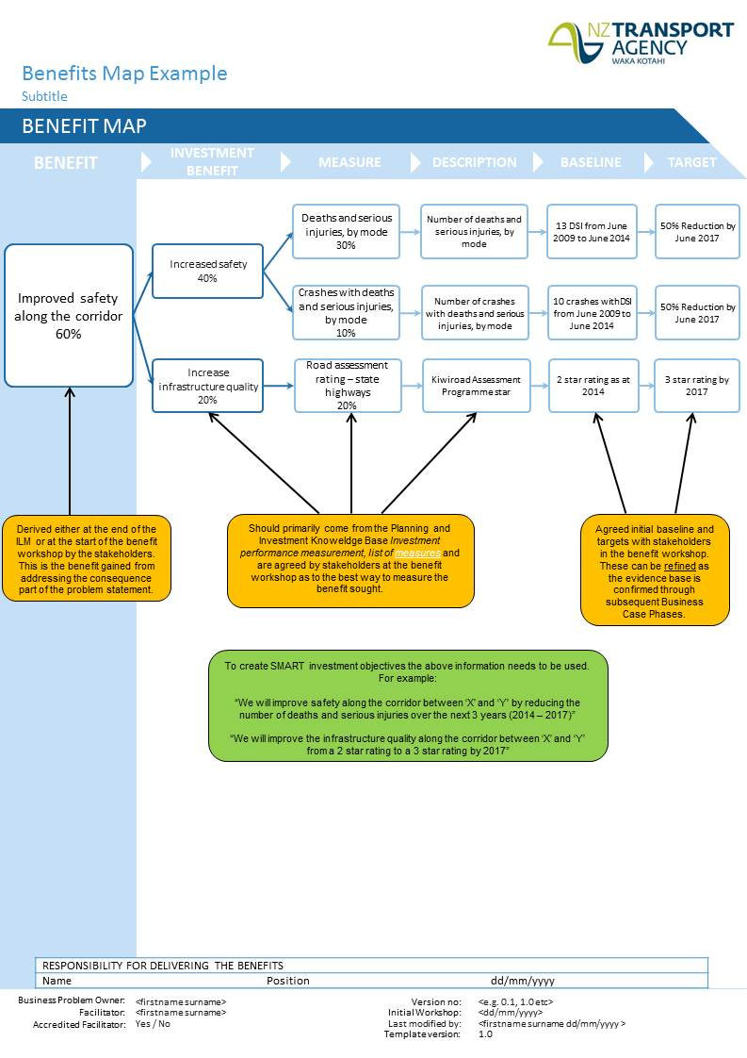

Problem 2

The evidence
Text

Implications of the evidence
Text

SMART investment objectives
Text

Problem x, etc

The evidence
Text

Implications of the evidence
Text

SMART investment objectives
Text

Anticipated strategic fit and effectiveness
Outline the strategic fit and effectiveness of investing in the problem/opportunity in accordance with the requirements of the Investment Assessment Framework.
Meaningfully, explain in summary the rationale for the profile proposed with reference to the IAF criteria. Generic statements such as ‘it meets the criteria of high’ are not acceptable.
Use tables and diagrams where relevant to portray the information succinctly.
Example text
An assessment of the anticipated strategic fit and effectiveness has been undertaken in accordance with the Transport Agency Investment Assessment Framework. The stakeholder partners to this strategic case have determined that the anticipated profile would be X/X/-.

Strategic fit
Explain how you’ve reached your rating using information from the IAF link above.
More information on strategic fit for investment management and on strategic fit for road improvements is available.

Effectiveness
The assessment considers all criteria. The overall effectiveness assessment is reported as the lowest rating for any criterion, ie an overall M rating will be given when all criteria and parts have either an M or H rating. An overall L rating will be given if any criterion is rated L.

Criteria for effectiveness
All six criteria set out in the Knowledge Base for the assessment framework for the 2015-18 NLTP, are to be assessed for any programme or activity proposed for NLTP inclusion or funding approval.
The criteria for effectiveness explanations are most appropriate when applied to road improvement activities. Variations of these are appropriate when assessing activities other than road improvements. The explanations are a guide to assessment, highlighting aspects that need to be considered. If any of these aspects is not applicable to the activity then it should not form part of the assessment. Amend the information in the table to suit what you need, don’t just use what’s there. Include your own explanation as it relates to your project.
Example table
Component | Explanation | Rating
Eg. outcomes focussed, integrated, affordable, etc. | - Describe how the activity achieves a L/M/H rating consistent with the PIKB explanation | Use: L/M/ or H
Overall | - assessment based on lowest rating of all components | L/M/H

More information about and variations on assessment of activities other than road improvements is available.

PART B – DEVELOPING THE PROGRAMME
The Land Transport Management Act 2003 (LTMA) stipulates that the NZ Transport Agency can only approve activities if it is satisfied that the activity has, to the extent practicable, been assessed against other land transport alternatives.
Part B of the programme business case maps the path from identifying a broad range of alternatives and options through to considering a range of programmes (combinations of alternatives and options) to identifying a recommended programme. Consideration of a range of programmes provides the opportunity for the Transport Agency and stakeholders to influence the direction of the programme business case and form their own view of a preferred programme.

Alternatives and options

Alternative and option generation
The purpose of this section is twofold: (a) to present an overview of the methodology adopted to alternative/option generation, and (b) demonstrate and present a summary overview of the alternatives considered. These should not be detailed accounts (which can be presented through supplementary technical papers), but need to be sufficient for the reader to comprehend the scope and likely impact of an alternative/option and to give confidence that the development of alternatives and options has been based on the broadest consideration of potential alternatives.
In identifying alternatives and options it might be that some are clearly not candidates through some element of fatal flaw against one or a number of dimensions before progressing to a more thoughtful assessment of the alternative. It is important that the consideration of these, and the rationale for this first sift, be recorded and this should be reported in this section.
Within the development of a good set of alternatives and options the questions likely to be asked by the business problem owner include:
- Can the existing arrangements for the provision of services be better utilised, or are more fundamental changes required? What are the constraints?
- What are the aims of the proposed alternative/option and how do they address the problems identified?
- How do the alternatives/options draw on evidence about what has worked in the past and/or understanding of existing and potential barriers to behaviour change?
- What are the attitudes of key groups (eg the general public, residents, businesses and wider stakeholders) to the alternatives/options and how have those attitudes informed the assessment?
- What was the process for generating and shortlisting options?
- What are the constraints and dependencies, in light of other programmes and projects which are underway?

Alternative and option assessment
The purpose of this section is to record, in brief, the assessment of the alternatives identified in section 5.1 which passed the first sift. This should not be a detailed account, but should be sufficient for the reader of this document to be confident that the assessment has been undertaken appropriately with the right balance of qualitative and quantitative analysis. This would include the appropriate interpretation and application of threshold ‘scores’ and that a clear rationale for retention or rejection of an alternative or option is evident.
Use of the PBC summary table available at http://www.nzta.govt.nz/roads-and-rail/highways-information-portal/processes/project-development/programme-business-case/ is preferred for recording a summary of individual alternative/option assessments.

Programme options development and assessment
The questions likely to be asked by an investor include:
- What was the process for grouping alternatives and options together to form programmes?
- Have a sufficiently broad range of programmes been considered and evaluated?

Programme development
The purpose of this section is to record, in brief, the development of the possible programmes to meet the strategic case SMART Investment objectives. This should not be a detailed account, but should be sufficient for the reader of this document to be confident that the development of programmes has been undertaken in a robust and open minded manner. Reference should be made to the Transport Agency’s Alternatives and preferred programme workshop templates where these have been used.

Do-minimum option
Describe the do-minimum programme scenario against which the recommended programme option has been assessed. Describe the rationale and process for establishing this as the do-minimum programme.
In developing the business case, the do-minimum should represent the minimum level of expenditure required to maintain a minimum level of service, NOT the minimum level of investment required to achieve the project objectives. The exercise of comparing the minimum investment against other programmes for achieving the SMART investment objectives is anticipated to have been undertaken as part of the programme evaluation process.
It is important not to overstate the scope of the do-minimum, ie it shall only include activities which are absolutely essential to preserve a minimum level of service.
This definition is consistent with that described in the NZ Transport Agency Economic evaluation manual.

Programme assessment
The purpose of this section is to record, in brief, the assessment of the programmes developed (and supported by technical papers). It should highlight the key benefits and dis-benefits arising from the analysis and any points of particular relevance to the decision making process to retain or reject a programme. Reference should be made to the NZ Transport Agency Alternatives and preferred programme workshop templates where these have been used.

Recommended programme

Programme overview
Provide an overview of the overall recommended programme. This involves identifying and describing the work that is needed in the next phase in sufficient detail to ensure that:
- The investor understands the level of outcome/investment risk; and
- All of the programme work that is reasonable has been identified.
What constitutes ‘sufficient detail’ will vary by programme; too much detail can be as troublesome as too little detail. In addition, control may often be exercised at a level higher than that needed for understanding.
It is also useful to state what is excluded from the programme; this is important because by identifying clearly what you do not want to happen will help everyone keep things contained.
In scope:
- Core activities that are expected from the programme: these reflect the essential elements that must be successfully delivered;
- Desirable requirements to be met: these are the requirements that would add value and bring about additional benefits but are not essential to successful delivery;
- Optional requirements: those things that might be delivered if sufficient budget were available; and
- Excluded from scope: those things that are excluded from this programme. This is a powerful tool to prevent scope creep.

Programme implementation strategy and trigger points
In developing a programme implementation strategy the following questions need to be considered:
- What is the optimal timing for activities in the programme to achieve the SMART objectives?
- Where activities in the programme rely on certain trigger points or synergies with changes in land use?
The implementation strategy will identify the organisations responsible for delivering on their parts of the programme, and will give direction to the criticality of each element to achieving the SMART investment objectives.
The implementation strategy should also consider how the SMART investment objectives will be reviewed after delivery of each activity in the programme. There may be no need to pursue parts of the programme if after review, a few of the activities have delivered the majority of the outcomes and benefits. This could also then result in a change in the trigger points for when further activities in the programme may be required.

Recommended programme – assessment
The assessment of the recommended programme identifies all the significant impacts of the programme, and the resulting value for money, to fulfil the Agency’s requirements for appraisal and demonstrating value for money. It draws on the summary of the assessment of all programmes presented in section 6.3 but is not a repetition, rather a more fulsome report, commensurate with a recommended programme, drawing on more detailed supporting information.
In line with the Transport Agency’s appraisal requirements, the impacts considered are not limited to those directly impacting on the measured economy, or to those which can be monetised. The economic, environmental, social and distributional impacts of a programme are all examined, using predominantly qualitative information with quantitative and monetised information where this is available. In assessing value for money, all of these are consolidated to determine the extent to which a programme’s benefits outweigh its costs.
The Transport Agency will ask what economic, environmental, social and distributional impacts a programme is expected to have, and whether these have been estimated in line with the current best practice and Agency guidance. It will also ask how strong the resulting value for money is expected to be.
The questions likely to be asked by an investor include:
- How does the recommended programme contribute to key SMART investment objectives, including wider transport and government objectives?
- What will constitute success for the programme, and how will it be measured? Is there a clear logic model for how the outcomes will be achieved? What wider impacts will the project have?
This section assesses the performance of the recommended programme against three key criteria:
- Programme outcomes;
- Programme risks; and
- Value for money.
A summary of performance against the above criteria is given.

Programme outcomes
How will the recommended programme meet the desired project outcomes? Which programme items make the greatest contributions to the outcomes? What is the distribution of outcomes between stakeholders accountable for delivery of programme outputs?
Does the programme meet all of the specific outcomes? How certain are we of achieving these outcomes?

Programme risk
This section considers the risks associated with the programme. These can be broken down into the key risk areas such as:
- Technical;
- Operational;
- Financial;
- Stakeholder/Public;
- Environmental and social responsibility;
- Safety; and
- Economy.

Value for money
This section will detail the results of the economic analysis. An indicative benefit cost analysis should be provided. Indicative BCR ranges should be calculated for activities, and the programme as a whole.

Sensitivity analysis
The forecasting of future costs and benefits at the programme level will involve a degree of uncertainty and the economic analysis will be sensitive to the assumptions or predictions inherent in the analysis.
Two types of uncertainty may occur: the first relating to the size or extent of costs or benefits, such as variations in construction, maintenance or operating costs, or predicted traffic flows not eventuating and the other relating to the timing and scale of unpredictable events.
Summarise the sensitivity analysis undertaken, what variables have been examined, and what the impact is on the programme BCR.

Assessment profile
The assessment profile for the programme should be assessed using the latest NZ Transport Agency Investment Assessment Framework. The guidance provided on the knowledge base should be your first point of reference for helping to determine your programme assessment profile. The following link to the knowledge provides information for how the assessment profile should be determined https://www.pikb.co.nz/assessment-framework/support-through-the-business-case-approach/.
For programme business cases the strategic fit assessment will need to be confirmed, whereas the effectiveness and BCR appraisal will be indicative. The benefit and cost measure at this stage should be a range, reflecting the range of potential benefits, costs, options and the effectiveness of the preferred programme to achieve the benefits.
Example text
An assessment profile of XXX has been determined for the programme using the Transport Agency’s Investment Assessment Framework as detailed below:
Strategic fit of the problem, issue or opportunity that is being addressed: H/M/L
Explain rationale …
Effectiveness of the proposed solution: H/M/L
Explain rationale …
Benefit and cost appraisal: H/M/L
Explain rationale …

Programme financial case
This section highlights the affordability of the programme, and what elements are to be funded by the partnering organisations.

Indicative cost
Indicate the total financial cost and cost ranges of the programme, broken down by constituent activities. Include consideration of not only capital expenditure but also any operating or maintenance costs of activities as well as development costs to bring activities to delivery.

Funding arrangements
Indicate consideration of how the recommended programme activities might be funded.

Affordability
Confirm the affordability of the overall programme, indicating any agreements or understandings in place with commissioning bodies and/or any affordability gaps.

PART C – DELIVERING AND MONITORING THE PROGRAMME

Management case
The management case assesses whether a programme is deliverable. It tests the programme planning, governance structure, risk management, communications and stakeholder management, benefits realisation and assurance.
There should be a clear and agreed understanding of what needs to be done, why, when, how, and by whom with measures in place to identify and manage any risks. The management case sets out a plan to ensure that the programme benefits are realised and will include measures to assess and evaluate this. The PBC should have a risk management plan, proportionate to its scale.
The management case contributes towards the overall business case and needs to demonstrate that an appropriate project management regime is in place for the programme. The questions likely to be asked include:
- Who is the programme client/sponsor?
- What are the key go/no go decision points? Is it clear what would happen at each stage after a go/no go decision?
- Who is in charge? Is there a programme board or similar?
- What is the allocation of roles and responsibilities between HNO, stakeholders and other groups in the Transport Agency? Who has the final say on committing funds and accepting risk?
- What is the composition of the programme board (eg is it people who make decisions, or are they people who simply represent interests)?
- What are the metrics: milestones, targets, desired outcomes and wider impacts? Is there a programme for measuring/evaluating them? Is there a clear logic model for how the outcomes will be achieved?
- What is the proposed reporting and approval process?
- Who is responsible for delivering which activities?
- How are stakeholders involved? Are they being managed?
- Does the programme have independent assurance in place?

Programme governance and reporting
Outline the proposed overarching programme governance. Describe the relevant roles and responsibilities. Indicate parties/persons who will be accountable for delivering activities as they become programmed.

Stakeholder engagement and communications plan
Outline an indicative stakeholder engagement approach through the programme lifecycle.

Programme performance and review
How will performance of the programme in delivering outcomes be monitored and reported? What will be the triggers for revisiting the programme?

Appendix A – Investment logic map
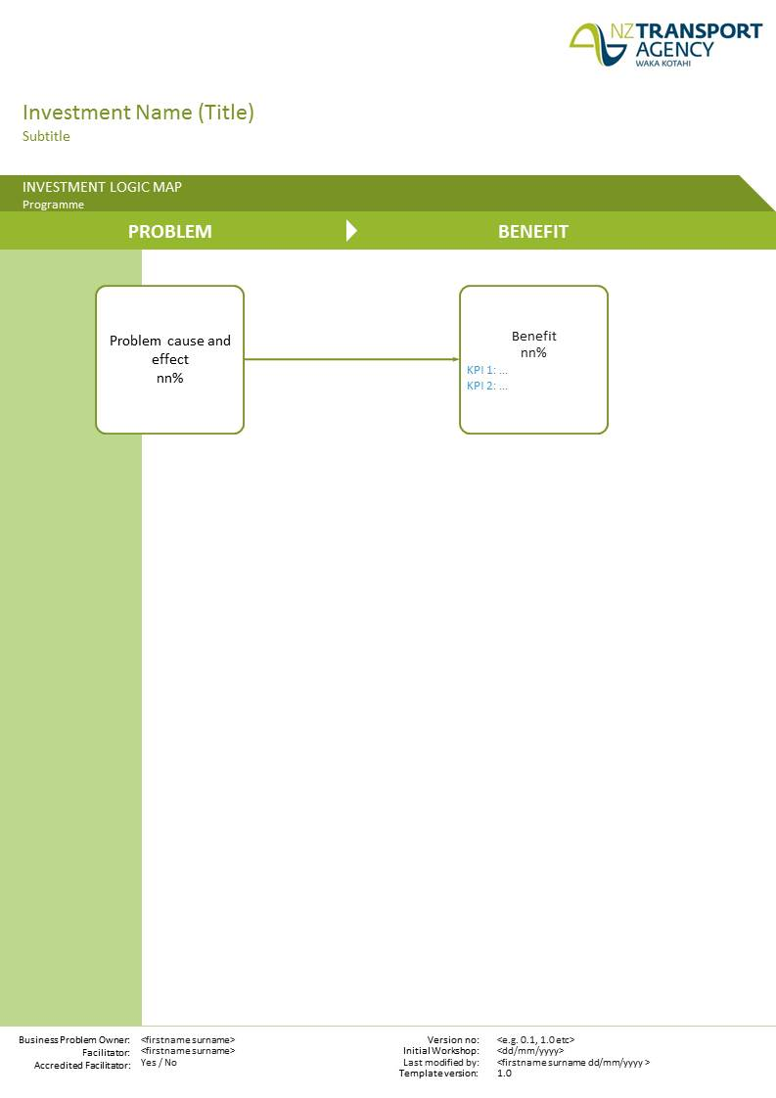

Appendix B – Benefit map

Appendix C – Assessment of alternatives summary tables for each option

Appendix D – Consultation summary
Engagement is an important step for confirming problems and benefits, evidence gathering, establishing investment objectives, and developing and assessing alternatives and options. This appendix should be used to provide a summary of the engagement undertaken through the PBC process and be drawn from a separate Consultation and Engagement Report.

A) Consultation and communication approach
This section will detail the consultation and communication approach used during development of the programme business case. This will include:
- Process used to identify, consult and communicate with each group; and
- Identification of groups to be engaged.

B) Professional engagement process
This section will detail the professional engagement process that was undertaken as part of the business case around option development and project selection. This is likely to include the following participant groups:
- Constructors;
- Funders;
- Operators;
- Maintenance; and
- Planners (transport and regulatory).

C) Views provided
This section will detail the views of the groups engaged, including how their views have been incorporated (or not) into the option development.

