RTC Region: e.g. Waikato | Submitted by: e.g. Jack James  Phone No: | Date:
NOC: e.g. West Waikato South
Safety Project? ☐ | Resilience Project? ☐ | Efficiency Project? ☐

The local System Manager supports the delivery of this project? Yes ☐
PROJECT OUTLINE
Activity name | e.g. SH1: Warkworth and Wellsford Webcams
Location/ Site Description | e.g. SH 1N: RP 346/0
Source of Project | e.g. Network Management Inspections, Crash Reduction Study
Planning Reference | Describe the problem, 50 words or less
Problem/ Opportunity | Describe the problem, 50 words or less
Brief scope description | Describe the proposed solution, 50 words or less
Main Type of Intervention | Choose an item.
Road Classification | Choose an item.
Main Primary to short term impact | Choose an item.

options
Options | Description | Total Estimated Cost $
Option 1 – Do Nothing
Option 2 – Do Minimum
Option 3
Recommendation

RECOMMENDED OPTION COST SUMMARY
Investigation cost:
Design cost:
Construction cost:
Total Estimated Cost:

PHOTOS
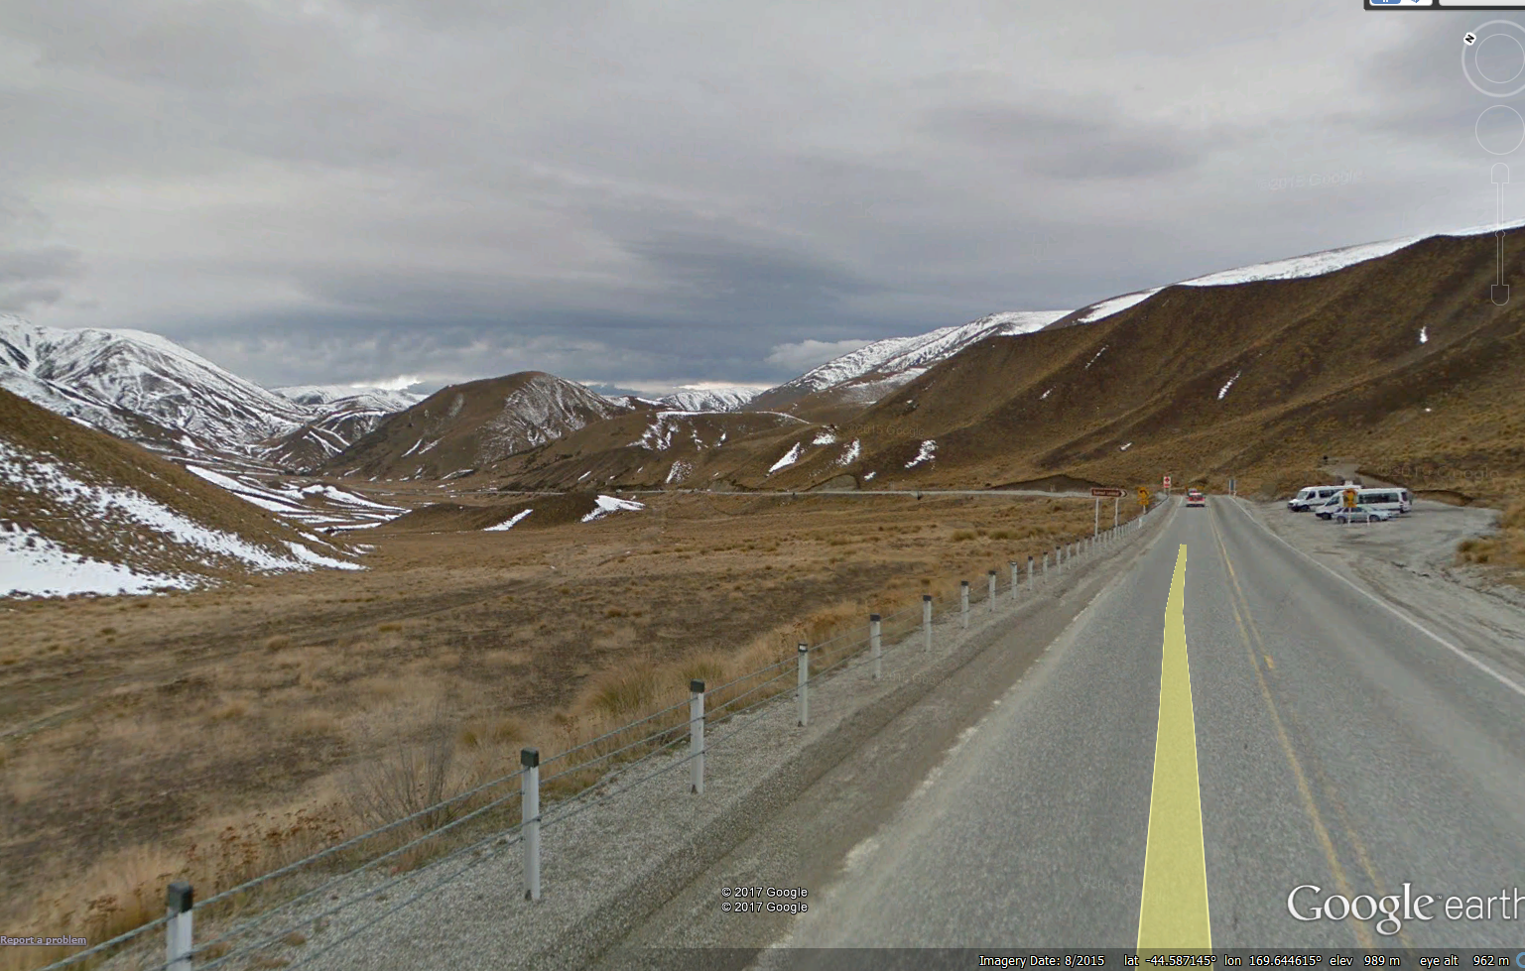
Title | e.g. SH8 Lindis Pass Summit – View of rest area / SH8 from one proposed camera location.
Notes | e.g. Final location tbc

APPROVALS (FOR ADMINISTRATOR USE ONLY – DO NOT DELETE)
Efficiency ☐  Resilience ☐  Safety ☐ |  | SAP Project Name  SAP Project Number  (funds going to)
Minor Improvements  Funding Variation Received By: | Ron Minnema, Tristan Hook, Ranjan Pant  (Safety / Resilience / Efficiency Manager s) |  | Date:
 |  |  | Approve: ☐
SAP Project Number - 6036011  (funds coming from) | PLI ☐  Contingency ☒ |  | SAP Project Name:  MIP 2015-18, Tasman
Senior Manager OPPP Approval | e.g. Refer to InfoHUB link: https://infohub.nzta.govt.nz/otcs/cs.dll/properties/28886081 |  | Date:
COMPLETION AND NOTIFICATION
Updated in SAP & TIO ☐ | Senior Programme Manager, Investment and Finance |  | Date:
MIP Template Updated ☐ | MIP Administrator |  | Date:
Project Manager notified ☐ | e.g. Jack James |  | Date:

