Claims user guide

Table of Contents

Claims 2
Introduction 2
Responsibility 2
Access to claims 2
Breadcrumbs 3
Show all 3
Meaning of icons on left hand menu 3
User admin – add or change a user’s profile 4
Adding contact details 4
Conditions 4
Creating a new claim 5
Automated upload of claim data 6
Automated Upload of Claims Data (Continued) 7
Creating 1st claim of each year (new functionality) 8
Submitting a claim 9
Editing a claim 10
Deleting a claim 10
To view the claims status for each Approved organisation 11
Authorising, declining or unsubmitting a claim 11
Transferring a claim to SAP (Finance only) 12
History of change/Print record 12
Copy and paste to Word document 13

Claims

Introduction | Claims module will allow users access to enter, submit and authorise claims. All users will initially be given ‘read only’ access to this module. To edit and/or submit claims, users must have the appropriate permissions which are determined by your local administrator.  You also now have the option of downloading the claim to an excel spreadsheet, completing and uploading it directly into TIO claims module.  You can access your local administrator by clicking on the link at the bottom of your home page.

Responsibility | Approved organisations are responsible for submitting claims. More than one claim can be submitted each month but not until the previous claim has been authorised.  NZTA regional persons are responsible for authorising claims.  NZTA Finance is responsible for payment of claims.

Access to claims | Access to the Claims module is via your Home Page.  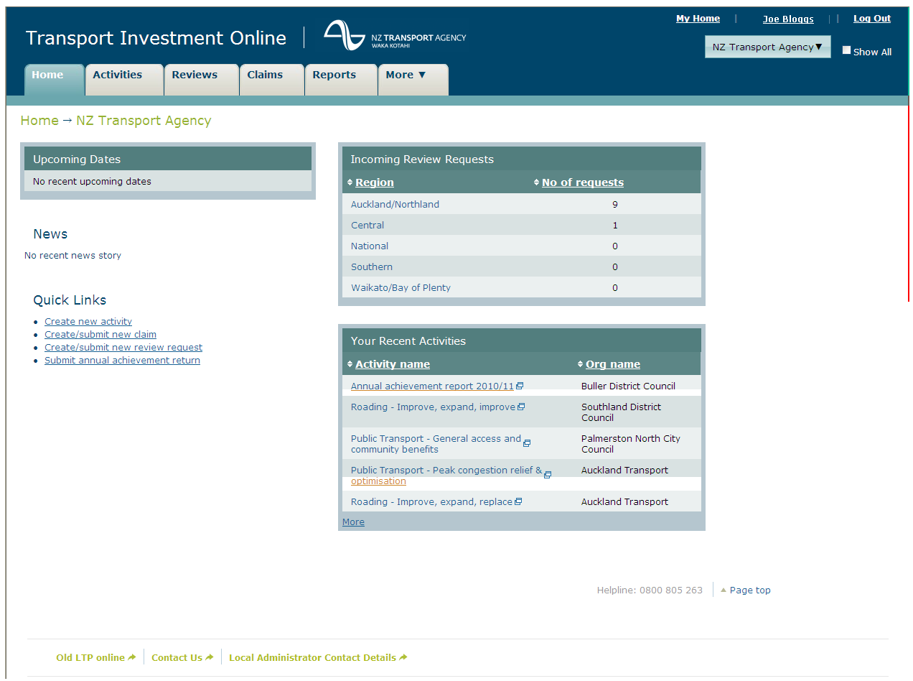
Continued on next page

Claims, Continued

Breadcrumbs | Highlighted in the screen above is what we call ‘breadcrumbs’. These will always show you at a glance where you are and how you got there. For example, you’ve clicked on the ‘Claims’ tab, ‘Name of your organisation’ will always appear automatically, ‘claims 01’. If you click back on the word ‘Claims’ or ‘Claims tab’ it will take you back to your list of current year’s claims.

Show all | Clicking on the ‘show all’ checkbox will enable RTC, HNO and Auckland Transport access to all Approved Organisations within their regions. You can also click on your organisation’s name to get the same results.  RTC and Auckland Transport users will be able to view approved Authorised Organisation’s claims within your region.  NZTA users will be able to view all claims.  For Approved Organisations this button will be inactive.  Step Action Screen example  1 Select your organisation name or click on the show all checkbox on top right hand corner of your home page.  2 List of organisations with your region will appear.  3 If you are viewing another AO you are able to come back to your own home page by clicking on ‘My Home’, from top right hand corner of screen.

Meaning of icons on left hand menu | Meaning of icons.  = required information has been completed  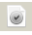 = claim has been submitted
Continued on next page

Claims, Continued

User admin – add or change a user’s profile | If you require access to this module to either view or enter in data you will need to contact your local administrator. To do this, click on ‘Local administrator contact details’ at the bottom of your home page.  Each organisation is responsible for managing their users and allocating the role of ‘local administrator’. To do this, from your Home page select the ‘More’ drop down list then ‘user administration’. NZ Transport Agency will not be responsible for day to day user administration.  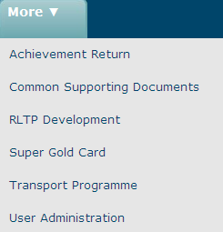  Please note: users will receive an automated email every time their profile is updated.

Adding contact details | This will ensure that you receive emails updating you on the status of your claim. There is space for up to three contacts.  Step Action Screen example  1 Select ‘claims’ from home page, then ‘contact details’ from right hand side of 2nd level heading. Press ‘save’ when completed.

Conditions | If there is a condition type of ‘precedent’ for an Activity, this means that you cannot claim for that project until the condition has been met.  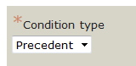  If there is a condition type of ‘subsequent’ for an Activity, this means that you can start the project and claim at any time. Condition will still be required to be met at some stage
Continued on next page

Claims, Continued

Creating a new claim | It is important to note that only one claim can be created at a time.  Please note: At the beginning of each financial year there will be no claims listed  Step Action Screen example  1 Select ‘Claims’ from your home page.  2 Select ‘New claim’ from left hand side of claims module.  3 Complete the expenditure to date column on right hand side of screen.  4 Select ‘Save & Next’ button at either the top or bottom of the screen and you will be taken to the Tax invoice (summary of the claim).  5 The Tax invoice can be printed by selecting “Print record”.  6 To attach documents select ‘Supporting documents’ from left hand menu. Select the ‘browse’ button and locate your document. Double click on the document and it will appear. Select save. Please note: It is not mandatory to supply this information.  7 Once you have completed the claim and saved in ‘draft’ you will then have access to delete and/or submit the claim. Once submitted you will no longer be able to delete it.
Continued on next page
Claims, Continued

Automated upload of claim data | New feature - All Approved organisations are able to automatically upload their claims data using the upload interface rather than completing on screen. Although, you will still be able to completed on screen if you prefer.  To use the automated upload process:  Step Action Results  1 Select ‘Download Claims for completion’ from the left hand menu. This creates an Excel file of all the funding approved activities that you are able to claim.  2 You will be prompted to open or save file. Select open.  3 File opens in Excel. The fields that are shown in Blue are the only fields that you change. Note – if not claiming for an activity please put in a zero dollar value same as you do now when completing on screen.  4 Once the data is ready for upload, ensure all dollar values are displayed as numbers by formatting the cells as “General”. Important - Save upload data in a Text (Tab delimited) file, with the extension “.txt”. Note – if you are using Excel 2007, you will not have to add a file extension as the system will do this for you. Note – you may get warning messages about features being incompatible with the file type. Ensure that the active worksheet (the one that you are viewing) is the data to be uploaded and ignore the warnings.
Continued on next page
Claims, Continued

Automated Upload of Claims Data (Continued) | Step Action Results  6 Select “Upload completed Claim” in the left hand menu and browse to locate the file and click on “Upload File”.  7 As the data is uploaded the Claims module will check that the fields have been correctly populated. If all ok you will receive notification as per top screen. If there are any errors with the upload, TIO will produce a list of any errors that it finds. These errors must be corrected and saved before you upload again.  8 To get back to the data input screen click on ‘Claims’ in the breadcrumb trail.  9 If all goes well you will see all green ticks on the Claims left hand menu.  11 Once the Claim has been successfully uploaded (icons show Green), then it can be submitted for authorisation.
Continued on next page
Claims, Continued

Creating 1st claim of each year (new functionality) | Both the claims and activities modules have been updated to query whether or not improvement projects have been completed along with a substantially complete date. This question will only appear on the first claim for each year, and is designed to:  - Identify surplus funds that may be made available for other activities across the National Land Transport Programme.  - Provide the Transport Agency with feedback on the timeliness of completion of improvement activities.  - Provide a date "substantially complete" for each improvement activity, so that the Transport Agency's Post Implementation Review sample can be selected on the basis of this date.  To complete:  - Complete your claim as usual.  - Select the appropriate box under the heading of ‘is this activity complete’. Please note: only one box can be selected.  - If you selected either ‘substantially complete’ or ‘claiming complete’ you will need to enter in the ‘substantially complete’ date.  The information that is provided here will be replicated under the ‘activities’ module, phase page and vice versa.  Claims page  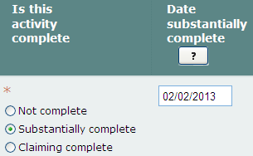  Phase page  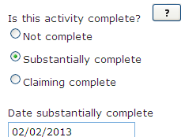
Continued on next page

Claims, Continued

Submitting a claim | Claims can only be submitted by users with “Submit” access rights.  Please note: the Submit claim button is visible to all users, but only a user with ‘submit’ access will be able to submit a claim.  Step Action Screen example  1 Select ‘Claims’ from your home page  2 From the claim list screen select ‘submit claim’ from the left hand menu. If you select ‘claim’ tab from your home page you can also submit a claim from here by clicking on ‘Submit claim’ from menu at top of screen. The submitted claim will now be ready for approval by NZTA.  3 After selecting ‘submit claim’ you will be asked to tick a box confirming a statement that the information you are providing is true and correct. Go to bottom of submit page and tick the box  4 Generating a buyer created tax invoice by selecting it from the left hand menu or by selecting ‘next’ from the submit claim screen.  5 The buyer created tax invoice can be printed by selecting “Print record” on the left hand menu.
Continued on next page

Claims, Continued

Editing a claim | To edit a draft claim  Step Action Screen example  1 Select ‘Claims’ from your home page.  2 From the claims list screen select the ‘Claim #’.  3 After editing the claim press save by using the ‘save’ button at top or bottom of screen.

Deleting a claim | You can only delete a claim If you have the appropriate access rights AND it has not been submitted. Deleting a draft claim is also carried out via the Claim List screen. Select “Delete claim”. Please note: once a claim is deleted it cannot be reversed.  Step Action Screen example  1 Select ‘Claims’ from your home page.  2 Select ‘Delete claim’.  3 You will be asked to verify if you wish to continue. If ‘yes’ the claim will be deleted.
Continued on next page
Claims, Continued

To view the claims status for each Approved organisation | To access the claims module from your Home Page:  Step Action Screen example  1 Select ‘Claims’ from your home page and ‘claim#’.

Authorising, declining or unsubmitting a claim | To authorise, decline or unsubmit a claim NZTA users need to access the ‘claims’ module  Step Action Screen example  1 Select ‘claims’ from your home page then ‘claim#’. Claims list screen will appear.  2 Select the ‘show all’ button.  3 Select the ‘pending authorisation’ tab on top menu.  4 Select either ‘authorise’, ‘decline’ or ‘unsubmit’.  5 For authorise and unsubmit – you will be asked to confirm your decision.  6 For decline – you will be asked to enter in a reason and confirm.  7 To review the claim, click on the claim name.  8 You can print any part of the claim by selecting the ‘print record’ on left hand menu.
Continued on next page
Claims, Continued

Transferring a claim to SAP (Finance only) | As noted above the transfer of authorised claims to SAP can only be carried out by selected Finance staff.  Step Action Screen example  1 Select ‘Claims’ from your home tab then ‘pending transfer’ from 2nd level heading. Then select ‘Transfer claims’ from left hand menu.  2 Tick the box under the heading of ‘transfer’ and select ‘confirm transfer’  3 Transfer to SAP results

History of change/Print record | History of changes shows all changes that have been made and by whom.  Print Record will open in a print friendly format read to be printed.  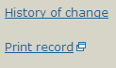
Continued on next page
Claims, Continued

Copy and paste to Word document | For example, to copy a part of a claims screen make sure the part you want to copy is showing on the screen.  Step Action Results  1 Select ‘Ctrl’ and PrtScr’ on your keyboard at the same time  2 Open ‘Paint’ from Accessories: - Click on start - Select ‘All Programs’ - Select ‘Accessories’ - Select ‘ Paint  3 Paste into screen by: - Selecting ‘Ctrl V’ together from your keyboard, or - Go to Edit and select ‘paste’  4 In ‘Paint’ --> Go to ‘Select’ tool and drag your mouse over what you want to copy = select  5 Open up Word document, right click and select paste

