Reviews module

Table of Contents

Reviews module 2
Introduction 2
Responsibility 2
Access to Reviews module 2
Breadcrumbs 2
Submitting a phase for approval 3
Review menu tabs 4
Show all 4
AOs monthly review list 5
NZTA monthly review list 5
Fields for funding approval 5
Assessment fields 6
Work category 6
Regional Office recommendation (NZTA only) 7
Conditions of approval (NZTA only) 8
Decision status 9
National Office recommendation 9
Approve or decline (NZTA only) 10
Delegated authority approvals 10
User administration 11
Approving new approvals 12
Reason for approval 12
Cost scope and cash flow adjustments 13
History of change/Print record 14
Copy and paste to Word document 14

Reviews module

Introduction | This module is used to request and approve all funding changes, including new approvals, cash flow and cost scope adjustments.

Responsibility | NZTA regional users are responsible for recommending a phase to be funding approved. Note that the activity MUST have already been included in the current NLTP or have an earlier phase with funding approval. If an activity is being added during an NLTP, its “Status” cannot be changed to show “Included in NLTP”. All that can be done is to attach evidence that the activity has been added to the NLTP (usually approved by the Regional Manager). For further details refer to https://www.pikb.co.nz/home/the-way-we-work/investment-decisions-and-delegations/nzta-planning-funding-and-procurement-delegations/.  NZTA National Office users are responsible for approving the phases.  Delegated authority users are Approved Organisations who have NZTA Board authority to approve funding changes up to their delegated level, subject to the activity already being in the NLTP.

Access to Reviews module | Your home page will look similar to this. Select the Reviews tab to get access to the Review Request list.  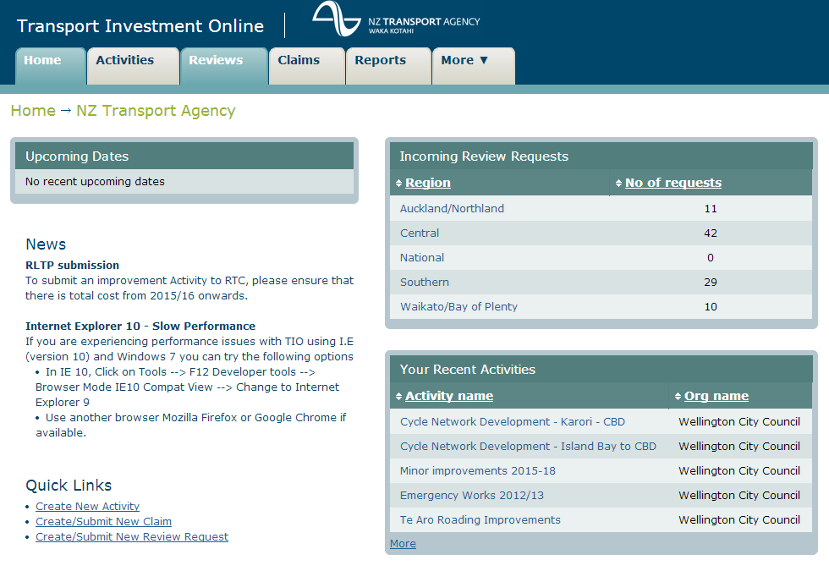

Breadcrumbs | Below is what we call ‘breadcrumbs’. These will always show you at a glance where you are and how you got there. For example, you’ve clicked on the ‘Review’ tab and it shows the Approved Organisation/NZTA and ‘current monthly review’.
Continued on next page
Reviews module, Continued

Submitting a phase for approval | Once you’ve completed all the required fields for your activity and phase you can submit to a review for approval. Complete any fields that are required then select ‘submit to review’ button.  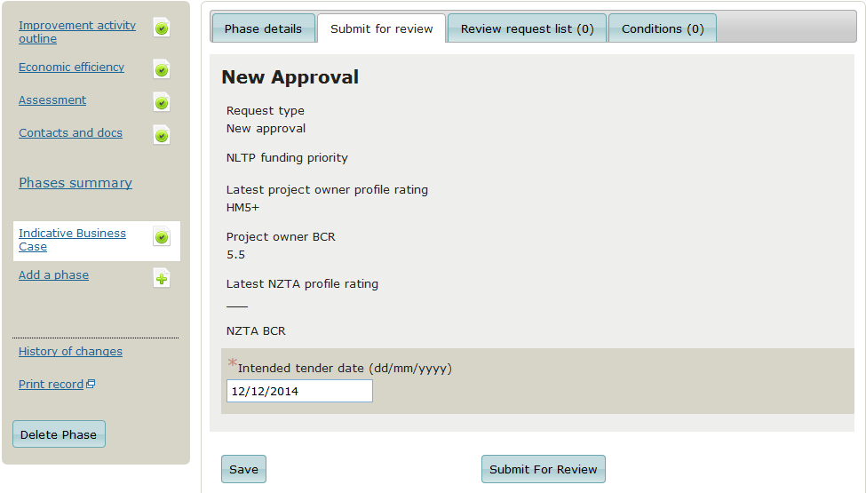  Note that approved organisations who have NZTA Board authority to approve will be provided with the option to ‘Approve under delegation’ as follows:  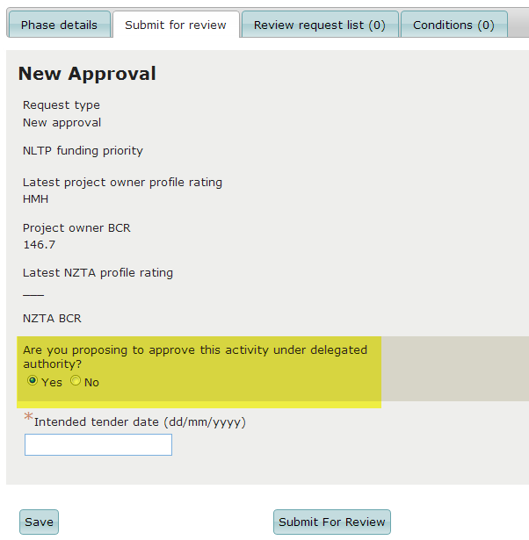  Your phase will now show as ‘under review’ on the ‘Not yet approved’ tab for new approvals. Once approved it will automatically be moved to ‘Funding approved’ tab. If it’s a cost scope or cash flow adjustment then it will show on the Funding Approved tab.  For further information re submitting cost scope and cash flow adjustments refer to Cost scope and cash flow adjustments
Continued on next page
Reviews module, Continued

Review menu tabs | Each monthly review will automatically be set up for you.  Review page tabs  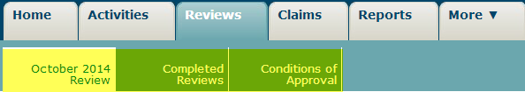  October 2014 Review – current review for AOs to submit their activities to  Completed Reviews – all completed reviews for the current year  Conditions of Approval – all conditions that have been added to an activity at approval time  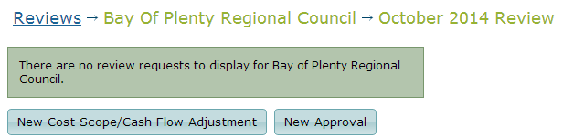  New cost scope/cash flow adjustment button will take you to the funding approved tab  New Approval will take you to the draft activities

Show all | All users can see their own activities in the Reviews module.  However, there are some users, for example Auckland Transport and Highway and Network Organisation National Office who can also view other AOs within their region. When ‘show all’ is selected it will show a list of all organisations and their activities along with submitted and decision dates.  
Continued on next page
Reviews module, Continued

AOs monthly review list | The review list displays the list of requests that have been added to the selected review by approved organisations. The request list includes the ability to change the way the records are displayed by clicking on each heading.  After you have submitted your phase to a review, go to ‘Reviews’ tab and you will see the following page. This list displays your requests that you’ve added to the Review.  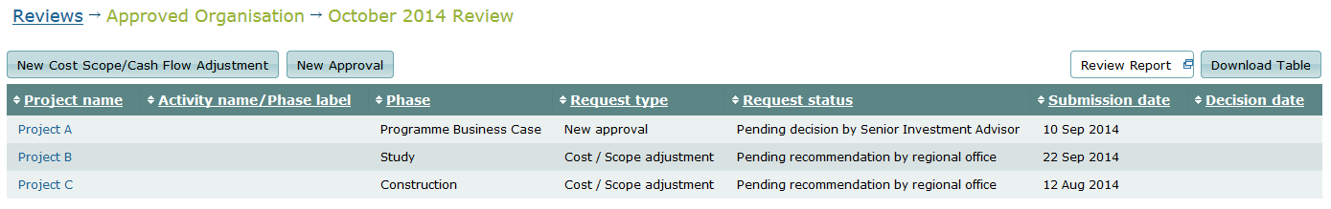

NZTA monthly review list | The review list displays all the AOs requests that were unapproved at the end of the previous month, plus any that have been added during the current month.  To access, select Reviews from the main TIO page and click on the ‘select all’ button.  To locate your region’s activities, click on the heading “NZTA region’ and it will automatically sort them in alphabetical order by NZTA region.  You can then further sort them by clicking on any of the headings.  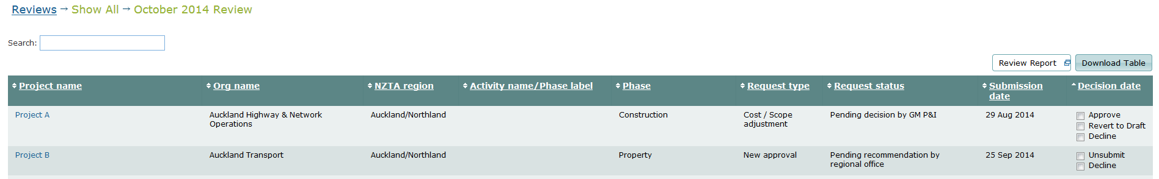

Fields for funding approval | This only applies to reviews which are not under delegation.  After the Approved Organisation has submitted their phase for approval, it’s up to the Regional Office to complete any outstanding fields, for example  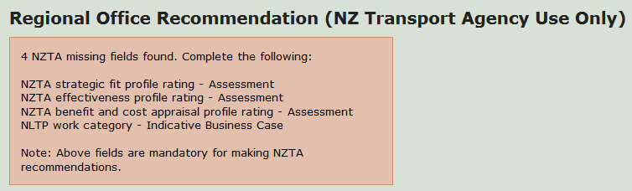
Continued on next page
Reviews module, Continued

Assessment fields | To complete the assessment fields as above go to the Approved Organisation’s activity assessment page and complete all fields under NZ Transport Agency Assessment.  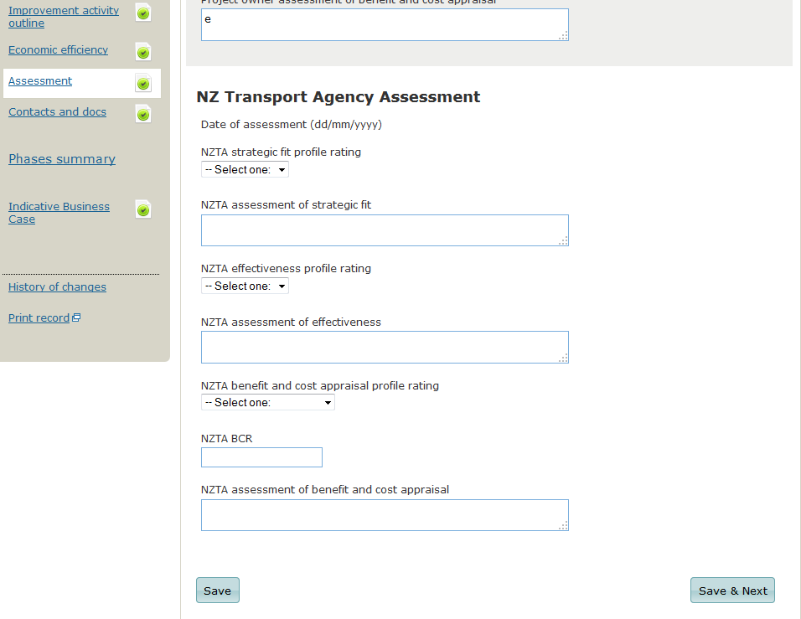

Work category | To complete the work category go to the phase page.  Please ensure that the work category you enter is the same as the Approved Organisation has entered on the same page. If not you should contact them to discuss.  The ‘Funding Priority’ field in screen below is set by NZTA National Office.  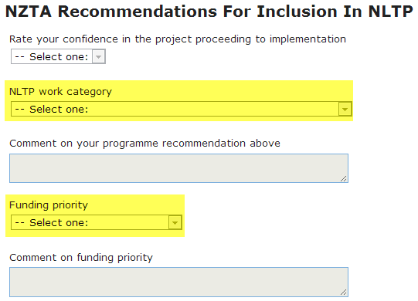
Continued on next page
Reviews module, Continued

Regional Office recommendation (NZTA only) | This section is used to capture the NZ Transport Agency Regional Office recommendation. When a recommendation is selected by the region you must also comment on the recommendation you are making.  Note: It’s up to NZTA regions to ensure the approved organisations within their region, have completed their activities correctly.  Once you’ve completed any missing fields (see page 6) go to the Review Request list  To make a recommendation:  - From the main TIO page, select “Reviews” tab  - Click on ‘show all’  - Select approved organisation  - Select activity name you require.  - Ensure that all the required fields are complete (Note All green ticks doesn’t mean that all the required NZTA fields have been completed  - Select the appropriate recommendation option from the ‘regional office recommendation’ drop down menu as below  - Enter a comment against the field ‘Provide a summary of the reason for change and justification for the recommendation made above’  - Answer the question ‘Are there any conditions Yes/No. Note Selecting ‘Yes’ does not add the condition.  - Select a decision status from the drop down list  - Click the ‘Save’ button  NOTE: Decision status is mandatory after regional office recommendations have been completed.  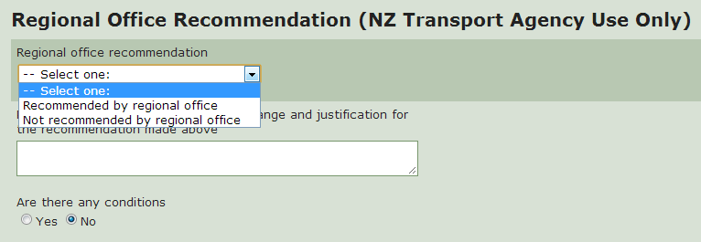
Continued on next page
Reviews module, Continued

Conditions of approval (NZTA only) | Conditions of approval may be applied to any funding approval, although their use should be restricted to extraordinary requirements or variations around approvals. They should not be used to require certain actions that would normally apply as part of an approval, delivery or monitoring process.  Conditions that the region requires certain action to be undertaken need to be very specific as to the action, the accountability for its delivery and its timing.  Examples where conditions of funding approval may be applied include:  - Variation from normal funding assistance rates  - Decisions to limit or cap funding assistance  - Requirements to undertake actions before the funding is able to be released (conditions precedent)  - Requirements to undertake actions after the funding is released (conditions subsequent) – often applies to an intermediate phase where an action is required before an application is approved  To set up conditions of approval in TIO:  - Go to Reviews module  - Select the Approval Organisation within your region  - Select the activity for approval  - Complete the required fields for funding approved  - Select ‘Conditions’ tab from heading tabs at top of TIO screen  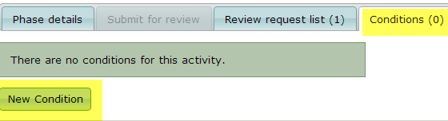
  Step | Action | Screen example
  1 | Select new condition type. See above for definitions of each | 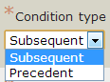
  2 | Answers all required questions and save
  3 | You can go back to the Review Request tab and you will notice there are outstanding conditions now attached to this activity. | 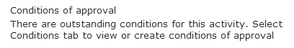
Continued on next page
Reviews module, Continued

Decision status | The decision status indicates who will be responsible for making the final decision on the request. This will be governed by NZ Transport Agency’s delegated authority policy https://www.pikb.co.nz/home/the-way-we-work/investment-decisions-and-delegations/  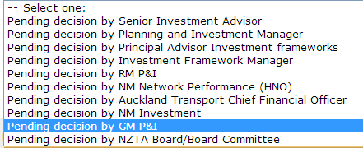

National Office recommendation | This section is used to capture the NZ Transport Agency National Office recommendation. When a recommendation is selected by a user they must also comment on the recommendation they are making.  Note Only required if approval is from GM P&I or higher.  To make a recommendation:  - From the main TIO page select ‘Reviews’ tab  - Click on ‘Show all’  - Select the Approved Organisation  - Select activity name you require  - Select the appropriate recommendation option from the National Office recommendation drop down list.  - Enter a comment against the field ‘Provide a summary of the reason for change and justification for the recommendation made above’  - Answer the question ‘Are there any conditions Yes/No. Note Selecting ‘Yes’ does not add the condition.  - Click on ‘save’ button  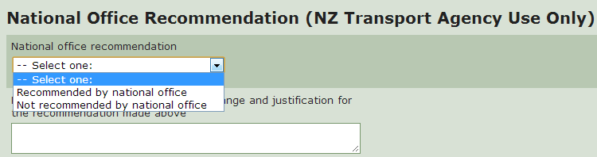
Continued on next page
Reviews module, Continued

Approve or decline (NZTA only) | Once the decision status has been set for a request it can then be approved or declined.  To ‘approve’, ‘decline’ or ‘revert to draft’ a request, the user must:  - be an NZTA employee, and  - have the ‘Approve’ TIO access type.  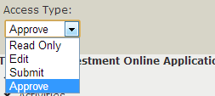  Approve requests  To approve review requests go to the Review Request page – see page 4.  You can either ‘approve’, ‘decline’ or ‘revert to draft’ from the Review Request page, or if further information is required then you can select the activity.  If you select ‘decline’ or ‘revert to draft’ you will be required to enter in a reason.  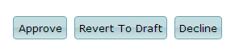  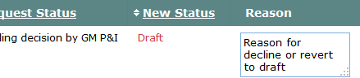  One or more requests can be ‘approved’, ‘declined’ or ‘reverted to draft’ at any time. This allows requests that can be approved under delegated authority to be approved or declined when a decision has been made.

Delegated authority approvals | ‘Delegated authority’ can be given by NZTA Board to an Approved Organisation to delegate certain NLTP funding decisions to them. This delegation is subject to certain conditions which must be met by the AO.  Currently the ‘Delegate approve’ is supported in TIO for new approvals. The functionality will be extended to cost scope and cash flow adjustments at a later date.  It will be up to the local administrator of the Approved Organisation to give the ‘Delegated Approve’ access to whoever requires it.
Continued on next page
Reviews module, Continued

User administration | After NZTA Board has given approval for you to approve your projects, TIO team will include ‘delegated approve’ in the access types in TIO.  To give a person access, go to main page in TIO and select the ‘More’ tab and ‘User Administration’. Locate the user and change their ‘Access Type’ to ‘Delegated Approve’  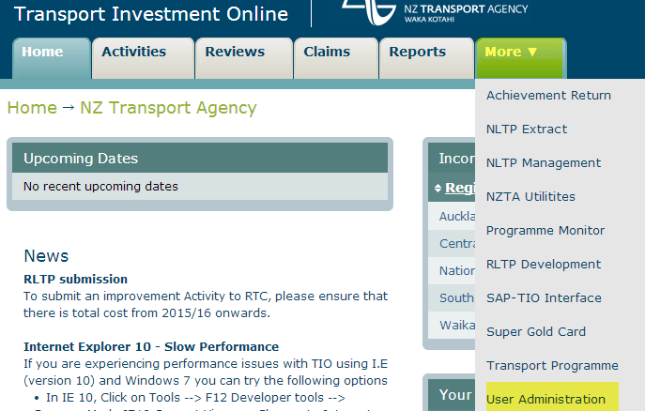  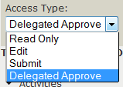
Continued on next page
Reviews module, Continued

Approving new approvals | To approve under Delegated Authority.  Note Only applies to ‘Improvement Activities’.  When you submit for review you will get the following screen. You will have the option of whether to approve under delegated authority by answering the following question ‘Are you preparing to approve the activity under delegated authority’ highlighted in the screen below.  If you select ‘yes’ you will then be able to approve your project.  Note TIO does NOT check whether the appropriate fields have been completed. It is up to the ‘delegated user’ to check that they are not exceeding their delegated authority.  If you select ‘no’ then NZTA will approve your project.

Reason for approval | If approving under ‘delegated authority’ you will need to provide a summary for the reason for approval.  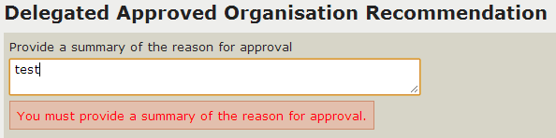
Continued on next page
Reviews module, Continued

Cost scope and cash flow adjustments | Currently, these can only be approved by an NZTA National User.  Note: approved organisations who have ‘delegated authority’ to approve new approvals are currently not able to approve cost scope or cash flow adjustments. This functionality is in the process of being developed.  Note: for Minor Improvements, Maintenance and Renewals for local roads and state highways, Public Transport Programme:  - If the total change of NLTA share in review request is less than $50 this will show as a cash flow.  - If the total change of NLTA share in review request is equal to or more than $50 this will show as a cost scope.  To set up a cash flow/cost scope adjustment:  Note If the change to the NZTA is less than $50, then the review is labelled as a ‘Cash flow adjustment’.
  Step | Action | Screen example
  1 | Go to Activities tab and approved activities | 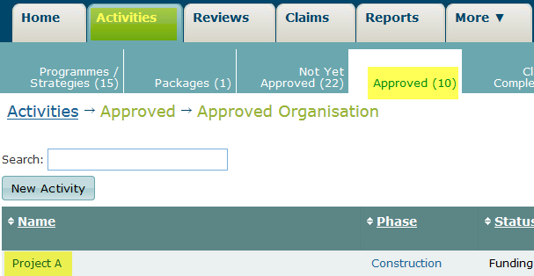
  2 | Select the activity you require from the activity list
  3 | Click on ‘Submit to Review’ tab | 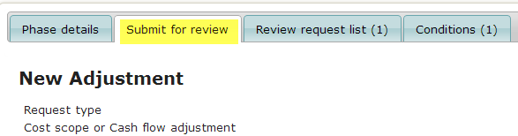
  4 | Scroll down to the ‘Revised cost section’ and change the required fields
  5 | You will need to enter in a ‘reason for change’ and save the page | 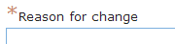
  6 | Then click on ‘Submit to Review’ tab at bottom of screen
  7 | NZTA will approve it
Continued on next page
Reviews module, Continued

History of change/Print record | History of changes show all changes that have been made and by whom.  Print Record will open in a print friendly format read to be printed.  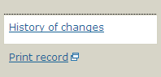

Copy and paste to Word document | For example, to copy a part of the Review screen make sure the part you want to copy is showing on the screen.
  Step | Action | Results
  1 | Select ‘Ctrl’ and PrtScr’ on your keyboard at the same time
  2 | Open ‘Paint’ from Accessories:  - Click on start  - Select ‘All Programs’  - Select ‘Accessories’  - Select ‘ Paint |   
  3 | Paste into screen by:  - Selecting ‘Ctrl V’ together from your keyboard, or  - Go to Edit and select ‘paste’
  4 | In ‘Paint’ Go to ‘Select’ tool and drag your mouse over what you want to copy | = select
  5 | Open up Word document, right click and select paste

