- NZGTTM TMP Form Guidelines

  - TMP Form Framework
The TMP Form is broken into three parts:
- TMP Planning Form  (intended for risk reviewers and approvers) | This part gives explanation and depth to the planning process and decision process for the chosen controls and is intended for delivery to the risk reviewer/s and TMP approver only.  This section is read in conjunction with the other TMP parts.
- TMP General Form  (intended for site staff and risk reviewers and approvers) | This part covers all general TMP information such as location details, activity details, contact information, and general contingencies.
- TMD Form  (there may be multiple TMD forms for one TMP. Attached to TMP General Form) | The TMD Form is repeated for each TMD phase/stage of the TMP. If a TMP has multiple layouts, then it will have one TMD form for each of those layouts. For example, one TMD form for an attended layout, and one TMD form for an unattended layout.
4. On-site Record Form | The on-site record form does not fit within the TMP itself but is a complementary document for use on-site by TTM practitioners to record implementation and on-going applicability of TTM controls. This is an example form only.

  - Usage Guidelines
Grey fields within the TMP form can be clicked and overwritten by typing. | 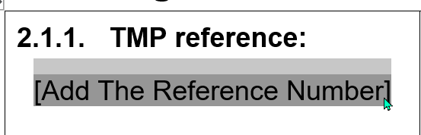
Sections that are not applicable in the TMP form can have the content removed and the heading struck through to allow shortening of the TMP form. | 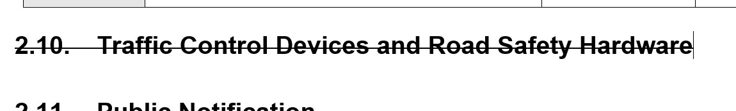
Table rows that are not applicable can be removed

