Reshaping Streets regulatory changes
Consultation document

Waka Kotahi NZ Transport Agency
Published August 2022 (22-276)
ISBN 978-1-99-004479-3
Copyright: August 2022
Waka Kotahi NZ Transport Agency NZBN: 9429041910085
Copyright information
Copyright 2022. This copyright work is licensed under the Creative Commons Attribution 4.0 International licence. In essence, you are free
to copy, distribute and adapt the work, as long as you attribute the work to Waka Kotahi NZ Transport Agency and abide by the other licence terms. To view a copy of this licence, visit http:// creativecommons.org/licenses/by/4.0/

Disclaimer
Waka Kotahi has endeavoured to ensure material in this document is technically accurate and reflects legal requirements. However, the document does not override governing legislation. Waka Kotahi does not accept liability for any consequences arising from the use of this document. If the user
of this document is unsure whether the material is correct, they should refer directly to the relevant legislation and contact Waka Kotahi.

If you have questions, call our contact centre on 0800 699 000 or write to us:
Waka Kotahi NZ Transport Agency Private Bag 6995
Wellington 6141
This publication is also available on our website www.nzta.govt.nz

Contents

Part one Context 4
Introduction 4
Glossary 5
Abbreviations 7
Part two The proposed changes 10
Summary of the proposals 10
A new approach for piloting street changes 12
Filtering and restricting traffic 18
School Streets 21
Community Streets 23
Closing roads for other functions and events 26
Pedestrian malls 28
Transport shelters 30
Part three Implementation approach 33
A new Street Layouts rule 33
Changes to the LGA1974 33
Implementation would be in three steps 34
How to make a submission 35
Annex: List of proposals 37

Part one

Context

Introduction
The Minister of Transport is proposing a set of regulatory changes to make it easier for local authorities (like councils) to make street changes that support public transport, active travel and placemaking. These proposals would enable local authorities to make street changes more efficiently and provide new ways for communities to be involved in changes that affect them.
The proposed regulatory changes include:
- a new ‘Street Layouts’ land transport rule for local authorities, as road controlling authorities (RCAs), to use for changing street layouts, piloting street changes, restricting vehicles, establishing Community Streets and School Streets, and for deciding on other street changes
- amending sections in the Local Government Act 1974 (LGA1974) covering pedestrian malls, transport shelters (like bus shelters), and temporary road closures
- changes to other rules and regulations so that local authorities can reduce speed limits as part of pilots, trial Traffic Control Devices (TCDs) more effectively, and to make legislation more accessible.
This consultation document explains what is being proposed, and why. You can also access the draft Street Layouts rule here
We want to know what you think of these proposals and how they could affect you, your community, your organisation, or your business. We will consider your
feedback before finalising any proposals. The Minister of Transport and Cabinet will then decide whether to progress any or all of these regulatory changes.
How you can provide feedback
In this document, we have asked some questions to help you tell us what you think. Answering these questions will help us to understand the impact that the proposed changes could have on you.
Questions can be found at the end of each proposal in this document.

Page 35 has information about how to provide a submission on these proposals.
You can also find information about how to submit here

You need to tell us what you think by midnight on Monday 19 September 2022.

Glossary
This document includes some terms that you may not be familiar with, so we have included some definitions here.

Community Streets
These are events (also known as Play Streets) that restrict motor vehicles on quiet local streets so that children and parents can play or hold activities on their street. They are led by residents with approval from RCAs. Community Streets often last for a couple of hours and can be held on a regular basis (eg once per month).

Filtering traffic
This involves using physical objects (see modal filters) or traffic controls (eg signs) to restrict or prohibit some vehicles from travelling through part of a street while providing access for other road users. For example, bollards can be used to filter traffic at one end of a street so that people travelling by foot, wheelchair, pram, or bike can pass through while motor vehicles need to take an alternative route.

Local authority
This is a term used to describe New Zealand’s regional, district, city, or unitary councils. This includes Auckland Transport.

Low traffic neighbourhoods and filtered traffic areas
These are low-speed, people-friendly areas that let motor vehicles access a street, but in a way that encourages slow speeds, or restricts them from using residential streets as short cuts when other routes are available. Objects such as concrete blocks, planter boxes, or curb cut outs may be used to narrow the street and encourage motorists to drive at a slower speed. Low traffic neighbourhoods have various names such as ‘quiet streets,’ ‘slow streets’ or ‘neighbourhood greenways.’ In our proposals, we call them ‘filtered traffic areas’.

Modal filters
These are physical features that can be used to prioritise or restrict access by different travel modes (see filtering traffic). Modal filters include features like bollards, planter boxes, trees, street furniture, or concrete blocks.

Pedestrian malls
These are pedestrian-only areas of streets that attract high levels of foot traffic. They are often destinations for people to shop, dine, relax, play, and walk through. Pedestrian malls may also allow for people using devices, cycling, or trams to travel through
the area. For example, Cuba Street in Wellington and City Mall in Christchurch are pedestrian malls.

Pilots
These are short-term street changes used to test different street designs, or prototypes in various street environments. They are sometimes called trials or experiments.

Placemaking
This is the process of creating quality places that people want to live, work, play and learn in. For example, creating streetscapes with public seating, trees, and art can make urban spaces nicer to be in and help to develop a shared sense of place.

Regulatory changes
This means changes to legislation. It includes primary legislation (ie Acts of Parliament) and secondary legislation (eg land transport rules).

Road controlling authorities (RCAs)
These are the groups responsible for managing roads around New Zealand. For example, local councils and Auckland Transport are RCAs responsible for managing roads in their areas.

School Streets
These are streets that restrict motorised traffic outside schools during school drop-off and pick-up times. School Streets can also be applied to areas beyond the school, so that children have a clear, safe route to walk, cycle or ride a device to school.

Streets and roads
The terms ‘streets’, ‘roads’, and ‘roadways’ are often used inter-changeably in this document, as this is common in everyday discourse. In the Land Transport Act 1998, the definition of ‘road’ includes ‘a street’. Historically, major movement corridors (eg between different parts of a city or between different towns) were often called roads. Streets performed a wider variety of functions for people living and working nearby. These distinctions have blurred over time. Both streets and roads are public places that can serve a wide variety of place and movement functions. These functions are explained in the One Network Framework .

Traffic calming devices
These are measures used on a road to encourage drivers to travel at an appropriate speed for their surroundings, or to discourage unnecessary through traffic.
Examples include raised crossings, road humps, and objects that narrow the roadway. Modal filters can also be used as traffic calming devices.

Traffic control devices (TCDs)
These are devices used on a road for controlling traffic. They include signs, signals, notices, traffic calming features, and markings.

Transport shelters
These are installations on streets that protect people from rain, wind, and sunshine. An example is a bus shelter.

Abbreviations
LGA1974 Local Government Act 1974 LGA2002 Local Government Act 2002 LTA1998 Land Transport Act 1998

RCA Road Controlling Authority
TCD Traffic Control Device

Why we are proposing regulatory changes to support street changes
We need to make it safer, quicker, and more attractive for people to walk, bike, ride devices, and take public transport in our towns and cities. All these activities take place on streets – but most streets in New Zealand do not give dedicated space or priority to these modes.
Street changes that support public transport use and active travel will enable us to meet our emissions reduction targets. They can also make places more accessible for people, reduce deaths and serious injuries from transport, improve public health, and create well-functioning urban areas that are good for people and businesses.
In May 2022, the Government released its first Emissions Reduction Plan (ERP) . This plan includes a target to 'reduce total kilometres travelled by the light vehicle fleet by 20 percent by 2035 through improved urban form and providing better travel options, particularly in our largest cities.'
To meet this target, the ERP includes actions to accelerate widespread street changes to support public transport, active travel, and placemaking. One of these actions is to consider regulatory changes to make it simpler and quicker to make street changes. Regulatory changes are needed because the current system does not support local authorities to make street changes at the pace and scale required to meet national priorities.
This consultation document summarises regulatory changes that the Government is considering. The proposed changes will also support the delivery of other actions in the ERP for public transport, walking, cycling, school travel, and social outcomes.
Our legislation needs to reflect the ways communities use, or could use, streets. Streets are not just spaces that people move or travel through. Streets are public places that can be used for different purposes. People live on streets, they shop on streets, they meet friends and family on streets, and they may even play on the street.
While central government intends to make it easier to make street changes, local authorities will still be engaging with their communities when it comes to delivering any changes on the ground.

Street changes are needed for multiple reasons

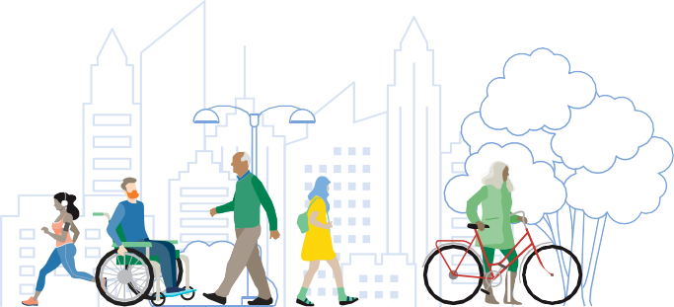
Streets need to be safe for everyone
The Government is committed to a vision for New Zealand where no one is killed or seriously injured in road crashes. This is outlined in Road to Zero: New Zealand’s Road Safety Strategy for 2020 – 2030, which recognises the need for safe streets in urban areas to support active travel. People who walk or travel by bike are over-represented in New Zealand’s deaths and serious injury statistics compared to people travelling by most other transport modes. Streets need
to be safe, and feel safe, for all road users.
Streets need to support public health

Street changes are needed to support shifts to higher-density living
New Zealand has the third highest adult obesity rate in the OECD, partly due to low amounts of physical activity.
On average, each New Zealander spends less than an hour walking per week. A third of all transport trips in New Zealand are less than two kilometres — a distance which is easy for most people to walk, scoot, or cycle. People are likely to become more physically active if they have safe and attractive options to walk and bike to places.
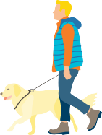
Recent initiatives such as the National Policy Statement on Urban Development and changes driven by the Resource Management (Enabling Housing Supply and Other Matter) Amendment Act 2021 will enable much more intensification in existing urban
areas. This will encourage more people to live in urban areas and travel through them in different ways. Streets that prioritise public transport, walking and cycling make efficient use of urban space, and maximise how many people can travel through the space available. Placemaking improvements
on streets, including green spaces and areas to rest or play, can also make towns and cities more liveable, vibrant,
and accessible.

Reshaping Streets complements other initiatives to make streets safer and healthier for people
The government has lots of ‘streets’ projects on the go. The table below summarises how Reshaping Streets complements two other ‘streets’ initiatives: Accessible Streets and the Streets for People programme.

Reshaping Streets
  - A collection of proposed changes to legislation, including land transport rules.
  - Focuses on how local authorities (like councils) can make changes to streets to support public transport, active travel, and placemaking.
  - For example, one proposal is to allow local authorities to pilot street layout changes and use the pilot process to consult with their community.

Accessible Streets
  - A collection of changes to land transport rules (previously consulted on).
  - Focuses on how people use paths and roadways.
  - Accessible Streets does not include changes to the physical layout of streets

Streets for People
  - A programme provided by Waka Kotahi.
  - Waka Kotahi provides guidance and funding to local authorities to make street changes or set up pilots or trials. Reshaping Streets proposes a new regulatory tool that would support local authorities to pilot street changes.

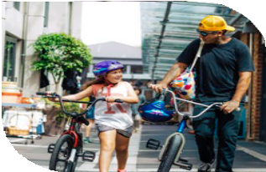
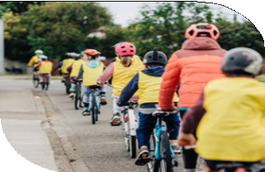
These will help deliver:
  - Safe and healthy streets for people
  - Improved travel options

- Lower carbon emissions
- More vibrant public places

Part two

The proposed changes

Summary of the proposals
Purpose: Making it easier for local authorities to make street changes that support public transport, active travel, and placemaking

A new approach for piloting changes
- Using pilots as a way to consult with communities
- Pilots could last up to two years
- Pilots could include speed changes
- A streamlined process for trialling new traffic control devices

Filtering and restricting traffic
Enable local authorities to restrict some types of traffic, including powers to install TCDs and modal filters

Community Streets
A new process to support resident-led traffic restrictions on quiet local streets

School Streets
Enable local authorities to restrict traffic outside schools at student drop- off and pick-up times

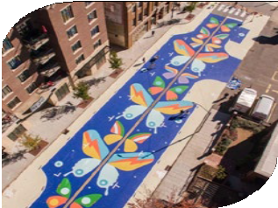
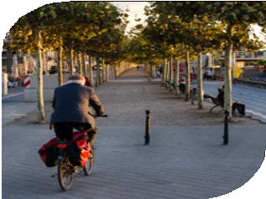
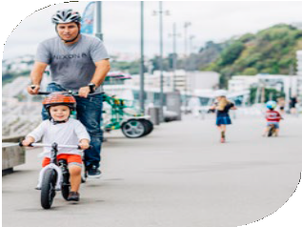
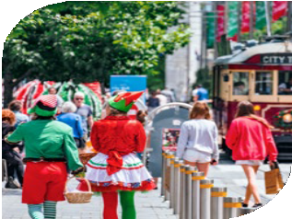
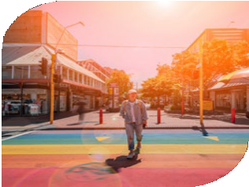
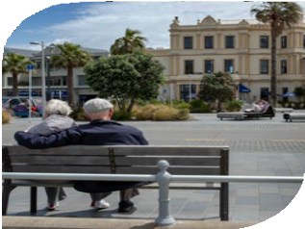

Transport shelters
Make the process for installing transport shelters more efficient

Making legislation clearer and more accessible
Shift provisions for making street changes in other land transport rules to the new rule

Closing roads for other events
Enable road closures for events, including markets, for more than 31 days per year

Pedestrian malls
Make the consultation process consistent with other types of street changes

How the changes would be implemented
rules

A new ‘Street Layouts’ land transport rule
Including powers and requirements for pilots, traffic filtering, Community Streets, Schools Streets, and closing roads for events
Changes to the Local Government Act 1974
Amending and shifting sections related to vehicle restrictions, road closures, pedestrian malls, and transport shelters
Other regulatory changes
- Revoking the Transport (Vehicular Traffic Road Closure) Regulations 1965
- Updating other land transport

1 | A new approach for piloting street changes

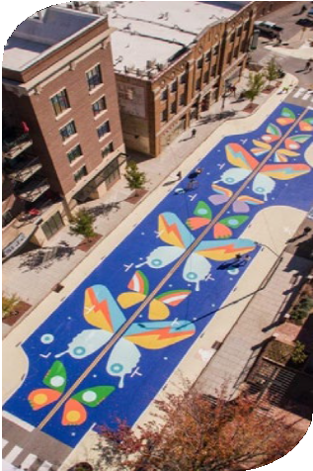
Why this is important
Pilots are short-term changes used to test different street layouts and features. For example, installing a bus lane or cycle path for 10 months so that a community can experience these changes and provide feedback could be considered a pilot. Many of the street changes implemented through the Waka Kotahi Innovating Streets for People programme (now known as Streets for People) can also be considered pilots. Street changes created through this programme have included new pedestrian crossings outside schools, pop-up cycleways, and various low-cost interventions to make streets safer for people walking and biking. These pilots have often delivered positive results, such as more children cycling to school.
Evidence shows that pilots can play a valuable role in community engagement (see case studies on page 13). This is because pilots give people something real to respond to and allow people to experience the benefits of street changes before forming a firm view on them. Pilots can also enable RCAs to quickly roll out low-cost changes to streets and to rapidly adapt these based on evidence and community feedback.
While some RCAs have already chosen to use pilot processes for their street changes, this is not something that the current legal system makes easy.

Current legislation
Existing legislation does not provide RCAs with a clear framework for piloting street changes.
Local authorities rely on schedule 10, section 11(b) of the LGA1974 to install pilots. This states that a council can 'close any road or part of a road to all traffic or any specified type of traffic… where in order to resolve problems associated with traffic operations on a road network, experimental diversions of traffic are required'.1 There are no provisions for how long pilots can stay in place, or what RCAs can to do to make piloted changes permanent if they are supported by the community. In other words, pilots are often treated as 'experimental diversions of traffic'. The LGA1974
was written long before pilots were considered a way to make street changes. As a result, many local authorities either use these provisions in the LGA1974 with some discomfort, or they do not install pilots because they do not feel empowered to do so.

1 Local Government Act 1974, schedule 10, section 11(b),
Temporary prohibition of traffic .

Case study

Pilots support community engagement and can increase support for street changes
Evidence shows that pilot projects can enable people to explore and engage with street changes in an innovative way, and that they can increase public support for permanent changes.
This was demonstrated in research into road space reallocation projects in San Francisco, New York, Bogotá, Copenhagen, and Yarraville in Melbourne. Projects in these cities included street changes such as ‘pop up’ bike lanes, bus lanes, footpath extensions, and parklets (ie turning on-street car parks into places for people to relax, dine, or play). Communities in these areas were often against the proposed changes before they were installed. Piloting these changes made it easier for communities to experience the piloted changes directly, reduced fears of negative impacts, and resulted in support for permanent changes.
This research also found that the duration of a pilot project can potentially be ‘dialled-up’ or ‘dialled-down’ to accommodate community attitudes and changing levels of comfort with a street change. Short pilots (eg less than a month) seldom make an impression on community attitudes, while longer pilots (eg more than one year) often lead to greater community support for changes.
As another example, in 2014 the Waltham Forest Council in London began trialling a low traffic neighbourhood. This aimed to make streets safer for people walking and cycling, improve public health, and reduce vehicle emissions. Residents of Waltham Forest were initially opposed to these street changes, as they were worried that they would negatively affect access to their homes and businesses. Residents also thought that these changes would lead to more traffic by schools. This trial overcame previous fears by demonstrating the positive impacts of changes. Results showed that traffic was more spread out across the day and maximum peak hour flows were lower on main roads. Walthamstow Village is now one of London’s most liveable neighbourhoods and traffic levels have fallen over 90 percent in some streets and by 56 per cent on average. Walking and cycling rates also increased. As an observer
of this trial commented, 'there’s more of a community feel in the area and more people visit the area because it’s easier to get around. It’s had a positive impact on local businesses, too, and many derelict shops have reopened'.
References:
Living Streets (2022), Creating Low Traffic Neighbourhoods
Lydon, M, eds, (2012) Tactical Urbanism: Short Term Action, Long Term Change, vol. 2, The Street Plans Collaborative.
Rowe, H (2013), Smarter ways to change: learning from innovative practice in road space reallocation , 6th State of Australian Cities Conference, 26-29 November 2013, Sydney, Australia.

What we propose
To support RCAs to pilot street changes, we propose to introduce clear powers and requirements for RCAs to pilot street changes as a way to consult with their communities. These powers would be established in a new Street Layouts rule.
Pilots would enable RCAs to test street changes that could be made permanent in the future. They could be used to monitor the impacts of changes for meeting a particular objective (eg to improve safety for pedestrians), and to receive community feedback on these street changes.
This approach would differ from traditional types of consultation where people are expected to look at written plans and respond to them. Instead, people in the community would be able to experience the proposed street changes for themselves and tell their local authority about their experiences and views.
Pilots could include street changes like:
- extending or widening footpaths and shared paths
- new bus lanes, cycle lanes, or cycle paths
- removing or reconfiguring on-street car parks
- traffic calming devices like speed bumps
- creating shared zones (areas where people driving motor vehicles need to give way to pedestrians)
- installing modal filters.2
We propose introducing the following powers and requirements for pilots.
- A pilot could be installed for up to two years. An RCA would be able to stop and remove the pilot early if it is not meeting the needs of their community.
- RCAs would not need to consult before installing a pilot, as the pilot is meant to be used as a method for consultation. However, an RCA could engage with
people in their community before installing a pilot if they want to. For example, an RCA could collaborate with a community group to ensure street changes improve accessibility. Waka Kotahi will provide guidance to RCAs on engaging effectively with communities on pilots.
- An RCA would need to notify the public and emergency services of a pilot at least two weeks before installing it. Notification requirements would include details on where the pilot will be located, what will be installed, any restrictions for road users, the pilot’s duration, how to provide feedback, and when feedback is needed.
- During the pilot, an RCA would need to give the public a reasonable opportunity to provide feedback. The RCA would also need to monitor the impacts of the pilot.
- Based on feedback and monitoring, an RCA could decide to modify the pilot. This could include removing parts of the pilot or changing physical features.
- Before the end of a pilot, an RCA would need to decide whether to make any or all of the piloted changes permanent. This decision would need to be informed by public feedback and monitoring done during the pilot.

2 The types of street changes that local authorities could pilot is not limited to this list.

- If an RCA decides to make the street changes permanent before the pilot ends, these changes could remain in place. Otherwise, the piloted changes would need to be removed.
It is important to note that all the requirements outlined above would be minimum requirements. This means that an RCA could do additional consultation before and after the pilot is installed, and/or give more advance notice of a pilot, if the RCA decides to do so.
Specific elements of these proposals that we are seeking feedback on are summarised in the tables below, along with questions that we are seeking feedback on.

Proposal 1A
Provide RCAs with new powers and requirements to install pilots, and set requirements for how to install them
Proposed Street Layouts rule Section 4 (Pilots of street layout changes)

What do you think?
Do you support RCAs being able to do this? Why/Why not?
Is anything that you think RCAs should specifically consider before installing a pilot?
Note: The following question is targeted at RCAs
We have not specified how RCAs should make the decision to install a pilot, or to decide whether to make the piloted changes permanent. If you are providing feedback from an RCA, we are keen to hear your views on this approach. Do you foresee any difficulties with making these decisions?

Proposal 1B
Enable pilots to be used as a form of consultation, by using feedback collected during the pilot to consider whether to make street changes permanent
Proposed Street Layouts rule Section 4 (Pilots of street layout changes)

What do you think?
Do you support pilots being used as a way to publicly consult with communities?
Why/Why not?

Proposal 1C
Enable pilots to be installed for up to two years
Proposed Street Layouts rule Section 4 (Pilots of street layout changes)

What do you think?
Do you think this amount of time is suitable, too long or too short?
If you answered 'too long' or 'too short', what would be a good time period for a pilot to be installed?

We propose amending current provisions in the LGA1974 to support pilots
By creating a new rule for RCAs to pilot street changes, RCAs would no longer be required to use the LGA1974 to install pilots.
However, there could still be some legal ambiguity with schedule 10, section 11(b) of the LGA1974, given that many RCAs currently use this provision to install pilots.
To resolve this ambiguity, we propose making changes to this clause in the LGA1974 so that is very clear that RCAs should not look to this provision when making these types of street changes. We are interested in your views on what this change should look like.

Proposal 1D
Amend the LGA1974 to make it clear that RCAs should not use the provision for ‘experimental diversions’ when piloting street changes
Relevant part in the LGA1974: schedule 10, section 11(b)

What do you think?
Note: This question is targeted at RCAs
Does your RCA close roads to traffic for ‘experimental diversions’ for any purposes other than piloting street changes?
If yes, what else do you use this provision for?
We propose to enable RCAs to lower the speed limit to support a pilot Some RCAs may wish to lower the speed limit on a street to encourage people to travel at lower speeds in areas where a pilot is installed.
To support this, we propose to allow RCAs to lower the speed limit as part of a pilot, in areas with a posted speed limit of 60km/h or less. In these situations, RCAs would need to install a sign with the pilot speed limit on it. A supplementary sign would not be required.

To change the speed limit, RCAs would need to follow the rules and requirements for installing pilots, as outlined above. For example, they would need to notify
the public and emergency services about the proposed change, collect data and feedback on the piloted speed limit, and decide at the end of the pilot whether to keep it or remove it.
RCAs would not be required to consult before installing the piloted speed limit, as the pilot is meant to be used as a method for consultation.
RCAs would not be able to pilot speed limits on their own. The piloted speed limit would need to support other features of a pilot.

Proposal 1E
Allow RCAs to lower the speed limit to support a pilot, in areas with a posted speed limit under 60km/h, during the pilot.
Proposed Street Layouts rule, section 6.2: Amendments to the Land Transport Rule: Setting of Speed Limits 2022

What do you think?
Do you support RCAs being able to do this? Why/Why not?

We also propose to update rules related to TCD trials to support RCAs that want to trial TCDs as part of their pilot
RCAs can currently trial potential TCDs (eg signs, road markings, and traffic signals), but the notification process to install these is outdated. For example, RCAs must notify people by advertising the change in at least two newspapers.
We propose to update these requirements so that RCAs can choose a reasonable way to notify the public about the trial.

Proposal 1F
Update rules for trialling TCDs, so that RCAs can trial TCDs as part of pilots and choose how they notify people about TCD trials.
Proposed Street Layouts rule, section 6.1: Amendments to Land Transport Rule: Traffic Control Devices 2004

What do you think?
Do you support these changes? Why/Why not?

2 | Filtering and restricting traffic

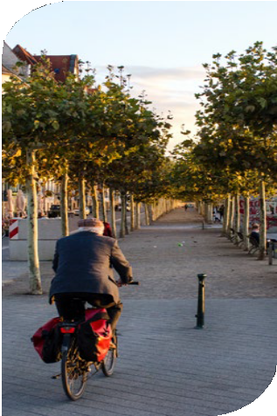
Why this is important
RCAs are becoming increasingly interested in tools that they can use to prioritise people walking, cycling, riding devices, or taking public transport, as well as improving the overall efficiency of key routes.
Inexpensive and effective tools that are often used overseas to do this are modal filters and regulatory filters.
Modal filters are physical features that are installed on roads to control access to different parts of a road, or to calm traffic. For example, bollards could be installed at one end of a street so that only people travelling by foot, bike or device can use that entrance. Bollards can also be used to restrict access to side streets along high traffic roads to keep traffic running smoothly.
Regulatory filters are devices like signs and road markings that are used to clarify which users can access a section of road and who cannot. A ‘bus only lane’ is a good example of a regulatory filter, because road markings (or signs) are used to tell people that only buses are allowed to use that space. Regulatory filters achieve the same effect as modal filters, but they do not require physical features blocking the roadway.
Each of these features can be used to create safer and quieter residential streets that are known as low traffic neighbourhoods or filtered traffic areas.

Current legislation
Current legislation does not adequately support RCAs to use modal filters such as bollards or planter boxes to filter access to parts of a road, because modal filters are not defined or provided for in land transport rules.
Under the LGA1974, local authorities can construct any facilities on the road 'for the safety, health, or convenience of the public, or for the control of traffic or the enforcement of traffic laws' but only if these facilities will not, in the opinion of the council, 'unduly impede vehicular traffic entering or using the road.'3
Local authorities can make their own bylaw under the LTA1998 to prohibit or restrict vehicles from using roads. However, they are only permitted to restrict a vehicle through a bylaw if 'by reason of its size or nature or the nature of the goods carried, [it] is unsuitable for use on any road or roads.'4 This makes it difficult for local authorities to restrict vehicles for the purpose of creating filtered traffic areas.
Some local authorities have used provisions in the LGA1974 to create pedestrian malls as a workaround to close sections of road to some traffic5, which is often a time-consuming process (eg declaring small stretches of a road a pedestrian mall just to filter traffic).

3 LGA1974, section 334(1)(d) Local authorities also use
these provisions to install features such as public seats and public toilets.
4 LTA1998, section 22AB(1)(c)
5 LGA1974,
section 336

RCAs also face barriers installing regulatory filters. Under current settings, they can install special vehicle lanes (eg bus lanes, and cycle lanes), but need to create a bylaw and pass a resolution under this bylaw to create these lanes. This can be a long and resource-heavy process to add some road markings or put up a sign,
which can deter local authorities from doing so. In addition, our rules do not provide for regulatory signs that allow for spaces to be restricted to just people walking, cycling, or riding devices.
In other jurisdictions, like the United Kingdom, signs with text such as 'pedestrian and cycle zone' are used. New Zealand could benefit from replicating some of these features.
Some RCAs have also advised us that they do not have clear powers to install, modify or remove TCDs, like signs, road markings, traffic signals and other features in their local areas that are used to instruct road users of a prohibition or restriction.

What we propose
We propose to make changes to our rules so that RCAs can install or remove modal filters on their streets. This will enable RCAs to limit through-movement of vehicles and filter traffic. RCAs would be able to use any physical object as a modal filter, provided it is safe.
Under these proposed changes, RCAs could still lay out modal filters in a way that enables people and deliveries to access places they need to get to (including via alternative routes). Waka Kotahi will provide guidance to RCAs on how to filter or restrict traffic in a way that appropriately maintains access.
Modal filters would only be able to be installed by RCAs if they meet one of the following purposes:
- to improve the access and mobility of pedestrians, people using mobility devices, cyclists, and people using other devices (eg scooters and skateboards)
- to improve public transport operations
- to protect and promote public health and safety
- to support environmental sustainability, including reducing carbon dioxide emissions
- to create public places that promote the well-being of communities.
We also propose making changes to the LGA1974 to support these changes, by removing the condition in current legislation that road facilities cannot (in the opinion of the council) 'unduly impede vehicular traffic entering or using the road.' This will ensure RCAs have a strong legal foundation to filter traffic.

Proposal 2A
Enable RCAs to install modal filters if the objects they use are safe.
Proposed Street Layouts rule, section 2.1: RCAs may change the use of roadways

What do you think?
Do you support RCAs having clear powers to install objects as modal filters?
Why/Why not?
We are also interested in your views on whether we should make any changes to our rules related to regulatory filters
Should we investigate creating signs and markings to create pedestrian and cyclist only zones on sections of the roadway? Why/Why not?

Ensure legislation provides clear powers for RCAs to filter traffic, by removing the requirement in the LGA1974 that facilities built on roads cannot, in the opinion of a council, 'unduly impede vehicular traffic entering or using the road'
Relevant part in the LGA1974: section 334
Proposal 2B

What do you think?
Do you support making this change? Why/Why not?

We also propose to empower RCAs to restrict the use of motor vehicles and install or remove traffic control devices (TCDs)
We want to make the process for local authorities to make street changes clear and efficient, and this includes changes that require TCDs. We propose to empower RCAs, through the Street Layouts rule, to:
- prohibit or restrict the use of motor vehicles, or one or more classes of motor vehicle, on the roadway
- install or remove traffic control devices to instruct road users of a prohibition or restriction
- install or remove traffic calming devices
- install or remove modal filters.
A prohibition or restriction of motor vehicles could apply at all times, at specified times, or during specified conditions.
These restrictions would need to meet any of the purposes outlined above for installing modal filters (ie related to access, public transport, health, safety, environmental sustainability, and community wellbeing).

RCAs could use the proposed Street Layouts rule when deciding to install TCDs, including traffic calming devices, if they choose to do so. This would allow the installation of TCDs (like signs) to ensure that street changes are enforceable.
We also propose to make it explicit in this rule that RCAs may install or remove on- street car parks to change street layouts. This would not limit the abilities of RCAs to install TCDs or make other changes to the roadway using other legislation.

Proposal 2C
Enable RCAs to restrict or prohibit the use of some or all motor vehicles on specified roadways to support public transport use, active travel, health and safety, emissions reductions, and/or to create public spaces that promote community well-being.
Proposed Street Layouts rule, section 2.1: RCAs may change the use of roadways

What do you think?
Do you support RCAs having clear powers to restrict or prohibit traffic for the specified purposes? Why/Why not?

Proposal 2D
Provide RCAs with an explicit power to install TCDs
Proposed Street Layouts rule, section 2.1: RCAs may change the use of roadways

What do you think?
Note: This question is primarily targeted at RCAs
Is it useful to include this power for RCAs in the new rule? Why/Why not?

3 School Streets

Why this is important
School Streets make it safer to travel to and from school, by restricting motorised traffic on streets outside schools, or nearby, during student drop-off and pick-up times.
School Streets are used in other jurisdictions, including the United Kingdom and Canada, to make walking and cycling to school more appealing, improve air quality around schools, and to reduce the chance of crashes between students and motor vehicles. Several RCAs are looking to install School Streets in New Zealand.

Current legislation
There are no clear processes for creating School Streets in current legislation.
RCAs are also unable to install signs or other features (like movable gates) that could be used to support and enforce School Streets.

What we propose
We propose to allow RCAs to create School Streets in their local areas, in partnership with local schools. Powers to create School Streets would be established through the proposed Street Layouts Rule.
The new rule would define a School Street as an area of roadway that restricts motor traffic outside or nearby a school during student drop off or pick up times.
School Streets would be treated as a traffic restriction. Vehicle access to the street could be blocked during the restriction, while children walk, cycle, or ride a device on the street to school. Anyone who needs to access a property on the street could still drive through the restricted area, provided they give way to children and travel at walking speed. A school street may also be installed as part of a pilot.
School Streets could be held during student drop-off and pick-up times on every school day, or only apply on certain days at certain times (eg pick-up times on Fridays). Outside of these times, the street would be open to all road users.
We also propose to introduce new signs and features to support School Streets and ensure people follow the restrictions. These would be like signs used in the United Kingdom and Canada, which outline the times when vehicle access is restricted.
RCAs would be required to install signs under the proposed changes, but any other features would be optional, depending on the school environment.
If an RCA decides to install a School Street, the RCA would be required to notify emergency services and anyone who may be affected by the proposed changes.

Proposal 3
Establish powers and requirements for RCAs to create School Streets in partnership with local schools
Proposed Street Layouts rule, section 2.1: RCAs may change the use of roadways and section 3: Rules for Community Streets and School Streets

What do you think?
Do you support RCAs and schools working together to provide more spaces for children to walk, cycle or ride a device to school by restricting access on some streets during pick up and drop off times? Why/Why not?
Is there anything that you think RCAs and/or schools need to consider when designing or installing School Streets?

4 Community Streets

Why this is important
Community Streets (also known as play streets) enable children and their whānau to meet, play, and be active in their neighbourhood. They are small, resident-led events held on quiet neighbourhood streets during the day. They normally last between two and three hours and must be approved by an RCA. During Community Streets, vehicle movements are restricted, so that the street is safe for people to meet and play on.
Community Streets have gained in popularity in recent years, especially in the United Kingdom, United States, and Australia. Waka Kotahi and Sport New Zealand, alongside councils, regional sports trusts, Healthy Families New Zealand, and other organisations, have been working together since 2019 to make it easier for Community Streets to happen in New Zealand. Recently, Waka Kotahi has created guidelines to support the installation of Community Streets, but because of current legislative settings, not all RCAs feel supported to use these.

Current legislation
Under current legislation, Community Streets can be held by following requirements under the Transport (Vehicular Traffic Closure) Regulations 1965 (the 1965 Regulations) or under schedule 10, 11(e) of the LGA1974. The 1965 Regulations state that an RCA may close roads for up to 12 hours within any 24-hour period where those sections of road are being used for 'any vehicle races or trials, or any processions, carnivals, celebrations, sporting events or other special events.6
These regulations have specific notification requirements, including a requirement to give a 42 days’ notice of the closure in a local newspaper. The RCA must also be satisfied that the promoter of the event has adequate insurance to cover any damage resulting from the event.

6 Transport (vehicle Traffic Road Closure) Regulations 1965), section 3, Controlling authority may close road

Schedule 10, 11(e) of the LGA1974 states that a council can temporarily close any road, or part of a road, to traffic 'for a period or period not exceeding in the aggregate 31 days in any year for any exhibition, fair, show, market, concert, film- making, race or other sporting event or public function.'7 This section also states that a council cannot close a road 'if that closure would, in the opinion of the council, be likely to impede traffic unreasonably.'
While current legislation can be used to create Community Streets, it does not outline clear rules for situations when residents want to lead the creation of a Play Street, with support from their local RCA. Existing settings also require a lot of planning and resources to install any kind of street event, which means that organising a Community Street can be expensive and resource heavy. For this reason, many RCAs do not feel confident supporting their community to install Community Streets, even with the support of guidance.

What we propose
To support residents and RCAs to create Community Streets, we propose to introduce rules for how Community Streets can be created and used. These changes would align with Play Streets guidelines created by Waka Kotahi.
The guidance outlines best practice advice about how RCAs can design their own processes to support the creation of Community Streets in a way that balances safety risks and the needs of their community, rather than requiring the use of formal traffic management plans.
The proposed changes are intended to introduce principles-based rules that RCAs must consider before approving a Community Street, while still giving them the freedom to design their own Community Streets processes based on guidance.
Under the proposed changes, anyone would be able to apply to their RCA to hold a Community Street in their local area. They could apply for any number of events over a 12-month period. If their application is approved and they want to continue holding Community Streets at the end of the 12-month period, they would need to apply to the RCA to get approval for another 12 months.
An RCA would have the option to approve or deny any application to hold a Community Street.
If an RCA decides to approve a Community Street, it must be satisfied that:
- the Community Street will be safe for people using it, during the period it is held
- pedestrians and people using mobility devices will be able to access properties on the Community Street
- conversations or consultation with residents who live on the Community Street (and other affected streets) has been carried out
- there is a plan for how motor vehicles will be guided through the Community
Street if any vehicle needs to access a property located on the Community Street. 7 Local Government Act
1974, Schedule 10, 11(b) Temporary prohibition of traffic

RCAs would also need to consider:
- the ability for motor vehicles to safely take alternative routes
- whether the Community Street is located on a major freight bus or emergency vehicle route
- any guidance that Waka Kotahi has released about holding Community Streets or Play Streets.
When approving a Community Street, RCAs would be able to set conditions that Community Street organisers would need to follow. Before setting conditions, the RCA would need to assess the overall risk of the Community Street by considering:
- how many people are expected to attend the Community Street
- how many roads/streets will be impacted
- the type of road the Community Street will be located on, and what type of roads connect with it
- how many vehicles use the street
- the speed limit on the street
- the day and time that the Community Street will be held
- how long the Community Street will last for.

Proposed requirements
We propose to include the following requirements for setting up a Community Street:
- If an RCA approves a Community Street, a person (who could be a resident) would need to be designated as the 'organiser' of the Community Street. The organiser would be the point of contact for the RCA and would be responsible for notifying other residents about the Community Street. RCAs would be responsible for notifying emergency services about the Community Street.
- When a Community Street is held, it would be treated as a traffic restriction. This means the street is blocked off to general traffic, but anyone can drive through to access a property located on the Community Street (eg people who live on the street). No one would be allowed to drive faster than walking speed when doing this.
- People walking, using a mobility device, cycling, or riding a device (like a skateboard or e-scooter) would be able to travel through the Community Street at any time.

Proposal 4
Establish clear powers and requirements for residents to hold Community Streets, provided they have approval from RCAs
Proposed Street Layouts rule, section 2.1: RCAs may change the use of roadways and section 3: Rules for Community Streets

What do you think?
Do you support residents being able to create Community Streets with approval and support from RCAs? Why/Why not?
Do you think the proposed requirements for Community Streets are satisfactory, too prescriptive, or not prescriptive enough?
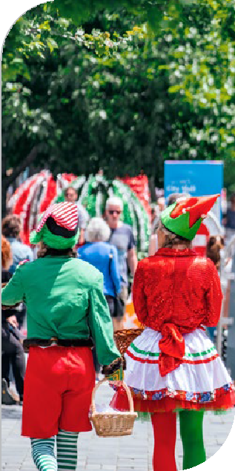
Is there anything else that you think RCAs need to consider before approving a Community Street? Is there anything else that should be included in guidance?

5 Closing roads for other functions and events

Why this is important
Communities and RCAs sometimes want to close roads to vehicles for short periods (eg for a few hours or for a day) to hold other events and public functions such as fairs, festivals, and celebrations, or for regular events such as weekend markets. Many cities around the world temporarily hold popular open street events that involve closing roads to vehicle traffic for a few hours so that people can use these public spaces for activities such as exercising and participating in community activities.8
While RCAs can currently approve road closures for these types of purposes, they are hindered from closing roads for events on a regular basis (eg weekly).

Current legislation
Under the LGA1974, local authorities can temporarily close roads for events, but roads can only be closed for 'a period or periods not exceeding in the aggregate 31 days in any year' and 'no road may be closed for any purpose specified… if that closure would, in the opinion of the local authority, be likely to impede traffic unreasonably.'
Local authorities can also use the 1965 Regulations to close roads for events, in this case for a period or series of periods of not more than 12 hours each in any consecutive 24 hours. These regulations have specific notification requirements, including a requirement to give a 42 days’ notice of the closure in a local newspaper. The RCA must also be satisfied that the promoter of the event has adequate insurance to cover any damage resulting from the event.

8 There is a distinction between Play Streets and Open Streets events. The former are resident-led events that are held in quiet residential areas. Open Streets events can be held on major streets and roads and require more planning and organising.

The 1965 Regulations overlap with the provisions in the schedule 10 of the LGA1974 to close roads for races, sporting events, or other special events. The 1965 Regulations also include powers to close roads for processions, carnivals, and celebrations.
Having road closure powers for events spread across multiple legislation can be confusing and makes legislation unnecessary difficult to navigate.

What we propose

Proposal 5A
Allow RCAs to close roads for reoccurring events, by removing the 31-day limit per year for road closures in the LGA1974
Relevant part in the LGA1974: schedule 10, section 11(e)

What do you think?
What’s your view on limiting how often a road can be closed for regular events?
- There should be a limit, like the current limit
- The limit should be increased to enable closures once per week
- There should not be a specific limit
To make legislation more accessible, we propose to bring together powers and requirements to close roads for events in one piece of legislation. During this process, we will update notification requirements. RCAs would have more flexibility to decide how to notify the public, rather than being required to notify the public via a local newspaper. We propose to set a minimum two-week notification requirement for events. RCAs could provide more advance notice if they choose to do so.
We could remove the requirement for promoters or organisers of events to have insurance cover for any damage associated with the event. Local authorities could still set insurance requirements if they choose to do so.

Proposal 5B
Bring together powers and requirements to close roads for events in one piece of legislation and update notification requirements so that RCAs can notify the public in any way that they consider appropriate at least two weeks before an event.
Revoke the Transport (Vehicular Traffic Road Closure) Regulations 1965 and create equivalent powers to close roads for events in the proposed Street Layouts rule
Shift powers in schedule 10, 11(e) of the LGA1974 to close roads for public functions, markets, fairs, sporting events, and exhibitions to the proposed Street Layouts rule

What do you think?
Do you support the proposal to put all road closure powers for events in one piece of legislation?
Do you support the proposal to update notification requirements for events, so that RCAs can notify the public in any way that they consider appropriate at least two weeks before an event?
The 1965 Regulations requires that an RCA must be satisfied that the promoter of an event has adequate insurance to cover any damages from the event. Should these insurance requirements be kept if powers and requirements for events are shifted to the Street Layouts rule?

6 Pedestrian malls

Why this is important
Pedestrian malls are pedestrian-only areas of streets that attract high levels of foot traffic. They are often destinations for people to shop, dine, relax, play, and walk through. Pedestrian malls may also allow for people using devices, cycling, or riding trams to travel through the area. For example, Cuba Mall in Wellington and City Mall in Christchurch are popular pedestrian malls.
Local authorities need to engage closely with residents and businesses when creating a pedestrian mall. While pedestrian malls are often very popular with people once they are established and can become magnets for business activity, they do need to be planned carefully. For example, businesses and residents on pedestrian malls need to be able to send and receive deliveries (eg by providing parking and loading zones for delivery vans and bikes in adjacent areas).

Current legislation
For most types of street changes, local authorities are guided by the consultation requirements in the LGA2002. This sets out clear principles for local authorities to decide how to best consult with their local communities. Local authorities also have their own policies and guidelines for consultation and engagement.
For pedestrian malls, the LGA1974 sets additional consultation requirements. To create a pedestrian mall, local authorities need to use the special consultative procedure.9 This section also establishes that any person can appeal the declaration of a pedestrian mall to the Environment Court. Even if it just one person objects to creating a pedestrian mall, they can lodge an appeal that needs to be considered by the Environment Court. This can add significant cost and delays to a project. These requirements can therefore make it unnecessarily difficult and costly to establish pedestrian malls, which deters local authorities from establishing them.
If the specific consultation requirements for pedestrian malls in the LGA1974 did not exist, local authorities would still need to apply the consultation principles established in the LGA2002. If the right of appeal to the Environment Court for establishing pedestrian malls did not exist, members of the public could still seek a judicial review of a local authority decision to establish a pedestrian mall.
There is also an opportunity to make legislation more accessible and easier to navigate by locating provisions for making similar types of street changes in one piece of legislation.

What we propose
Proposal 6A
Remove the requirement for local authorities to use the special consultative procedure when establishing pedestrian malls. Instead, they must apply the consultation principles in the LGA2002.
Relevant part in the LGA 2002: section 82 (principles of consultation)
Relevant part in the LGA1974: section 336

Proposal 6B
Remove the ability for people to appeal to the Environment Court when a pedestrian mall is being created. People would be able to challenge the installation of a pedestrian mall through judicial review.
Relevant part in the LGA1974: section 336

What do you think?
Do you support making consultation requirements and the appeals process for creating pedestrian malls consistent with other types of street changes? Why/Why not?
9 The special consultative procedure is outlined
in section 83 of the LGA2002.

Proposal 6C
Shift legislative provisions for pedestrian malls to the proposed Street Layouts rule
Relevant section of the LGA1974 to shift: section 336

What do you think?
Do you support the proposal to shift the powers and requirements for establishing and managing pedestrian malls to the new rule? Why/Why not?

7 Transport shelters

Why this is important
Transport shelters, such as bus shelters, protect people from the elements and provide them with a place to wait for buses, trains, trams, and ferries. RCAs regularly install shelters at public transport stations and stops. The legal provisions for erecting these shelters make the installation process inefficient.

Current legislation
While RCAs are guided by the LGA2002 and their internal engagement policies when making most types of street changes, the LGA1974 sets specific consultation requirements for erecting transport shelters. To install a shelter, RCAs must give written notice to the occupier and landowners of any land affected by the erection of the shelter, give opportunities to hear their concerns, and cannot make a resolution to erect a shelter until the RCA has heard all objections.
It is not clear why this prescriptive process applies for transport shelters. These requirements do not apply to other public facilities such as pedestrian crossings, public seats or transport stops (eg bus stops). To set up a bus stop with a shelter, local authorities need to go through two separate legal processes. They need
to pass a traffic resolution to set up a bus-stop (which has its own consultation process) and install relevant markings and signs, then follow an additional consultation process outlined in the LGA1974 for installing the shelter. This is an inefficient process.
Equally inconsistent is that these requirements for transport shelters do not apply to facilities that also require the installation of important infrastructure, such as public toilets.
If the specific consultation requirements for transport shelters in the LGA1974 did not exist, local authorities would still need to apply the consultation principles established in the LGA2002.

What we propose

Proposal 7
Remove special notification requirements for creating transport shelters. Instead, RCAs would be able to publicly consult on transport shelters in the same way they do for other features, like bus stops.
Relevant part in the LGA1974: section 339

What do you think?
Do you support the proposal to remove the prescriptive consultation requirements for installing transport shelters? Why/Why not?

Part three

Implementation approach

A new Street Layouts rule
To implement the proposed regulatory changes, the Minister of Transport is proposing to create a new land transport rule (a new rule) called the Street Layouts rule. It would create powers and requirements for RCAs to make street changes covered by the new rule.
This rule would include powers and requirements for pilots, restricting and filtering traffic, School Streets, and closing roads for events including Community Streets. You can access the draft Street Layouts rule here
RCAs could continue to use existing legislation, including bylaws, to make street changes that they are already empowered to make, if they choose to do so.
RCAs are already familiar with applying other land transport rules, such as the
Traffic Control Devices Rule 2004 and the Setting of Speed Limits Rule 2022 .
During the implementation process, the Minister of Transport may also take the opportunity to reorganise or integrate provisions between related land
transport rules, to make legislation more accessible. For example, there could be opportunities to integrate some elements of the Accessible Streets package with the Street Layouts rule.

The legal basis for the new rule
The Minister of Transport has the power to make ordinary rules (land transport rules) to meet one or more purposes under section 152 of the LTA1998. These purposes include improving access and mobility, protecting and promoting public health, ensuring environmental sustainability, and assisting land transport safety. A new rule could contribute to these outcomes.
Section 157(1)(a) of the LTA1998 establishes that a rule may 'regulate the use of roads, and empower RCAs to control, restrict, and prohibit traffic, and to close roads in specified circumstances or on specified occasions, in accordance with the rules.'

Want to know more?
An introduction to land transport rules is available on Resources webpage on the Waka Kotahi website.

Changes to the LGA1974
Some proposals in this document include links to relevant sections of the LGA1974 that would be amended to implement these proposals.
Government is intending to shift local authority roading powers out of the LGA1974 into transport legislation, such as the Government Roading Powers Act 1998. This is being considered as part of a Regulatory System (Transport) Amendment Bill .
The proposed changes to the LGA1974 covered in this consultation document, if implemented, would be made at the same time as shifting any roading powers from the LGA1974 to transport legislation. If the Government agrees to proceed with the proposed changes to the LGA1974 after public consultation, we will clearly communicate this process, particularly to local authorities.

Implementation would be in three steps
If Government agrees to implement any or all the proposed changes, these proposals would be implemented in three steps.
Step one: The proposed Street Layouts rule would be implemented.
Step two: The LGA1974 would be amended. Roading powers would be shifted to transport legislation and amended during this process. Sections that are intended to be included in the Street Layouts rule (ie for pedestrian malls and events) would be repealed. The 1965 Regulations would also be revoked at this stage.
Step three: The Street Layouts rule would be updated, with additional sections added (ie for pedestrian malls and events).
Steps two and three would occur simultaneously, so that RCAs would not lose any existing powers when these powers are transferred to the Street Layouts rule. This rule would be revised after changes to the LGA1974 are enacted, but before these changes commence.
We intend to take this approach to support swift delivery of the proposed changes. The proposed Street Layouts Rule could be implemented more quickly than the LGA1974 changes.
We will provide RCAs with guidance on these changes before implementation.

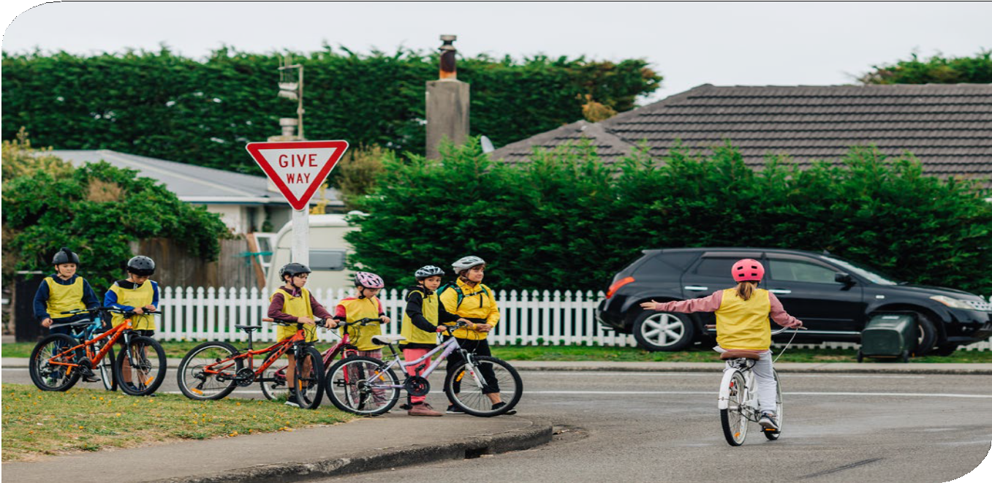

How to make a submission

We want to hear what you think.
In this document, we have asked some questions to help you tell us what you think. The questions are intended as a guide, and you do not have to answer them all. You can also tell us what you think in your own words if that is easier for you. Answering these questions will help us understand the impact that the proposed changes will have on you. Questions can be found at the end of each proposal in this document.
There are multiple ways you can provide feedback, from a online survey, to a Word document. Alternatively there are options listed below.
You can make a submission in the following ways:
Fill out our online survey www.nzta.govt.nz/about-us/ consultations/reshaping-streets-consultation
Fill in the submission form www.nzta.govt.nz/about-us/ consultations/reshaping-streets-consultation
Meet with us to discuss your views in person.
Write us a letter, email or video telling us what you think in your preferred language.
You can send your submission to us via email to:
reshaping.streets@nzta.govt.nz
You can post us your submission to:
Waka Kotahi NZ Transport Agency (Attention Transport Policy Team)
The Majestic Centre, Level 7, 100 Willis Street, Wellington Central, Wellington 6011
If you would like to send us a submission in another way, please contact 0800 699 000 and we will do what we can to help.

Please make sure you include the following information in your submission:
- your full name
- the name of the proposals you are providing feedback on (Reshaping Streets)
- your address or email address.
If you are sending us a submission on behalf of an organisation, please include the name of your organisation.
You need to make sure you tell us what you think by midnight on Monday 19 September 2022.

Your submission is public information
After public consultation, we will write a report that outlines the key themes, ideas, and feedback from public consultation. This report is called a summary of submissions and will be made publicly available for anyone to read.
In the summary of submissions, we might use:
  - Your name
  - Information about your views and feedback.
If you do not want your name or feedback to be included in anything we publish, please let us know in your submission. We can withhold the names of individuals, but not organisations. Please note that we never publish personal details such as addresses, phone numbers or email addresses when we publish the summary of submissions.
Your feedback will also be subject to the Official Information Act 1982 (OIA).
This means that other people will be able to request a copy of your submission by making a request under the OIA. If you do not want your submission to be shared, please let us know in your submission and why. We will take your reasons into account and may contact you to discuss further.

Annex: List of proposals

The table below identifies proposals that we are consulting on, and where to find more information on these proposals in this document.

Proposals

A new approach for piloting street changes |  | Page
1A | Provide RCAs with new powers and requirements to install pilots, and set requirements for how to install them. | 12
 | New Street Layouts rule, Section 4 (Pilots of street layout changes)
1B | Enable pilots to be used as a form of consultation, with feedback collected during the pilot used to consider whether to make street changes permanent. | 12
 | New Street Layouts rule, Section 4 (Pilots of street layout changes)
1C | Enable pilots to be installed for up to two years. | 12
 | New Street Layouts rule, Section 4 (Pilots of street layout changes)
1D | Amend the LGA1974 to make it clear that RCAs should not use the provision for ‘experimental diversions’ when piloting street changes. | 16
 | Relevant part in the LGA1974: schedule 10, section 11(b)
1E | Allow RCAs to lower the speed limit to support a pilot, by applying a ‘pilot speed limit’. | 16
 | New Street Layouts rule, clause 6.2: Amendments to the Land Transport Rule: Setting of Speed Limits 2022
1F | Update rules for trialling TCDs, so that RCAs can trial TCDs as part of pilots and choose how they notify people about TCD trials (with at least two weeks notice). | 17
 | New Street Layouts rule, clause 6.2: Amendments to Land Transport Rule: Traffic Control Devices 2004

Powers to filter traffic |  | Page
2A | Enable RCAs to install modal filters if the objects they use are safe, and people and deliveries can still access the places they need to get to. | 20
 | New Street Layouts rule, clause 3.1: Road controlling authorities may restrict traffic access to and change the use of roadways
2B | Ensure legislation provides clear powers to filter traffic, by removing the requirement in the LGA1974 that facilities built on roads cannot, in the opinion of a council, 'unduly impede vehicular traffic entering or using the road'. | 20
 | Relevant part in the LGA1974: section 334
2C | Enable RCAs to restrict or prohibit the use of some or all motor vehicles on specified roadways to support public transport use, active travel, health and safety, emissions reductions, and/or to create public spaces that promote community well-being. | 21
 | Proposed Street Layouts rule, section 2.1: RCAs may change the use of roadways

Powers to filter traffic |  | Page
2D | Provide RCAs with an explicit power to install TCDs. | 21
 | Proposed Street Layouts rule, section 2.1: RCAs may change the use of roadways

Schools Streets |  | Page
3 | Establish powers and requirements for RCAs to create School Streets in partnership with local schools 21 . | 21
 | New Street Layouts rule, section 2: Rules for Play Streets and School Streets

Community Streets |  | Page
4 | Establish a clear process for residents to hold Community Streets, provided they have approval from RCAs 23 . | 26
 | New Street Layouts rule, section 2: Rules for Play Streets and School Streets

Closing roads for other functions and events Page
5A Allow RCAs to close roads for reoccurring events, by removing the 31-day limit per year for 26
road closures in the LGA1974.
Relevant part in the LGA1974: schedule 10, section 11(e)
5B Consolidate powers and requirements to close roads for events in one piece of legislation (ie 27
the proposed Street Layouts rule).

Shift powers in schedule 10, 11(e) of the LGA1974 to close roads for public functions, markets, fairs, sporting events, and exhibitions to the proposed Street Layouts rule
Revoke the Transport (Vehicular Traffic Road Closure) Regulations 1965 and create equivalent powers to close roads for events in the proposed Street Layouts rule

Pedestrian malls |  | Page
6A | Remove the requirement for local authorities to use the special consultative procedure when establishing pedestrian malls. Instead, they must apply the consultation principles in the LGA2002. | 28
 | Relevant part in the LGA1974: section 336
 | Relevant part in the LGA 2002: section 82 (principles of consultation)
6B | Remove the ability for people to appeal to the Environment Court when a pedestrian mall is being created. People would be able to challenge the installation of a pedestrian mall through judicial review. | 29
 | Relevant part in the LGA1974: section 336
6C | Shift legislative provisions for pedestrian malls to the proposed Street Layouts rule. | 30
 | Relevant section of the LGA1974 to shift: section 336

Transport shelters |  | Page
7 | Remove special notification requirements for creating transport shelters. Instead, RCAs would be able to publicly consult on transport shelters in the same way they do for other features, like bus stops. | 30
 | Relevant part in the LGA1974: section 339

