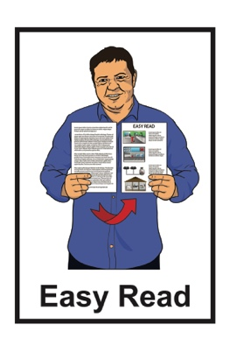



**Rules for urban buses in New Zealand 2020**

**Tell us what you think of the changes we want to make to the rules about how we use urban buses**

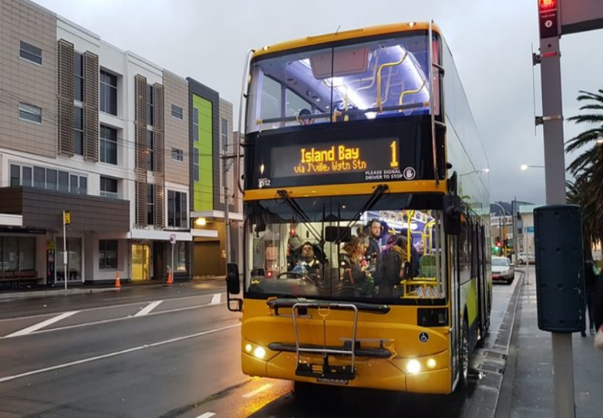



# What you will find in here

Page:

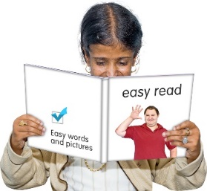

Before you start……………………..2

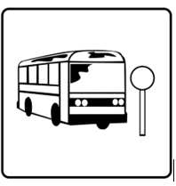

What are we doing?..........................6

What are the changes we

want to make?.................................13

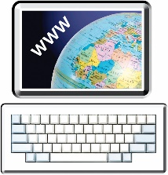

Where to find out more about

the **Requirements for Urban Buses 2020** ..………………….……..28

# Before you start

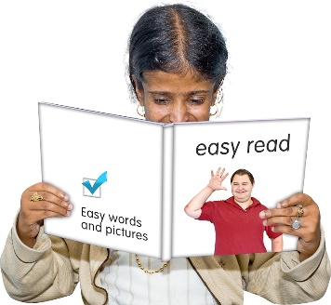

This is an Easy Read booklet about some changes that might be made to make our **urban buses** more:

* **accessible**
* safe to use.

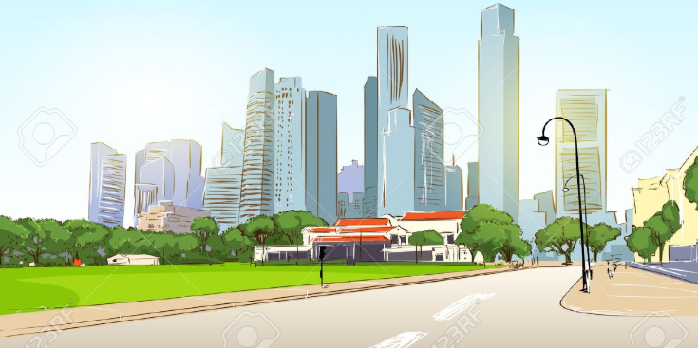

**Urban buses** are buses we usein a city area.

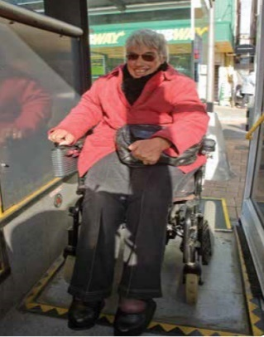

**Accessible** means making our buses easy for everyone to use.

This an Easy Read translation of a longer document called:

**Requirements for Urban Buses in New Zealand 2020.**

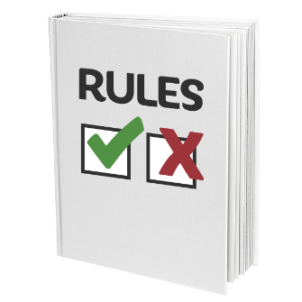

The **Requirements for Urban Buses in New Zealand 2020** tells us about the rules for urban buses.

****The Requirement for Urban Buses 2020 document has been written by **Waka Kotahi New Zealand Transport Agency.**

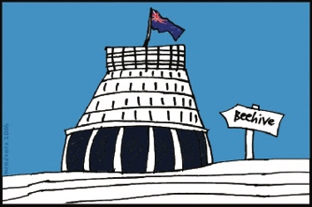

**Waka Kotahi New Zealand Transport Agency** is part of the government that looks after:

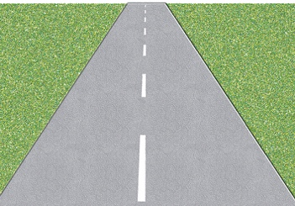

* roads
* transport.

****In this booklet **we** will mean Waka Kotahi New Zealand Transport Agency.

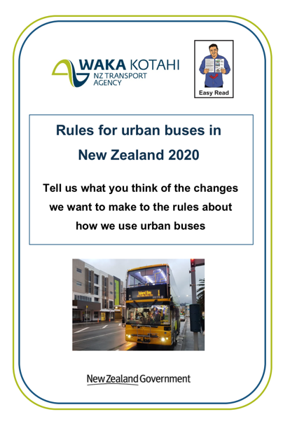

In this booklet we look at the rules for urban buses about:

* wheelchair ramps
* how high the ticket machine is
* a second wheelchair space
* seats in the priority area.
* mobility devices on buses
* bus stop buttons for wheelchairs.

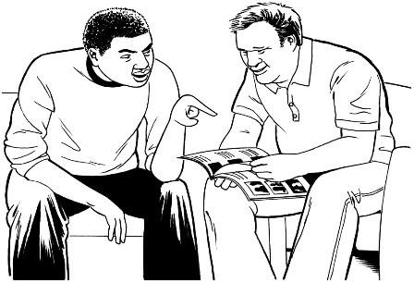Some things you can do to make reading this booklet easier are:

read it a few pages at a time

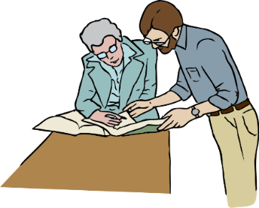ask someone to assist you to understand it

ask someone to assist you to fill in the question boxes in the document.

**What are we doing?**

Waka Kotahi New Zealand Transport Agency want to make some changes to the rules for buses in cities.

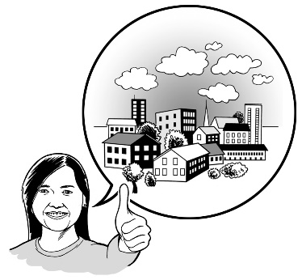We want to make changes to some city bus rules so that it is easier for everyone to get to where they want to go.

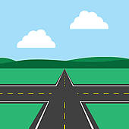

These changes are part of looking at the **Requirements for Urban Buses** **in New Zealand 2020** rules**.**

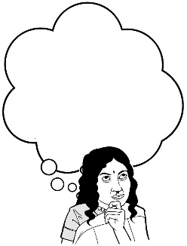

We want you to hear what you think about these changes.

In this booklet we have some questions to help you tell us what you think.

**You do not have to answer every question.**

## How to tell us what you think of the changes we

## want to make to city buses

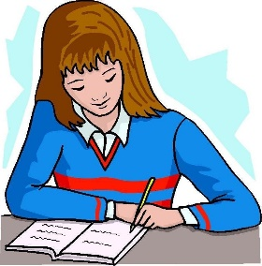

You can fill in the question boxes in this booklet then post it to us to read.



You can also tell us what you think by:

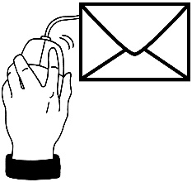

* writing us a letter
* sending us an email
* sending us a video message.

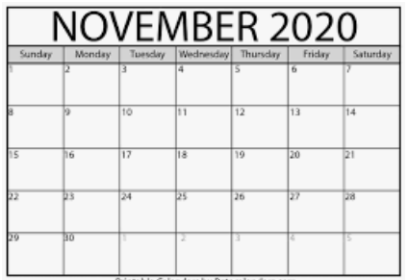

**You need to make sure you tell us what you think before 5pm on Friday 6th November 2020.**



****You can **post** in your booklet with answers or letter for free to:

**Requirements for Urban Buses 2020**

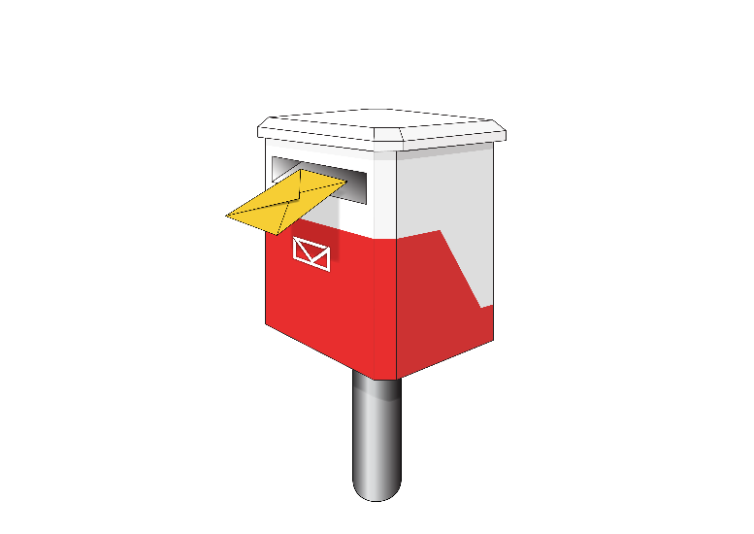

**Transport System Policy Team**

**Free Post 65090**

**Waka Kotahi NZ Transport Agency**

**Private Bag 6995**

**Wellington 6141**

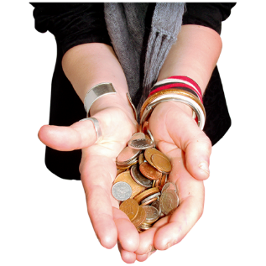

This is a free post address which means it does not cost you any money to send your letter.

You can send us an **email** to:

[**publictransport@nzta.govt.nz**](mailto:publictransport@nzta.govt.nz)



You can send us a **video** to:

[**publictransport@nzta.govt.nz**](mailto:publictransport@nzta.govt.nz)

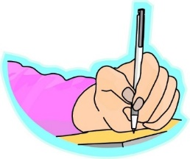**When you tell us what you think please make sure you tell us:**

1. your name

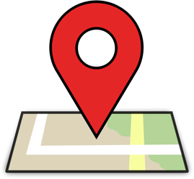

1. the name of this booklet – **Requirements for Urban Buses in New Zealand 2020**
2. your **address**
3. your **email address** if you have one.

## What we will do with the ideas you send in

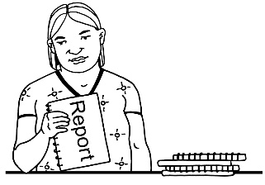

We will write a short report of all the ideas that people send to us.

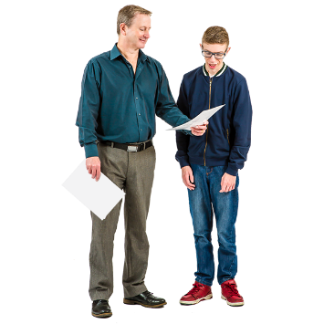

We will share the short report with everyone.

In that report we might use:

* 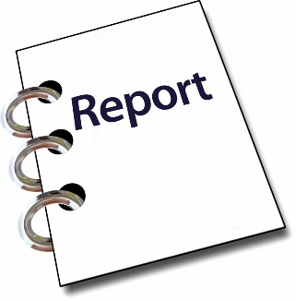your name
* information about your ideas.

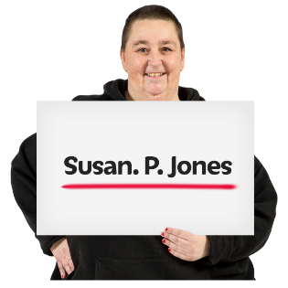

**Please tell us** if you do not want your name or your information to be in our short report.

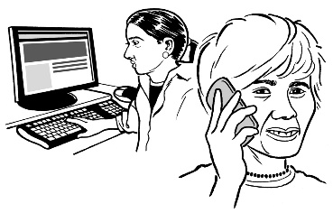

We may call or email you to talk about this.

**What are the changes we want to make?**

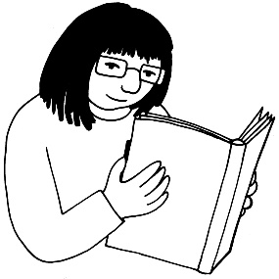

This booklet looks at 6 of the important things we want to change to the requirements for buses in our cities:

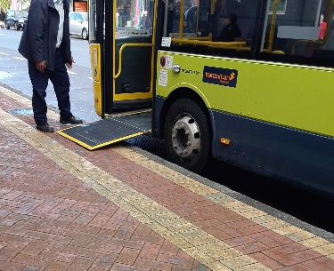

1. Wheelchair ramps

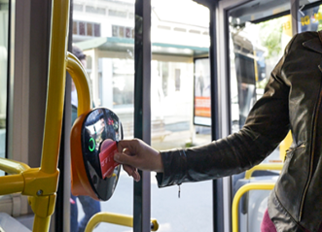

1. How high the ticket machine is
2. 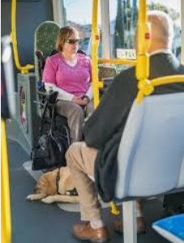A second wheelchair space
3. Seats in the priority area

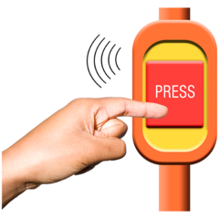

1. Mobility devices on buses
2. Bus stop buttons for wheelchairs.

# Wheelchair ramps

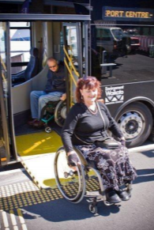

A **wheelchair ramp** is used by someone in a wheelchair to get on and off a bus.

The urban bus rules do not say how **steep a wheelchair ramp should be**.

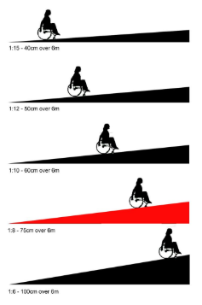

If the ramp is **too steep** it may be too hard for someone in a wheelchair to get on and off the bus.

We want **lower wheelchair ramps** to make it easier for people to get on and off an urban bus.

## Question 1:

Do you think it is a good idea to **lower** **the wheelchair ramp?**

|  |
| --- |
| **Please put your answer in here:** |

# Ticket machines

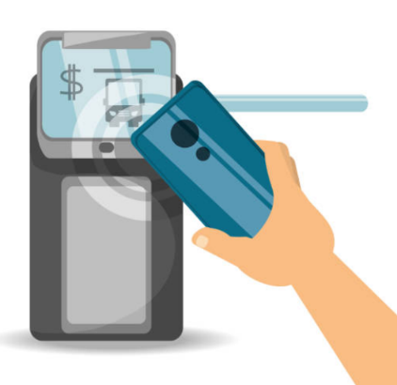

The **ticket machine** is where you touch your bus card to pay for your ride.

Sometimes:

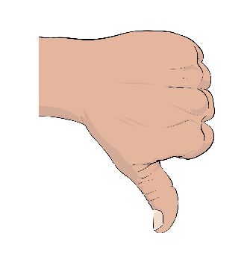

* the ticket machine is **too high to reach**
* it is hard for people to see the ticket machine **if they are blind or have low vision.**

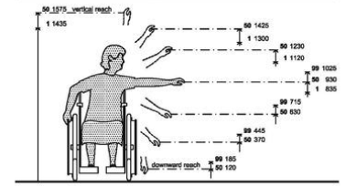

This picture shows a **good height** for the ticket machine.





We want the ticket machine to be in the **same place on every urban bus.**

## Question 2:



Do you think it is a good idea to **put the ticket machine in the same place?**

|  |
| --- |
| **Please put your answer in here:** |

# 2 wheelchair spaces

At the moment **only 1 person in a wheelchair** can travel on an urban bus.

This means:

2 people in wheelchairs **cannot** travel together

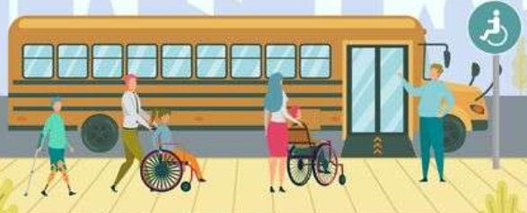

a person in a wheelchair **has to wait for another bus** if someone else is using the wheelchair space.

We want to **have 2 wheelchair spaces** on all urban buses.

This means more people in wheelchairs can use the bus.

## Question 3

Do you think it is a good idea to **have a second wheelchair space?**

|  |
| --- |
| **Please put your answer in here:** |

# Seats in the priority area

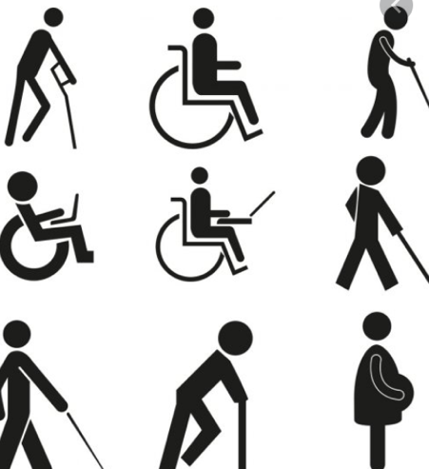On urban buses, **priority seating** is for:

* older people
* pregnant women
* people with a disability.



On urban buses, there are **4 seats** in the **priority area.**

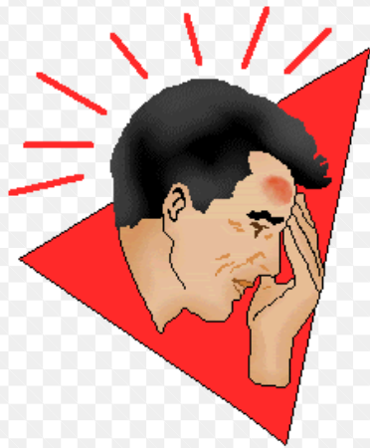These seats are **very close together.**

If the bus stops suddenly **people can get hurt.**

We want to **have 2 seats in this area to make it safer for people.**

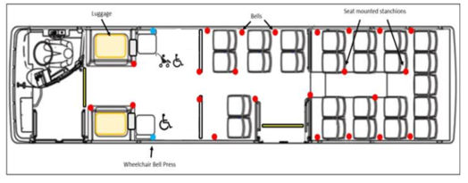

## Question 4

Do you think it is a good idea to **have 2 seats in the priority area?**

|  |
| --- |
| **Please put your answer in here:** |

# Mobility devices on buses

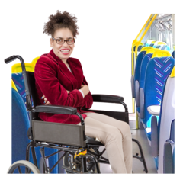

Some people use **mobility devices** to move around.

**A wheelchair** is a mobility device.

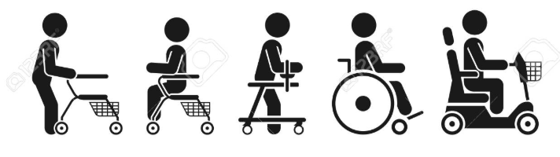**Wheelchairs are allowed** on urban buses but other mobility devices are **not allowed.**

Mobility scooters are **not allowed** on urban buses.



We are thinking about allowing other **mobility devices on urban buses.**

## Question 5

Do you think it is a good idea for other **mobility devices go on urban buses?**

|  |
| --- |
| **Please put your answer in here:** |

# Bus stop buttons for wheelchairs

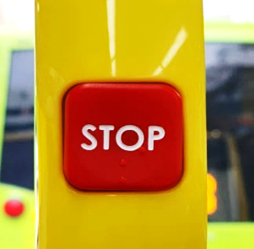

When you want to get off the bus you press the **stop buttom**.

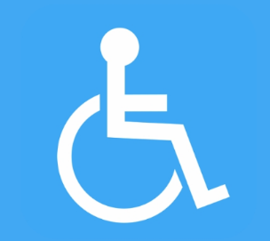

At the moment there is no bus stop button just for **people in wheelchairs**.

The bus driver needs to know if someone in a wheelchair wants to get off the bus so they can put out the wheelchair ramp.



If a lot of people press the stop button bus drivers do not know when someone in a wheelchair wants to get off the bus.

We want a **stop button** that only people in wheelchairscan use to let the bus driver know they want to get off at the next stop.

## 

## Question 6

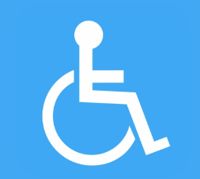

Do you think it is a good idea to **have a bus stop button for people in wheelchairs?**

|  |
| --- |
| **Please put your answer in here:** |

# Where to find more information about the Requirements for Urban Buses 2020

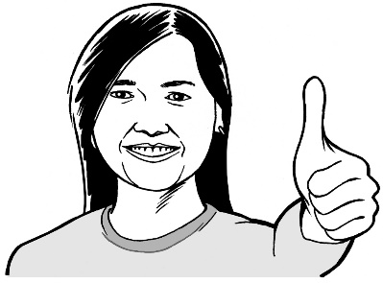

Thank you for telling us what you think of these changes.

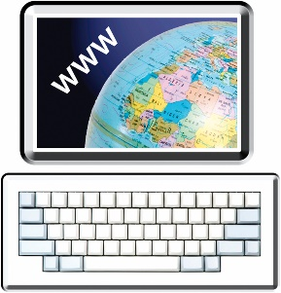You can find more information about the **Requirements for Urban Buses 2020:**

Website:

**www.nzta.govt.nz/about-us/ consultations/RUB**

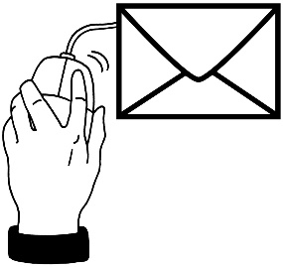

Email us at:

**publictransport@nzta.govt.nz**

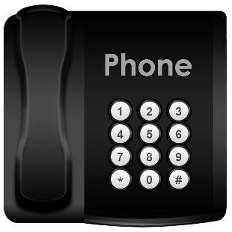

Phone us on:

**0800 699 000**

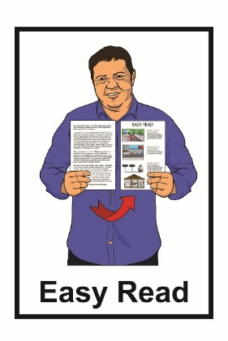**This information has been translated into Easy Read with advice from the Make It Easy service of People First New Zealand Inc. Ngā Tāngata Tuatahi.**

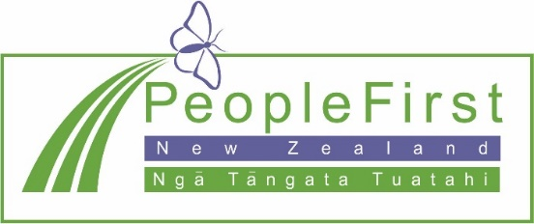

**The ideas in this document are not the ideas of People First New Zealand Ngā Tāngata Tuatahi.**

Change logo.
Change is the name of the organisation.

**Make It Easy uses images from:**



* **Changepeople.org**
* **Photosymbols.com**



* **Sam Corliss**

**Many of the images used in this Easy Read document are subject to copyright rules and cannot be used without permission.**