[Insert region name]

Regional Land Transport Plan 2021

Executive Summary

Type text here

Introduction

Type text here

This RLTP is the primary document guiding integrated land transport planning and investment within the [insert region name].

The relationship of the RLTP with other key the wider transport and land use planning and funding context is set out in the diagram below.

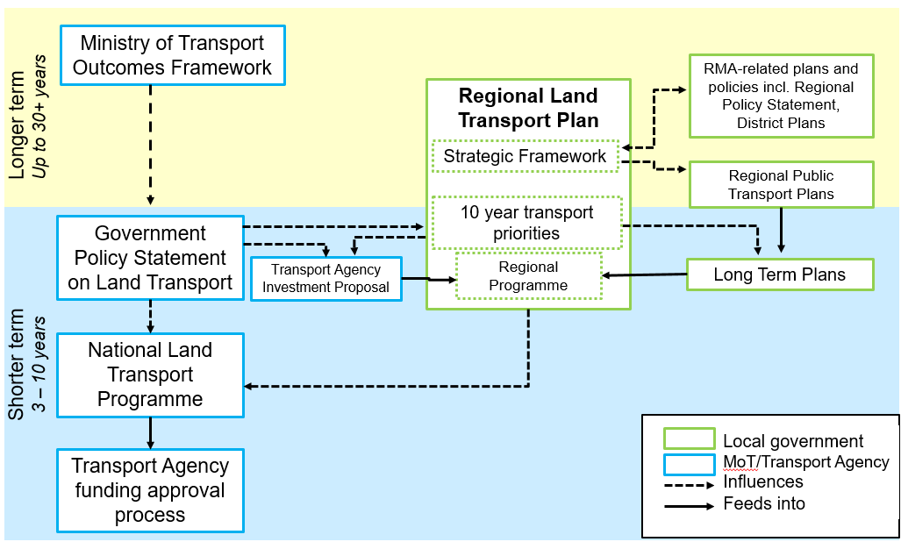

Strategic Context

Type text here

Our region

Xx
Our people

Xx
Our transport system

Xx
Future scenarios and opportunities

Xx

Strategic framework [Template A]

The Land Transport Management Act 2003 seeks an effective, efficient, and safe land transport system.

Outcome 5

Economic prosperity

Outcome 1

Inclusive access

Outcome 2

Healthy and safe people

Outcome 3

Environmental sustainability

Outcome 4

Resilience and security
Ministry of Transport’s Outcomes Framework

The purpose of the transport system is to improve people’s wellbeing, and the liveability of places

Regional Land Transport Plan – 30-year vision

[Describe the region’s desired long-term future in one sentence]

Strategic objectives – we will deliver our vision and targets with…

[Include up to six objectives that describe what the region will do to deliver the 30-year vision and headline targets.

Objectives are something measurable that work is directed towards. Delete boxes you don’t need.]

[Headline target title]

[Describe target in 1 sentence]

[Headline target title]

[Describe target in 1 sentence]

Objective 3

[Title]

[Describe objective]

Objective 2

[Title]

[Describe objective]

Objective 1

[Title]

[Describe objective]

Objective 6

[Title]

[Describe objective]

Objective 5

[Title]

[Describe objective]

[Headline target title]

[Describe target in 1 sentence]

[Headline target title]

[Describe target in 1 sentence]

[Headline target title]

[Describe target in 1 sentence]

Objective 4

[Title]

[Describe objective]

Headline targets

[Include up to six objectives that describe what the region will do to deliver the 30-year vision and headline targets.

Objectives are something measurable that work is directed towards. Delete boxes you don’t need.]

Objectives and policies [Template B]

[Right click image to change picture for your region]

Objective 1: [Type from strategic objectives in Template A. Create one page per objective]

Policies for Objective 1 [Write one-sentence policies that show how objectives will be achieved]

P1: [type text here]

P2: [type text here]

P3: [type text here]

Ten year transport priorities [Template C]

Transport priority 1: [type text here]

[Enter the title for each priority identified through the problem/opportunity identification process.

Use a separate page for each one – could be more than four below]

Problem | The case for investment
[Describe the core problem(s)/problem statement(s)] | [Write a short, concise and compelling investment story in plain English that makes the overarching need for investment clear: state the underlying problem(s) clearly and concisely; identify the desired outcome(s); be clear about who stands to benefit, and why]

Benefits
[Describe the benefits(s)] | Fit with strategic context
Summary of evidence | [Explain how the proposed investments fits with existing strategies and plans set out in the strategic context section of the RLTP, including Transport Outcomes Framework, RLTP Objectives and GPS Objectives]
[Write a summary of supporting evidence that indicates why the problem(s) is important – use bullet lists, graphics, etc. as relevant. Don’t include any ILM maps] | Long term results/Measure
Key investment partners | [Select key indicators from monitoring framework (see Template D)]

[Identify key investments partners for this investment area]

Priority investment areas (signals for the regional programme of activities)

1. [List key programmes and investment areas that will address this problem]

2.

3.

4.

Other priority implementation areas

[e.g. through Crown, PGF, etc.]

[e.g. non-transport solutions, such as land use policies]

Transport priority 2: [type text here]

[Enter the title for each priority identified through the problem/opportunity identification process.

Use a separate page for each one]

Problem | The case for investment
[Describe the core problem(s)/problem statement(s)] | [Write a short, concise and compelling investment story in plain English that makes the overarching need for investment clear: state the underlying problem(s) clearly and concisely; identify the desired outcome(s); be clear about who stands to benefit, and why]

Benefits
[Describe the benefits(s)] | Fit with strategic context
Summary of evidence | [Explain how the proposed investments fits with existing strategies and plans set out in the strategic context section of the RLTP, including Transport Outcomes Framework, RLTP Objectives and GPS Objectives]
[Write a summary of supporting evidence that indicates why the problem(s) is important – use bullet lists, graphics, etc. as relevant. Don’t include any ILM maps] | Long term results/Measure
Key investment partners | [Select key indicators from monitoring framework (see Template D)]

[Identify key investments partners for this investment area]

Priority investment areas (signals for the regional programme of activities)

1. [List key programmes and investment areas that will address this problem]

2.

3.

4.

Other priority implementation areas

[e.g. through Crown, PGF, etc.]

[e.g. non-transport solutions, such as land use policies]

Transport priority 3: [type text here]

[Enter the title for each priority identified through the problem/opportunity identification process.

Use a separate page for each one]

Problem | The case for investment
[Describe the core problem(s)/problem statement(s)] | [Write a short, concise and compelling investment story in plain English that makes the overarching need for investment clear: state the underlying problem(s) clearly and concisely; identify the desired outcome(s); be clear about who stands to benefit, and why]

Benefits
[Describe the benefits(s)] | Fit with strategic context
Summary of evidence | [Explain how the proposed investments fits with existing strategies and plans set out in the strategic context section of the RLTP, including Transport Outcomes Framework, RLTP Objectives and GPS Objectives]
[Write a summary of supporting evidence that indicates why the problem(s) is important – use bullet lists, graphics, etc. as relevant. Don’t include any ILM maps] | Long term results/Measure
Key investment partners | [Select key indicators from monitoring framework (see Template D)]

[Identify key investments partners for this investment area]

Priority investment areas (signals for the regional programme of activities)

1. [List key programmes and investment areas that will address this problem]

2.

3.

4.

Other priority implementation areas

[e.g. through Crown, PGF, etc.]

[e.g. non-transport solutions, such as land use policies]

Transport priority 4: [type text here]

[Enter the title for each priority identified through the problem/opportunity identification process.

Use a separate page for each one]

Problem | The case for investment
[Describe the core problem(s)/problem statement(s)] | [Write a short, concise and compelling investment story in plain English that makes the overarching need for investment clear: state the underlying problem(s) clearly and concisely; identify the desired outcome(s); be clear about who stands to benefit, and why]

Benefits
[Describe the benefits(s)] | Fit with strategic context
Summary of evidence | [Explain how the proposed investments fits with existing strategies and plans set out in the strategic context section of the RLTP, including Transport Outcomes Framework, RLTP Objectives and GPS Objectives]
[Write a summary of supporting evidence that indicates why the problem(s) is important – use bullet lists, graphics, etc. as relevant. Don’t include any ILM maps] | Long term results/Measure
Key investment partners | [Select key indicators from monitoring framework (see Template D)]

[Identify key investments partners for this investment area]

Priority investment areas (signals for the regional programme of activities)

1. [List key programmes and investment areas that will address this problem]

2.

3.

4.

Other priority implementation areas

[e.g. through Crown, PGF, etc.]

[e.g. non-transport solutions, such as land use policies]

Programming and funding

Sub-heading

Type text here

Monitoring indicator framework [Template D]

[Right click image to change picture for your region]

[Describes how monitoring will be undertaken to assess implementation of the RLTP (s16(6)(e) of the LTMA/how your transport priorities fir with the Transport Outcomes. Use one table for each Transport Outcome to outline the measures, indicators and data sources to be used to monitor progress. Include measures for the headline targets identified in Template A, and indicators (Long term results/Measure) from Template C.]

Outcome: Inclusive access

Measure | Indicator | Specifications | Data Sources
1: [type text here] | [type text here] | [type text here] | [type text here]

2:

3:

4:

Outcome: Healthy and safe people

Measure | Indicator | Specifications | Data Sources
1: [type text here] | [type text here] | [type text here] | [type text here]

2:

3:

4:

Outcome: Environmental sustainability

Measure | Indicator | Specifications | Data Sources
1: [type text here] | [type text here] | [type text here] | [type text here]

2:

3:

4:

Outcome: Resilience and security

Measure | Indicator | Specifications | Data Sources
1: [type text here] | [type text here] | [type text here] | [type text here]

2:

3:

4:

Outcome: Economic prosperity

Measure | Indicator | Specifications | Data Sources
1: [type text here] | [type text here] | [type text here] | [type text here]

2:

3:

4:

Appendices

