TIO USER GUIDE
Improvements Exemplar for NLTP Inclusion

New Starter?

Click on Introduction to TIO to learn important things about TIO, and correct or useful time-saving skills.

Role and Responsibility

Regional Transport Committees (RTC) | Activities in TIO are submitted to an RTC for inclusion in their RLTP. All activities, excluding Waka Kotahi nationally delivered activities, are required to be included in an RLTP to be included in the NLTP.
Activity Owner  (Approved Organisations (AO) or Waka Kotahi) | Create new and/or modify improvement activities in TIO. Submit the activity to RTCs for inclusion into the RLTP/NTLP
Waka Kotahi Investment Advisor | Review activity information and the Investment Prioritisation Method (IPM) profile for the activity. Input the Waka Kotahi IPM profile into TIO and liaise with the Activity Owner on any incomplete, inaccurate or incorrect information included in TIO for the activity.

What level is the exemplar set?
The exemplar is based on a State Highway activity with a view of both ‘Activity Owner’ and ‘Investment Advisor’ inputs. The information view is set at the requirements for NLTP inclusion; however, tips have been given for funding approval.

TIO New Activity Exemplar

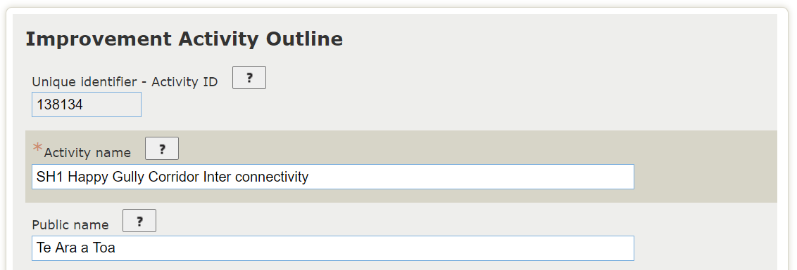
Improvement activity outline

The Activity name should describe it uniquely and be meaningful to others. We recommend that the Naming Guidelines are used when creating your Activity name. The TIO Activity name is required to be entered to move to the next page.
The public name field is optional and should only be completed if the activity is publicly known by a unique and meaningful name (gifted or Māori name) that is different to the "Activity name". Where possible, keep the Public Name consistent with the name of the activity included in the RLTP and LTP. This name may adapt as the activity develops.
The activity name is a mandatory field for Inclusion into the NLTP.

‘Your Reference’ is the organisation's own reference for the activity. This may be the WBC, SAP code or other accounting code, for example. As this is a Waka Kotahi project it is left blank as TIO links directly to the Waka Kotahi SAP system. This is not mandatory.
The ‘NTZA safety identifier’ is a unique identifier number from the pipeline development tool. Currently this is the asset id => Unique identifier number generated from a combination of the asset id, treatment philosophy and length in Pipeline Development Tool of an endorsed activity. The NZTA safety identifier will be entered by an NZTA National user (such as an Investment Advisor), to others the field will be read only.
All improvement activities for ‘Safety Infrastructure’, within the Road to Zero activity class, should have this unique identifier, if not, the activity owner should discuss with their Investment Advisor to confirm whether the activity can be included within the Road to Zero activity class. The activity ‘SH1 Happy Gully Corridor Inter connectivity’ is not a Road to Zero activity for safety infrastructure and therefore, will not have a NZTA safety identifier.

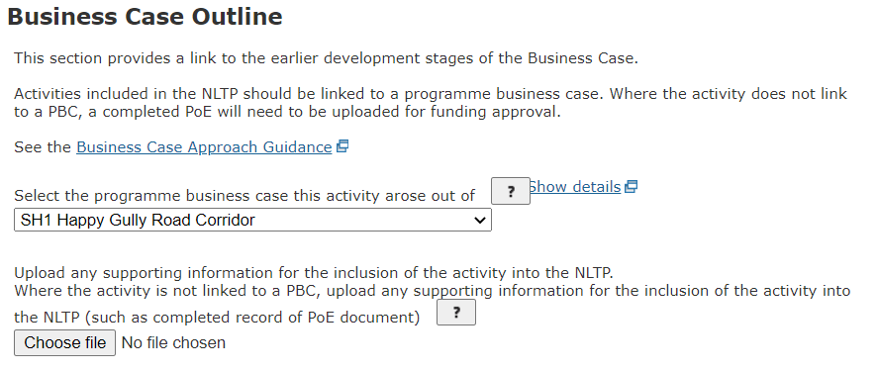

Where the activity is supported by an existing business case, provide a link to the business case. The ‘SH1 Happy Gully Corridor Inter connectivity’ activity forms part of the preferred programme of the ‘SH1 Happy Gully Road Corridor’ PBC.
Activities that have a previous business case phase, such as a PBC, must link to that previous business case phase for inclusion into the NLTP.
As the PBC, through its Management Case, clearly outlines risks, uncertainties & complexity of the investment and the business case next steps including activity level business cases requirements, timeframes and resource requirements, an activity level point of entry is not required to be completed. However, if this is not the case, a point of entry could be completed for the activity to record the pathway to be followed through investment decision making processes and to consider the full range of risks, timeframes and costs for the investment. If required, the completed Record of Point of Entry needs to be attached in TIO for funding approval.
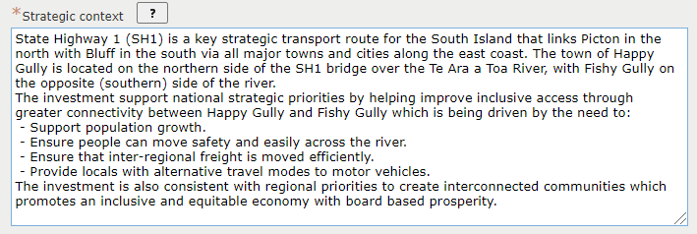

The strategic context establishes how well the activity/combination of activities aligns with local, regional and national priorities, other programmes and/or strategies, and other organisations’ priorities or programmes (such as housing or industrial developments), if relevant. It considers the alignment with spatial plans and/or integrated transport and land use plans.
The strategic context should also include a brief description of the activity which should include what outcomes the activity will deliver and the proposed output of the activity, not on the current phase. The description may need to adapt as the business case progresses.
The ‘Strategic Context’ is a mandatory field for Inclusion into the NLTP.
.
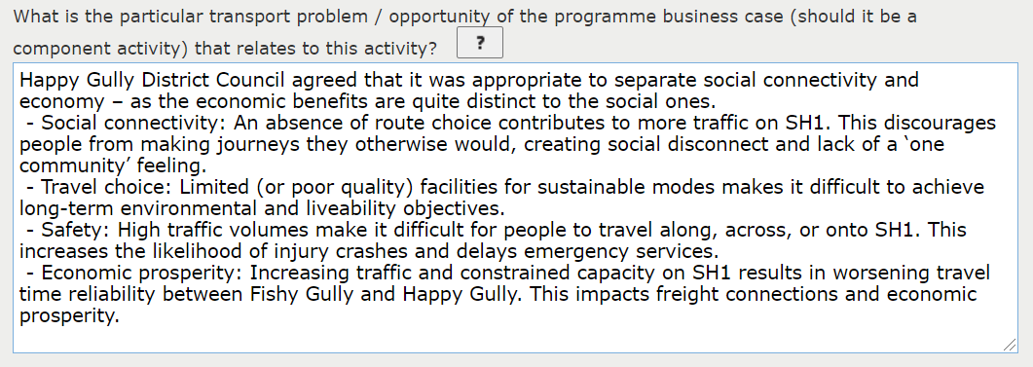

Requires a statement of the problem that the activity will address, or the opportunity that the activity will pursue. The statement should include the cause or opportunity and the consequence of addressing it, including the degree of impact to users, particularly due to availability (or not) of alternatives. This may arise out of the ILM, for example.
The ‘Problem/Opportunity’ is a mandatory field for Inclusion into the NLTP.

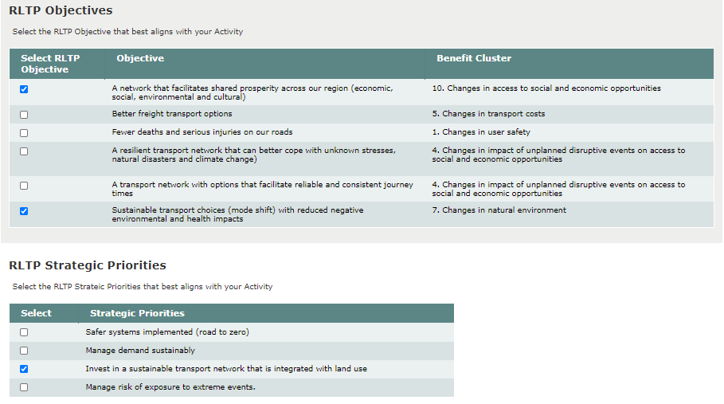

RLTP objectives and priorities are set by regional councils and unitary authorities which come into effect once the RTC approves the RLTP document. RTCs enter their RLTP objectives and priorities into TIO which then makes these objectives and priorities visible for new improvement activities within the region. The functionality was designed to provide greater transparency in how activities within the region aligns to the RLTP and to ensure RLTP prioritisation is considered.
Selection of at least one RLTP Objective and one RLTP Strategic Priority is mandatory for NLTP inclusion.

Benefits and Measures

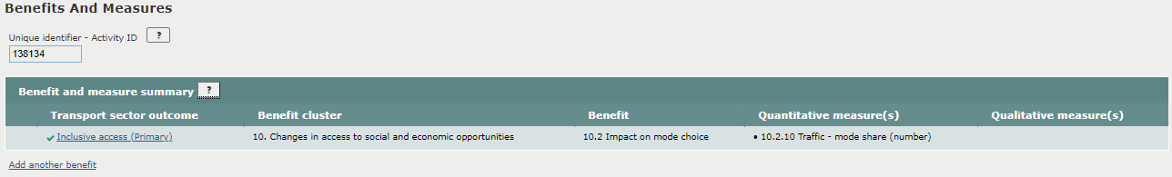

Primary benefits and co-benefits expected to be delivered by the activity, based on the Waka Kotahi benefits framework. Benefits are a cascade from the Point of Entry through to Implementation. When completing this section please consider benefits identified in previous business cases and how they are relevant to this phase of the activity.

The ‘Primary Benefit’ and required information is required for Inclusion into the NLTP.
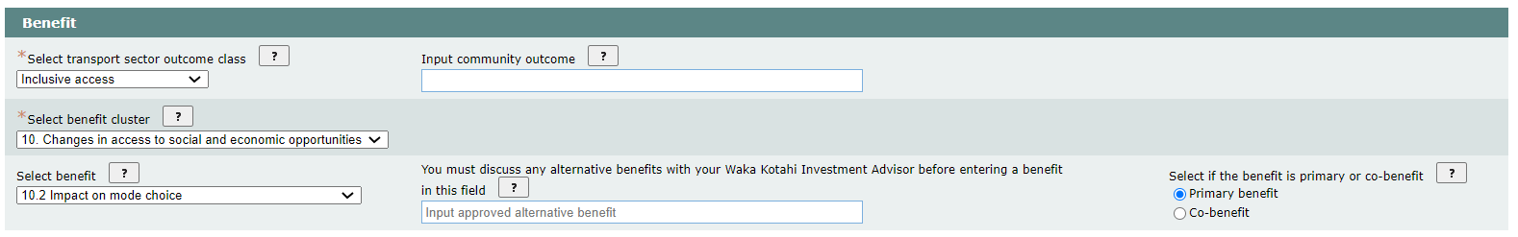

Please read the full description of related benefits which can be found in the Benefits framework and management approach guidelines.
Transport sector outcomes are based on the Ministry of Transport’s Transport Outcomes Framework. Benefit clusters and benefits are enduring and reflect the broad range of land transport benefits valued by the community. For inclusion one transport sector outcome, followed by a benefit cluster and benefit is required to be selected.
The community outcome field is optional. It allows community outcomes, relating to transport sector outcomes being sought, to be entered into TIO. These outcomes do not need to be land transport specific and allows connections to be made but does not mean that the NLTP will fund these outcomes.
Alternative benefits are optional and must be materially different to the benefits available for selection. Alternative benefits must start with the words "Impact on " and be succinct. You must discuss any alternative benefits with your Waka Kotahi Investment Advisor before entering a benefit in this field. This field has been left blank as suitable benefit was selected from within the benefits framework.
Primary benefits are the key benefit of an investment. Co-benefits support the primary benefits and will be delivered by the investment but are not the key benefit. A ‘Primary Benefit’ and a quantitative or qualitative measure with a baseline are required information for Inclusion into the NLTP. Co-benefits and all measure details are required in TIO for funding approval.

A measure will need to be selected that provides the best evidence about the selected benefit. The measure’s baseline is the reported result of the selected measure at the start of the investment. A unit of measurement will need to be reflected in the baseline as per the measure description, which are provided where available in the Non-monetised benefits manual.
While the example above includes the forecast range ‘do-minimum’, forecast range ‘preferred option’, forecast year, period for monitoring and forecast confidence rating, for NLTP inclusion a measure with its baseline will need to be captured within TIO.
Any content included for NLTP inclusion can be a high level estimate. The underlying evidence will not be developed until completion of the initial business case phase for the investment.
When the investment moves through to obtain funding approval, significant co-benefits and associated measures material will need to be added to TIO. We expect that a handful of benefits and measures will be included in each improvement business case, but further measures can be added if necessary.

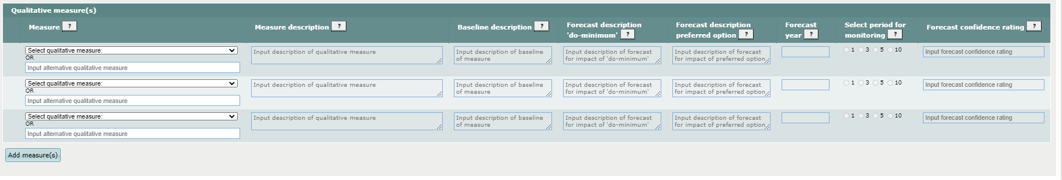

A qualitative measure has not been selected as the primary benefit is best evidenced through the quantitative measure ’10.2.10. Traffic – mode share’, however, additional benefits and measures, including qualitative measures, should be entered when the investment moves through to obtain funding approval.
If a qualitative measure is being input into TIO they are listed as 'user to describe' in the framework. Methodologies to describe the measures are provided where available in the Non-monetised benefits manual.

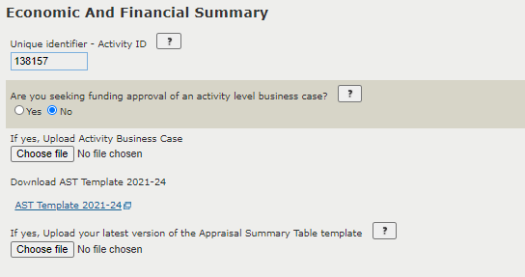

For inclusion into the NLTP the box ‘Are you seeking funding approval of an activity level business case’ should be checked as no. Additional information is required to be entered into TIO for funding approval.
A completed business case is not required for inclusion into the NLTP, as this will not be available until the initial business case step is completed. A draft business case should be uploaded into TIO when available, including reloading the business case for any significant revisions.
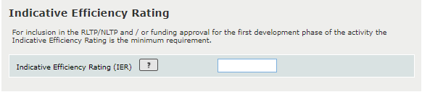
A completed AST is not required for inclusion into the NLTP. An AST is not required until funding approval is being sought and should be updated when any significant revisions are made.

For inclusion in the NLTP an activity needs to provide either an IER or a National/Government BCR.
An IER is to be used when you do not have an economic evaluation completed as part of a business case. An IER must be calculated using the IER tool. The example investment is linked to a PBC with a BCR. For inclusion into the NLTP, an activity that is part of a programme or package previously endorsed by Waka Kotahi may be assigned Efficiency rating of that programme or package.

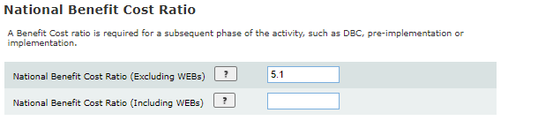

BCR represents present value of total benefits divided by present value of total costs. WEBs are indirect benefits additional to those captured in conventional appraisal methods, for example changes in productivity and local labour markets. The example investment is linked to a PBC with a BCR and therefore this BCR of the PBC has been used for inclusion into the NLTP.
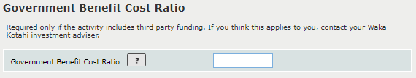

The BCRG is intended to indicate the level of benefits obtained from investment of government funds in situations where it is necessary to cover service provider costs in the event of a funding gap for the operation of PT services, or when government funding is mitigated by the availability of third-party funding. This is not applicable for this investment and therefore is not required for neither NLTP inclusion, nor funding approval.
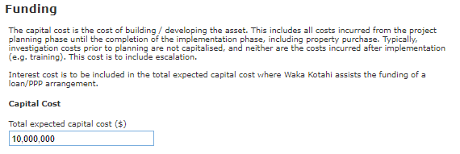

Please refer to our cost estimation manual for further information on how to estimate the total expected capital cost.
The total expected capital cost is required for NLTP inclusion.

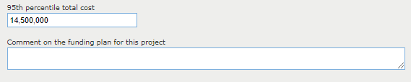

The 95th percentile total cost says that 95% of the time, the cost is at or below this amount. This field is required for funding approval if the expected Capital Cost is $10m or greater. Please refer to our cost estimation manual for further information on how to estimate the 95th percentile total cost.
Most activities will be funded from the NLTF only, however, some activities may be funded by way of loan, external or government funded, or through delivery models like public private partnerships. Information on the activity’s funding plan is only required for funding approval only.
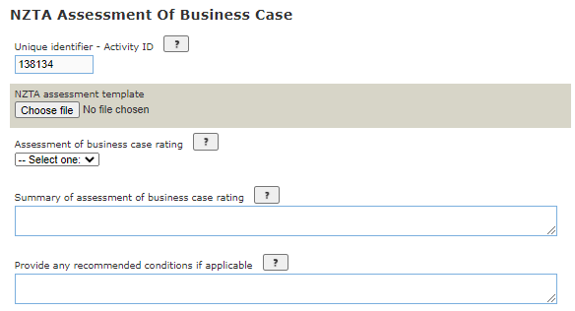

This section is completed by a Waka Kotahi Investment Advisor and is not required to be completed for NLTP inclusions and is not required to be completed until each of the activity’s business case phases is complete and the business case is being submitted for endorsement.
An IQA template should be completed and provided to decision makers to ensure:
- statutory legal obligations are met
- TIO is up to date
- the activity fits with Waka Kotahi investment principles and the IPM
- the necessary requirements for investment decisions have been completed and the activity is ready to move to the next phase.

The assessed business case rating is required to be input into TIO which is one of the following ratings:
- Pass - Signifies that a robust proposal that meets the expectations of Waka Kotahi and the Business Case Approach (BCA) principles have been applied relevant to the phase of the business case.
- Rework – Waka Kotahi considers that further work is required to ensure the business case is robust. The business case will either need to be updated to achieve a pass assessment (condition precedent) or proceed to the next phase with conditions attached (condition subsequent).
- Fail – The business case has not provided the necessary evidence to support the investment proposal. In most cases the business will need to be updated and reassessed.
The Investment Advisor will also provide brief commentary to demonstrate the overall outcome of the assessment of the business case and a summary of any conditions on attached to the business case.

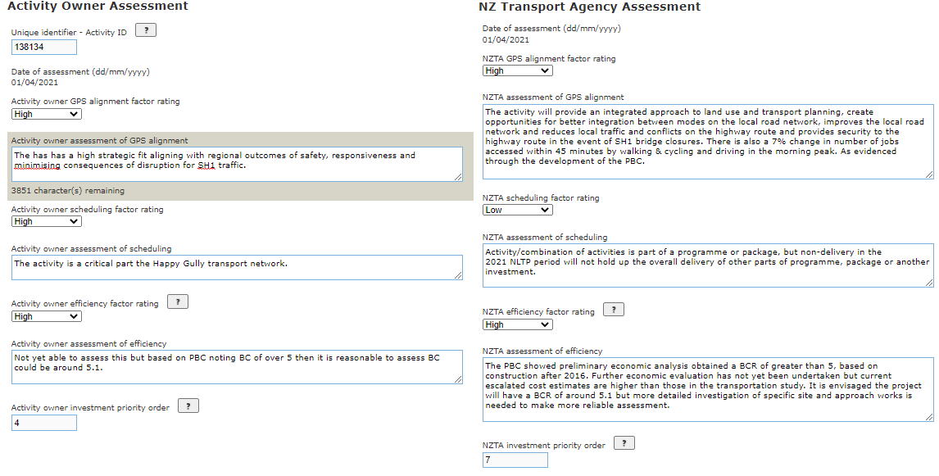

The activity owner will need to provide their own Investment Prioritisation Method (IPM) profile which is split between the three factors of GPS Alignment, Scheduling and Efficiency. The activity owner will need provide commentary on how they came to determine their rating, including any evidence to support their assessment. A waka Kotahi Investment Advisor will complete the ‘NZ Transport Agency Assessment’ which includes the Advisor completing their own independent assessment of the activity’s IPM profile. For each rating, the advisor will also need provide commentary on how they came to determine their rating, including any evidence to support their assessment.
A completed Owner assessment is required for submission to the RTC.
The activity owner and NZ Transport Agency assessment should be both based on the IPM. Both the activity owner and NZTA investment priority order is calculated automatically by TIO when all 3 ratings have been provided and the page has been saved.
A completed NZ Transport Agency assessment is required for NLTP inclusion.
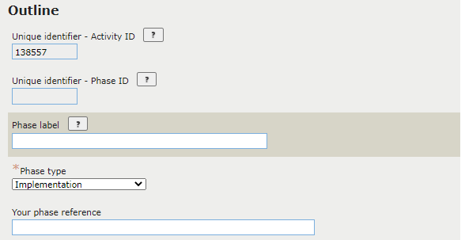

All phase that will be begin within the NLTP cycle will need to be completed for inclusion in the NLTP.
The activity will have two phases within the NLTP cycle, one for a Single Stage Business Case Lite and the other for Implementation. Additional phases can be added to the activity using the ‘Add a phase’ link.
The phase label is not mandatory but can be helpful in identifying the phase, particularly where there are many phases under a single activity. As this activity is simple with only two phases, we have not added a phase label.
Note: While the Naming Guidelines do not apply, the phase label should be sensible and differentiate between phases of the same type.
The phase type is a requirement for NLTP inclusion and needs to reflect the phase being included within the NLTP.
The phase reference is the organisation's own reference for the activity. This may be the WBC, SAP code or other accounting code, for example. As this is a Waka Kotahi project the field it is left blank as an TIO links directly to the Waka Kotahi SAP system. This is not mandatory.
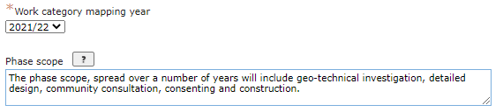

To ensure correct work category mapping the correct mapping year needs to be selected. While not required until funding approval. It is good practice to include the phase scope for NLTP inclusion. The phase scope is a brief description of the output to be delivered by the phase.
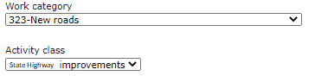

The work category is required to be selected based on the improvement activity being undertaken. Most of the time the Activity Class field will be automatically populated based on the selected work category, but for some road improvement work categories, the owner will also need to select the Activity Class, e.g. WC324
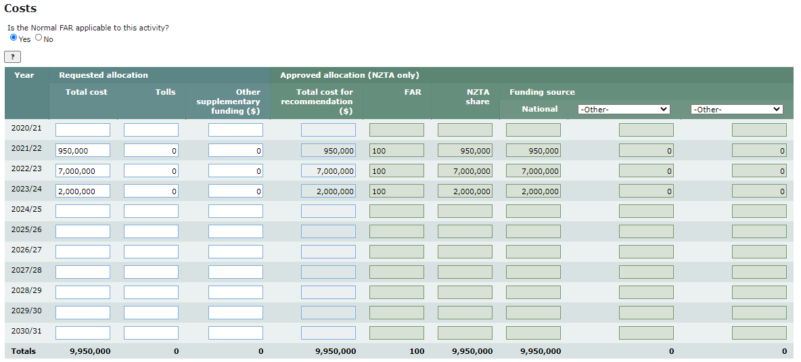
The work category and activity class are required fields for NLTP inclusion.

The expected total cost for this phase of the activity is required for NLTP inclusion.
The total cost of the phase is an annual cash-flow plan set out for the life of the activity (this may encompass more than one NLTP period). The approved allocation will be completed by Waka Kotahi on funding approval for the phase.

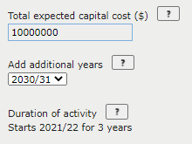
The total expected capital cost is pulled across from the economic and financial summary page.
Additional years are likely only required for large scale investment but can be added using the drop down box.
The duration of the activity is automatically calculated TIO when the page is saved based on the annual cashflow information entered into the table.

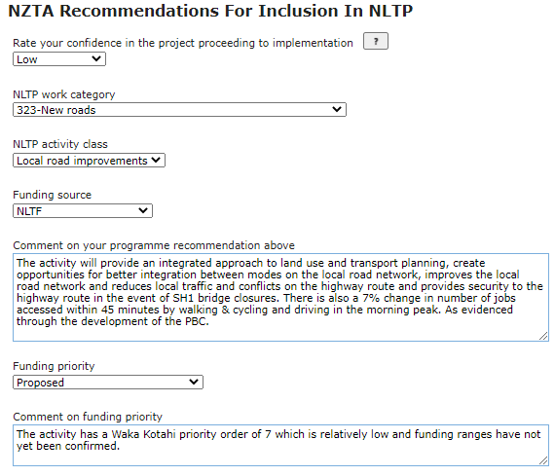

The NZTA recommendation for inclusion in the NLTP is completed by the Waka Kotahi Investment Advisor and is required for inclusion into the NLTP.
The Advisor will need to provide a rating on their confidence in the activity proceeding to implementation within the NLTP. This rating is from Very Low to Very High.
The Advisor will select the work category based on their assessment of the improvement activity being undertaken. The Activity Class field will be automatically populated based on the selected work category.
The advisor will select the funding source based on the provided cashflow and completed economic and financial summary table.
The Investment Advisor will provide comments on the activity’s programme recommendation and funding priority which should draw on their Waka Kotahi IPM profile assessment.

