TIO USER GUIDE
LCLR Programme Exemplar for NLTP Inclusion

New Starter?

Click on Introduction to TIO to learn important things about TIO, and correct or useful time-saving skills.

Role and Responsibility

Regional Transport Committees (RTC) | LCLR programmes in TIO are submitted to an RTC for inclusion in their RLTP. All LCLR programmes are required to be included in an RLTP to be included in the NLTP.
Activity Owner  (Approved Organisations (AO) or Waka Kotahi) | Submit their completed LCLR programme spreadsheet into TIO. Modify the pre-established LCLR programme in TIO. Submit the programme to RTCs for inclusion into the RLTP/NTLP
Waka Kotahi Investment Advisor | Review the LCLR programme spreadsheet and information input into TIO. Liaise with the Activity Owner on any incomplete, inaccurate or incorrect information included in TIO for the programme.

What level is the exemplar set?
The exemplar is based on an Approved Organisation programme with a view of both ‘Activity Owner’ and ‘Investment Advisor’ inputs. The information view is set at the requirements for NLTP inclusion.

TIO LCLR Programme Exemplar

Outline Page
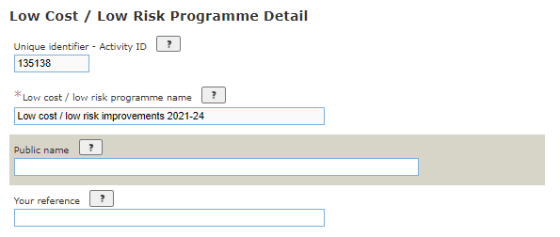

The programme name is a mandatory field for Inclusion into the NLTP.
The programme name is system generated in line with the Naming Guidelines and cannot be edited.
The public name field is optional and should only be completed if the programme is publicly known by a unique and meaningful name (gifted or Maori name) that is different to the "programme name". Where possible, keep the Public Name consistent with the name of the activity included in the RLTP and LTP. The majority of LCLR programmes will not have a public name.
‘Your Reference’ is the organisation's own reference for the programme. This may be the WBs, SAP code or other accounting code, for example. This is not a mandatory field.
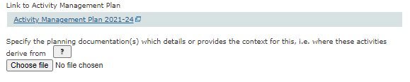

All LCLR programmes will link to their AMPs which are the programme business case for the district, city or region. Additional planning documents can be uploaded but this is optional.

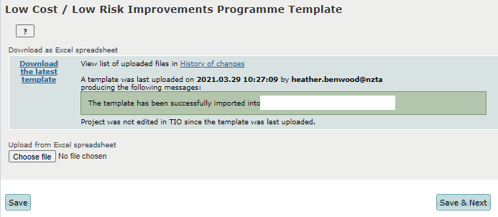

The link ‘Download the latest template’ allows you to download the latest version of your LCLR programme spreadsheet. Any changes you make to the LCLR bid or programme can be uploaded into TIO by saving the spreadsheet locally, clicking ‘Choose file’, selecting the locally saved spreadsheet and clicking save at the bottom of the page.
When uploading the file, you may get one of two messages:
- Green Box - The template has been successfully imported into [Approved Organisation] – The template was uploaded with no errors
- Yellow Box - The template has been imported into [Approved Organisation] with warning(s) - Review and correct these errors and try to import the spreadsheet again.
Note: TIO we still save your programme but some of the data will not be able to be read by the system.
Note: For Approved Organisations with SPR this view may differ slightly with two spreadsheets shown.

Benefits and Measures Page

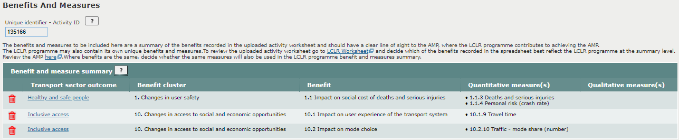
Benefits and measures should be selected based your overall LCLR programme, focusing on areas that form a significant part of your programme or that have a high GPS alignment rating. Measures selected should also consider benefits and measures selected previous business cases like the linked AMP.
We have selected 3 benefits and 4 measures to track against the LCLR programme.
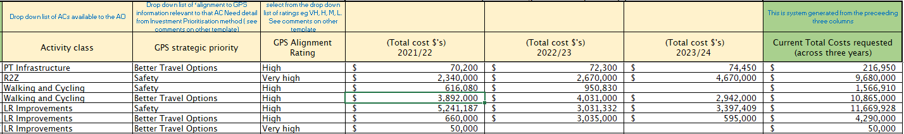

The measures selected align to the LCLR programme bid. Two safety measures were selected to measure performance for safety investments under the Road to Zero, Walking & Cycling and Local Road activity classes. Looking at the detailed activity list for the LCLR programme, the majority of Walking & Cycling – Better Travel Options projects related to mode choice, therefore the benefit ‘Impact on mode choice’ and the measure ‘Traffic – mode share (number)’ was selected to measure performance for these investments.
Measures were not selected for Public Transport Infrastructure projects as is a less significant parts of the overall LCLR programme for the Approved Organisation.

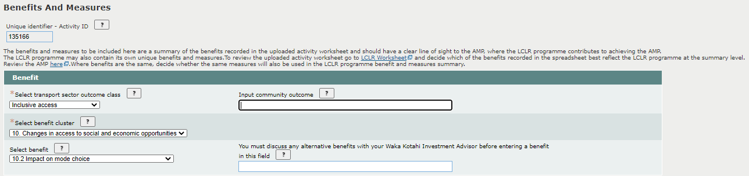

Please read the full description of related benefits which can be found in the Benefits framework and management approach guidelines.
Transport sector outcomes are based on the Ministry of Transport’s Transport Outcomes Framework. Benefit clusters and benefits are enduring and reflect the broad range of land transport benefits valued by the community. For inclusion one transport sector outcome, followed by a benefit cluster and benefit is required to be selected.
The community outcome field is optional. It allows community outcomes, relating to transport sector outcomes being sought, to be entered into TIO. These outcomes do not need to be land transport specific and allows connections to be made but does not mean that the NLTP will fund these outcomes.
Alternative benefits are optional and must be materially different to the benefits available for selection. Alternative benefits must start with the words "Impact on " and be succinct. You must discuss any alternative benefits with your Waka Kotahi Investment Advisor before entering a benefit in this field. This field has been left blank as suitable benefit was included within the benefits framework.
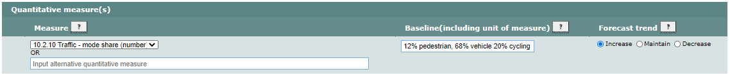

A measure will need to be selected based on the evidence they will provide about the selected benefit to which you are aligning them. The measure’s baseline is the reported result of the selected measure at the start of the investment. The baseline is the investment and measure’s area of influence for the measure. A correct unit of measurement will need to be reflected, we used people to reflect mode shift once the investment is undertaken.

A qualitative measure has not been selected as the benefit is best evidenced through the quantitative measure ’10.2.10 – Traffic – mode share (number)’. If a qualitative measure is being input into TIO they are listed as 'user to describe' in the framework. Methodologies to describe the measures are provided where available in the Non-monetised benefits manual. The baseline will also need to be described as the current state of the measure including the condition of any relevant features being measured, and a brief description of the forecast direction of the measure as a result of the investment and the expected scale of that directional change.
For NLTP inclusion you will need to select measures that reflect the LCLR programme being submitted (a handful of measures is normally sufficient), alongside baseline information and the forecast trend.

Bid Summary Page
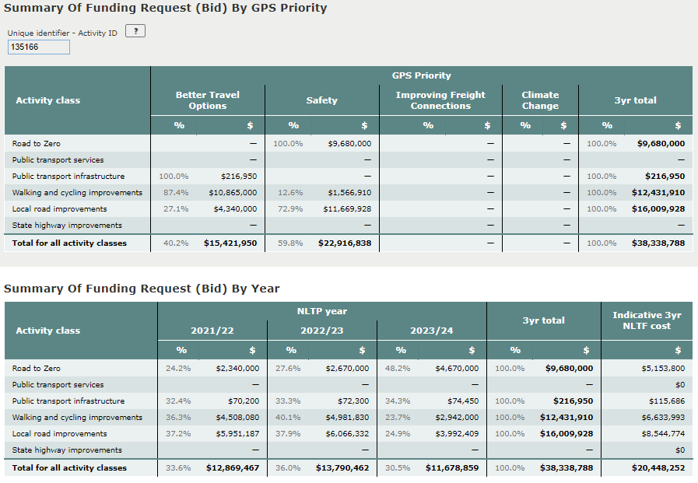
This is summary of data from your LCLR spreadsheet. This page will be updated when an amended LCLR programme spreadsheet is uploaded into TIO. No changes to this page can be made within the TIO module and no changes are required NLTP inclusion.
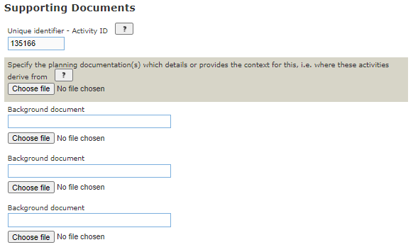
Additional supporting documents can be uploaded to support your LCLR programme, but this is not mandatory. The AMP is linked to this module which alongside the LCLR Spreadsheet, attached to the ‘Outline’ page forms the critical evidence base for the programme.
Note: there may be some activities in your programme that form part of the preferred programme of a PBC. You should consider whether it appropriate to upload these business cases in support of the programme versus providing a link to them in your programme spreadsheet.

Phase Outline Page

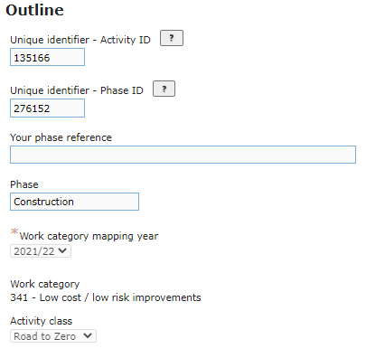
A phase will be created automatically in TIO for each activity class that has funding attached to it within the submitted LCLR spreadsheet. All the created information within this area will be selected by the system and cannot be edited.
Once LCLR allocations have been made in TIO, changes to LCLR allocations across the activity classes can be made by a cost scope adjustment

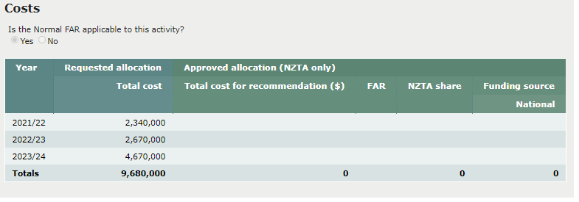

The total cost of the phase is an annual cash-flow based on the sum, for the activity class, of the bid submitted taken from the bid tab of the LCLR spreadsheet. This page will be updated when amendments are made to the spreadsheet. No changes can be made to this section of the TIO module, and the approved allocation will be completed by Waka Kotahi on adoption of the NLTP.
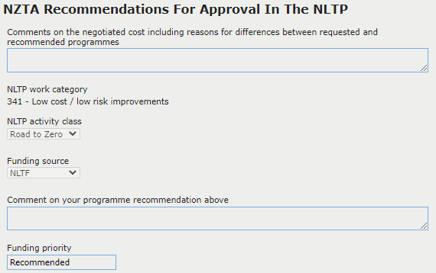
The NZTA recommendation for inclusion in the NLTP is completed by the Waka Kotahi Investment Advisor and is required for inclusion into the NLTP.
The Investment Advisor will need to provide a summary variance between the requested LCLR allocation and allocation approved by Waka Kotahi.
The work category, activity class and funding source will be set by the system and cannot be edited by the Investment Advisor.
Comments will also need to be provided on the LCLR programme recommendation which will to draw on the Investment Advisors assessment of the AMP, LCLR spreadsheet and any other evidence provided.

