THE BIG EASY

Health & Safety Plan

Contents
Event Overview: 3
Management Structure 3
Introduction 3
KEY CONTACT LIST 4
HEALTH & SAFETY POLICY 4
Safety Management Team 5
Safety Management Team members are: 5
POLICIES APPLICABLE TO THE EVENT 6
Medical and Injury Policy 6
Contingency/Weather Policy 6
Concession and Stall Holder Management Policy 6
HAZARD and SAFETY MANAGEMENT: 6
Health and Safety General 6
Hazard Identification Policy 7
Accident & Injury Reporting Policy 7
Identifiable Risks and Hazards: (see attached excel document) 7
STAFF MANAGEMENT: 8
Key Staff Training & Briefing 8
Volunteer Management 8
EMERGENCY PLANNING: 8
POST EVENT OPERATIONS: 8
Event Debrief 8
SUPPORTING DOCUMENT 9
• Black Barn Vineyards Health and Safety Plan 9
• Black Barn Vineyards Event Guide/Alcohol Management Plan 9
• Copy of Approved Traffic Management 9
• Safety Briefing and Map 9
• Contractors vetting form 9
• Near miss Incident form 9
• Serious harm & accident notification form 9
• Event Improvement form 9
• Big Easy Incident near mis database 9
• Big Easy Risk Management form 9
Appendix 1 Big Easy Route (2016) 10
Appendix 2 (Church Road site map) 11
Appendix 3 (Clive Site Map) 12
Appendix 4 (Black Barn Concert site map) 13

Event Overview:

The Big Easy is the ultimate antidote to all those serious lycra laden cycling events held across the country. Participants are encouraged to take their time and have fun savouring the food, drink and entertainment stops along the trail.

The aim of the event is to showcase the world-class Hawke’s Bay trails to locals and visitors to Hawke’s Bay alike. The event follows the HB Trails to Black Barn Winery, via Westshore, Ahuriri, Marine Parade and (See Appendix 1 for trail map).

This year the event is held on Easter Saturday 26th March 2016. The ride begins at 10.00am at Church Road Winery, with a family start at 10.30am from Farndon Park, Clive (See Appendix 2 & 3 for site maps).

The ride finishes with a concert at Black Barn Vineyards that takes place between 2pm – 6pm. (See Appendix 4 for site map).

Last year the event drew 1500 participants and numbers are expected to be similar for the 2016 event.

Management Structure

Hawke’s Bay Tourism, with support from Sport Hawke’s Bay, Napier City Council, Hastings District Council and Hawke’s Bay Regional Council, owns the Big Easy event.

Black Barn Vineyards are hosting the concert form 2pm- 6pm at their venue, Black Barn Amphitheatre. A seperate Health and Safety plan has been prepeared by Black Barn Vineyards for the concert (see supporting document 1)

Introduction

This Health and Safety plan has been developed to create a safe environment to all competitors, volunteers, contractors and public at the The Big Easy Event Team takes its obligatons to Health and Safety very seriously and encourage that if anyone sees anything that is dangerous or unsafe to report it to the Hawke’s Bay Tourism Office.

Throughout the manual, wherever the word “event” is used, this refers to all that happens within the framework of The Big Easy including, activity that happens pre, during and post event at any location that has obligations to The Big Easy.

The term “staff” refers to anyone under the employment of Hawke’s Bay Tourism and key part and the Big Easy partnering organisations including Sport HB, Napier City Council, Hastings District Council and the Hawke’s Bay Regional Council.

If you have any concerns throughout this Health and Safety plan, please contact The Big Easy Health & Safety Manager

KEY CONTACT LIST

Position | Name | Mobile Phone
Event Manager | Jenna Mabey | 021 621 911
Site Manager- Black Barn Vineyards | Kevin Murphy | 027 297 0238
Site Manager – Church Road Winery/Health and Safety Manager | Annie Dundas | 021 630 408
Traffic Management | Ivan Aplin | 027 221 0497
Site Manager- Clive, Farndon Park | Paul Mcardle | 027 747 9192
Media Liaison | Vicky Roebuck | 027 495 4656
Red Badge Security | Lee Campbell | 021 686 365
Church Road Venue Manager | Brent Pilcher | 027 281 6549
Black Barn Venue Manager | Francis de Jager | 027 226 9188

HEALTH & SAFETY POLICY
The Big Easy is committed to providing and maintaining a safe and healthy event for all staff, contractors, volunteers and participants. We will endeavour to ensure all are briefed as necessary, with training generally lays with their own organisations.
We will take all practicable steps by;

- Providing a safe event, safe equipment and proper materials
- Identifying and monitoring hazards and using the hazard management hierarchy of eliminate or minimise.
- Monitor staff, contractors, volunteers and participations for prolonged exposure to hazards
- Insist upon establishment of safe methods and best practices
- Comply with all H&S legislation, regulations and codes of practice
We will take responsibility for health and safety procedures, however, employees, contractors, volunteers and participants need to be aware of their responsibilities and comply with the event’s health and safety policy.
Employees (including contractors and volunteers) WILL be responsible for themselves at ALL times by observing safe practices and rules/instructions relating to their work procedures
Each employee, contractor, volunteer and participant is encouraged to play a vital and responsible role in maintaining a safe and healthy event through:
- Being involved in the event health and safety system.
- Following correct procedures.
- Safe and proper use of equipment.
- Reporting any pain or discomfort as soon as possible.
- Ensuring all accidents and incidents are reported.
- Informing your manager immediately of any health and safety concerns.
- Keeping the event facilities tidy to minimise the risk of any trips and falls.

Safety Management Team

A key strategy for the safe conduct of the event is the formation of a Safety Management Team (“SMT”) to act as a focal point for all matters relating to Health and Safety at the event. The Health and Safety Manager (convenor) will be responsible for all matters and may call on members of the SMT for assistance.

The SMT’s responsibilities include (but are not limited to):
- Bring to the Health and Safety Manager (convenor) attentions matters of safety
- Make recommendations to the Event Manager on any matters relating to safety
- Meet before and during the event to consider all aspects of safety
- Assess all hazards in terms of severity and impact, and recommend appropriate courses of action to the Event Manager (through the SMT Convenor).

Safety Management Team members are:

Ivan Aplin | Traffic Manager
Jenna Mabey | Big Easy Event Manager
Annie Dundas | Health and Safety Manager
Other members co-opted as required
Kevin Murphy | Site Manager – Black Barn Vineyards
Annie Dundas | Site Manager – Church Road Winery
Paul Mcardle | Site Manager- Farndon Park ,Clive
Francis de Jager | Event Manager - Black Barn Vineyards
Brent Pilcher | Event Manager - Church Road Winery

POLICIES APPLICABLE TO THE EVENT

Medical and Injury Policy

A trained First Aider will be stationed on-site at the Black Barn concert and roving First-Aid will be on hand across the trail to provide assistance when needed. St John’s have been notified of the event and in the event of a serious injury or incident, emergency services are in close proximity and can be called out using the emercency services line 111. Volunteers are fully briefed on this procedure.

Contingency/Weather Policy
Outdoor events are subject to and affected by weather conditions. The weather will be monitored closely by the Safety Manager and Event Manager and decisions made in conjunction with the HB Emergency Management Office.

If the prevailing weather is not considered safe and appropriate for the running of the event it may be shortened or cancelled which will be communicated to the participants in due course.

Concession and Stall Holder Management Policy

All stalls and concessions must possess the required permits and approvals in order to operate their business. They must be operated in accordance with the District Plan and the Food Hygiene Regulations 1974.

ALL electrical leads must be tagged and tested.

Where cooking with either Electrics or Gas takes place, a fire extinguisher suitable for the type of fire that may be encountered must be on hand within the stall.

All stallholders have received a Black Barn Vineyards Event Guide (see supporting document 2) which defines their responsibilities for Health and Safety and which should be read in conjunction with the Black Barn Vineyards Health and Safety Plan.

HAZARD and SAFETY MANAGEMENT:

Health and Safety General
We are committed to the safety of our staff, contractors, volunteers and, most importantly, our event participants.

There are many inherent hazards that exist in the outdoor environment and the nature of our event means we will at times be exposed to weather hazards.

Elimination of natural hazards is often not possible and a proactive approach is taken to identify the hazards and manage them in the most appropriate manner possible.

In deploying this proactive approach, we will:
- Assess the ability of staff/contractors/volunteers to determine whether they have the appropriate skills and experience for the task they are assigned
- Provide training to staff, contractors and volunteers where required
- Communicate expectations to staff/volunteers clearly
- Take all practicable steps to ensure the safety of staff at work
- Ensure that staff have all the necessary safety equipment
- Comply with any legislation regarding health and safety, and any other regulatory requirements such as relevant codes of practice
We require our staff (including contractors and volunteers) to:
- Take all practicable steps to ensure their safety and the safety of others and anyone else around the event
- Work in a responsible manner, and use all safety equipment
- Clearly communicate to their supervisor if they feel they do not have the skills for any task
- Proactively identify hazards and work to manage them

All The Big Easy operations, employees or contractors shall be in compliance with the Health and Safety in Employment Act 1992 (HSE Act) and the Health and Safety in Employment Amendment Act 2002 (HSE Amendment Act).

Hazard Identification Policy
It is our policy to identify hazards in the event. An extensive course reconnaissance will take place days prior to the event in order to identify any hazards, which will then be addressed appropriately. Significant hazards are eliminated. If this is not possible, they are isolated and if this is not possible, they are minimised.

Staff/ contractors/volunteers are able to halt any activity if an identified hazard threatens the safety of any person. Staff/ contractors/volunteers are involved in hazard identification, reporting, control and communication

Staff/ contractors/ volunteers may need to make quick decisions regarding hazards and take quick actions to manage new hazards. In the event of the hazard on the course, the Safety Manager or Event Manager will be notified as soon as possible to give instruction, however, in some cases staff may have to use common sense to deal with a given situation on the spot.

Accident & Injury Reporting Policy
All accidents and injuries must be reported and notified to the Safety Manager or Event Manager. The Safety Manager is an experienced H&S professional and he shall provide guidance to the Event Manager of any statutory reporting requirements to Worksafe NZ, Department of Labour or Police.

Identifiable Risks and Hazards: (see attached excel document)

STAFF MANAGEMENT:

Key Staff Training & Briefing

All key event staff receive a comprehensive briefing inclusive of both event and safety information.

Volunteer Management

The success of the event is dependent on the use of volunteers.

Volunteers will be provided a hard copy of safety briefing and a role outline prior to the event as well as an induction the morning of where possible.

EMERGENCY PLANNING:

Emergency planning is a key component of event operations and safety planning. Accidents and incidents will occur; it is how we deal with these occurrences that are important.

Accidents and incidents must be dealt with professionally and promptly by utilising the appropriately trained resources.

If a participant suffers an incident or accident a first aid personnel can access and travel to the injured competitor.

In the event of serious harm or injury, staff, contractors and volunteers are encouraged to:
1) Ensure safety of others in the immediate vicinity, check for hazards and secure the area.
2) Dial 111 to request medical services and report the situation to the Safety Manager and Event Manager immediately.
3) If capable assist with basic First Aid until Medical support arrives.

POST EVENT OPERATIONS:

Event Debrief
A comprehensive event debrief will be conducted as soon after event as practical and within one month.
All lessons learnt can then be applied to future events and all appropriate updates made to the Operations and Safety Plan.

SUPPORTING DOCUMENT

Black Barn Vineyards Health and Safety Plan

Black Barn Vineyards Event Guide/Alcohol Management Plan

Copy of Approved Traffic Management

Safety Briefing and Map

Contractors vetting form

Near miss Incident form

Serious harm & accident notification form

Event Improvement form

Big Easy Incident near mis database

Big Easy Risk Management form

Appendix 1 Big Easy Route (2016)
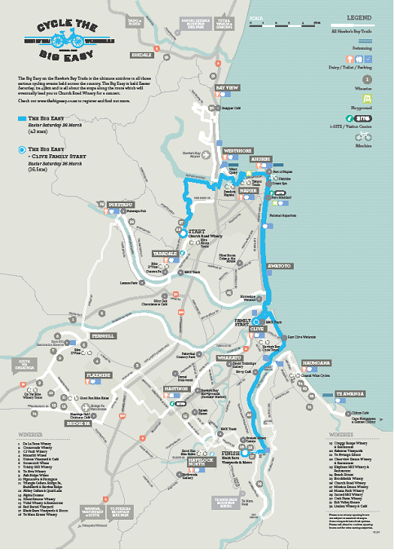

Appendix 2 (Church Road site map)

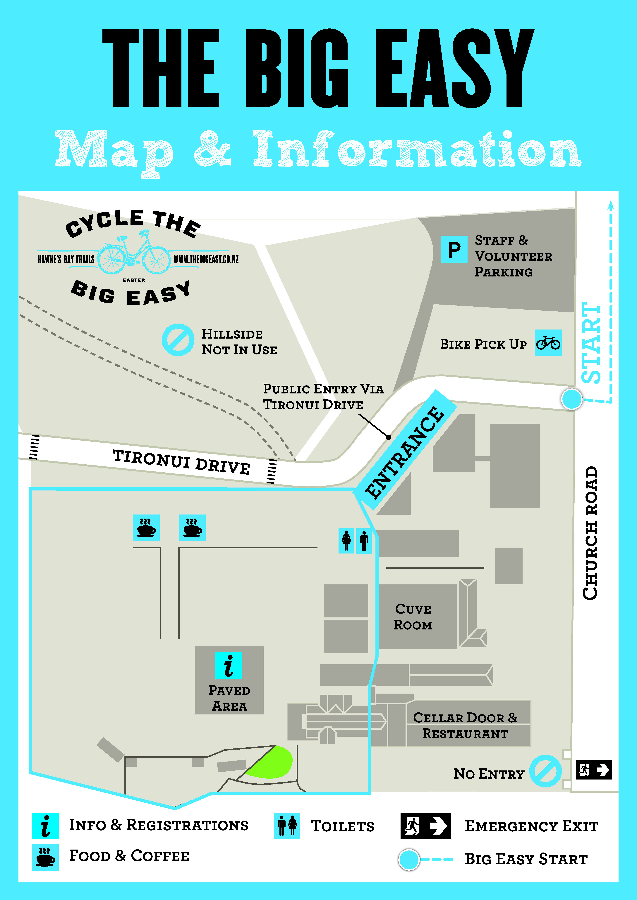

Appendix 3 (Clive Site Map)

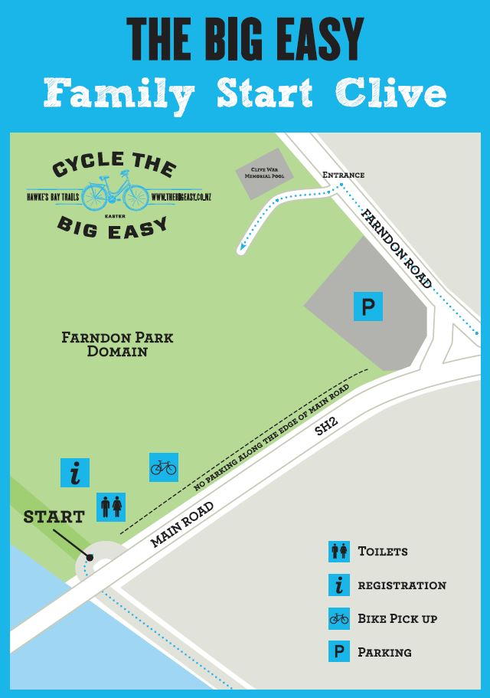

Appendix 4 (Black Barn Concert site map)

